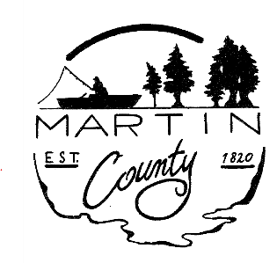

MEMBERS

Warren D. Albright
President
At Large
Term: 1/1/25 – 12/31/2028

Monty Gregory
Vice-President
District 3
Term: 1/1/2023 - 12/31/2026

Jordan Berry
District 1
Term: 12/11/2024 - 12/31/2026

Jim Hamby
District 2
Term: 1/1/2023 – 12/31/2026

Sheri Bowling
District 4
Term: 4/25/2024 – 12/31/2026

Gerald D. Montgomery
At Large
Term: 1/1/2025 – 12/31/2028

Jim Woody
At Large
Term: 1/1/2025 – 12/31/2028

TO: Council Members & Petitioners
FROM: Michelle Norris
DATE: July 30, 2025
RE: Council Meeting Agenda for August 4,2025
Time/Location: 8:00 a.m. Commissioners’ Room, Martin County Courthouse

Council Meeting Link
Dial In: 312 626 6799
Meeting ID: 894 9992 0094
Passcode: 654178

Opening President Warren Albright

Minutes of July 14, 2025

Discussion of Wheel Tax and LIT Rates

Abatement Renewal Auditor Michelle Norris

Additional Appropriations:

USG Grant 2020- Fund 9144
Capital Expenditures $2,461.86

Sales Disclosure- County Share- Fund 1131
Capital Expenditures $25,000

Cumulative Bridge- Fund 1135
Lead Operator W/CDL $25,636
Operator W/CDL (6) $24,992
TOTAL FOR FUND 1135 $50,628

Auditors Ineligible Deductions- Fund 1216
Furniture and Equipment $300

MCSW Health Insurance Fund- Fund 4050
Insurance Premiums $2,000

OVER ----

De-Appropriations:

MOTOR VEHICLE HIGHWAY- FUND 1176
Operator W/CDL (6) -$24,992
Lead Operator W/CDL -$25,636
TOTAL FOR MOTOR VEHICLE HIGHWAY FUND -50,628

Other Essential Business

Next Council Meeting and Public Hearing for 2026 Budgets – Monday, September 8th at 6:30 pm

PRESIDENT MAY MODIFY AGENDA

