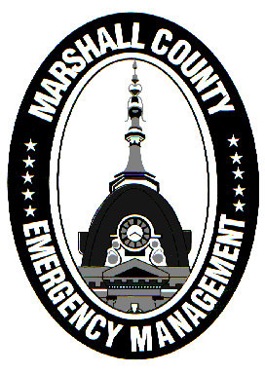
Marshall County Emergency Management Agency
Jack Garner, Director
112 W. Jefferson Street Room 207
Plymouth, Indiana 46563
Phone: 574-936-3740
E-mail: ema@co.marshall.in.us

NEWS RELEASE
November 5, 2025

As Winter Approaches, Marshall County EMA Reminds All to Stay Safe!
It may still be early November, but snow is in the forecast for this weekend! While meteorologists are not predicting the “storm of the century”, any amount of snow, ice, or freezing rain can disrupt travel and risk public safety.
Marshall County EMA, along with our county partners at the Marshall County Highway Department and the Marshall County Sheriff’s Department, are ready to take on what looks to be a wetter winter than normal. Your local first responders are ready for winter operations… but are you?
Here are a few action items for YOU to take in order to keep yourself safe in winter conditions!
- Have a Way to Receive Alerts
Extreme winter weather events can take us by surprise. Having a method of receiving alerts is critical to ensuring your safety. EMA highly encourages local residents to download the Marshall County App, which is available on Apple and Android devices. Once in the app, you can toggle on push notifications from the National Weather Service, EMA, and others. When an advisory, watch, or warning is issued, county app users will be notified.
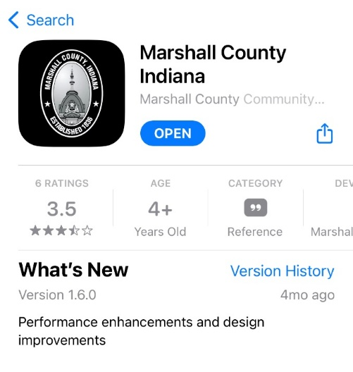
Additionally, you can follow EMA on Facebook for forecasts and other safety messages. It is important to receive your weather alerts from viable sources, such as the National Weather Service or licensed meteorologists. Amateur meteorologists and bad actors love to post inaccurate or misleading information to gain more clicks and fame. For updated road conditions and live snow plow cameras, Hoosiers can visit INDOT’s TrafficWise website, at 511in.org.

- Know Your Terms
Winter weather messaging can be confusing. There are several products the National Weather Service issues to alert us of incoming hazardous weather.
The most frequently issued products include a Winter Weather Advisory, Winter Storm Watch, and Winter Storm Warning. An Advisory is issued for lower-level winter events. A Watch is issued in advance of a more significant winter event. A Warning is issued when confidence is high that a significant winter event will occur/is occurring.
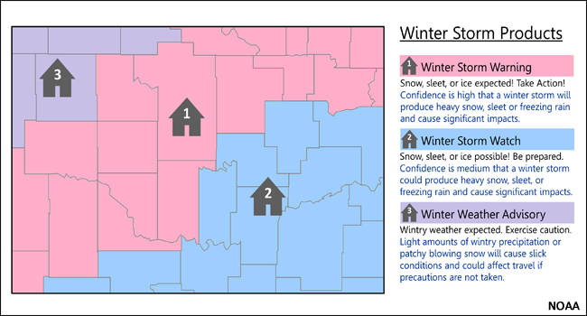
Following the winter storm model, the National Weather Service also issues Cold Weather Advisories, Extreme Cold Watches, and Extreme Cold Warnings.
Know the difference between different levels of travel advisories! A basic Travel Advisory means that routine travel or activities may be restricted because of hazardous situations. It urges people to use caution when navigating the roads. A Travel Watch means that conditions are threatening the safety of the public. Only essential travel is recommended during a Travel Watch.
A Travel Warning, also known as a “travel ban”, is issued when travel is restricted to emergency workers only. Do NOT endanger yourself, your neighbors, or first responders and stay off the roads during a Travel Warning!
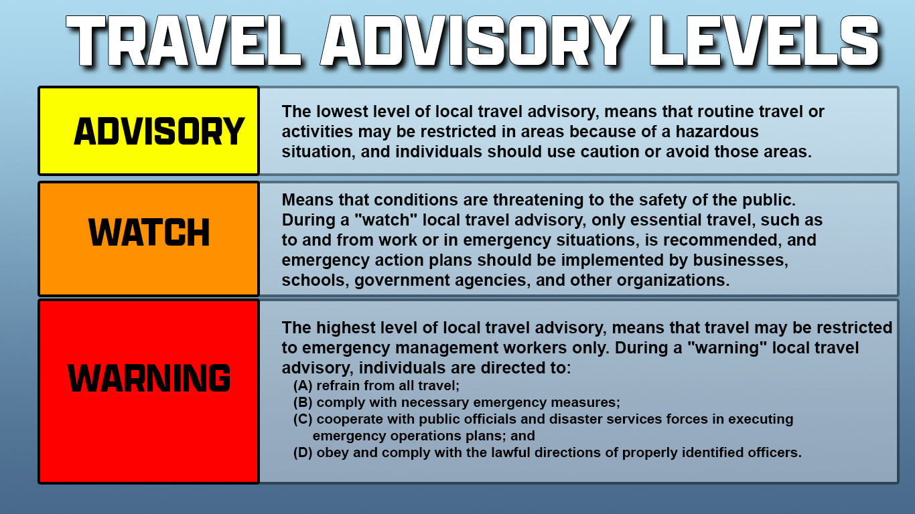
The public can check the latest travel status by visiting in.gov/dhs/travel-advisory-map.

- Prepare Yourself for Freezing Temperatures
When temperatures and wind chills drop, dress appropriately by wearing multiple layers and covering as much skin as possible. Frostbite, hypothermia, and overexertion can cause medical emergencies and even death. Know the symptoms and be vigilant.
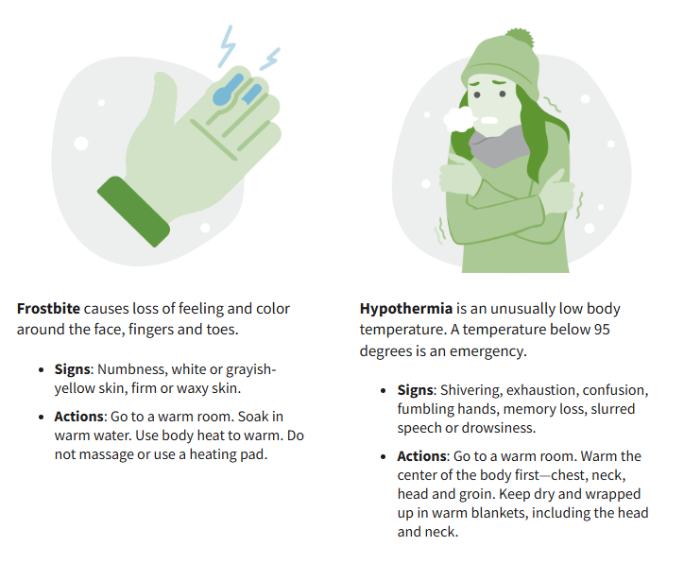
Consider placing additional items in your car for winter travel, including spare clothes, an ice scraper, food and water, a flashlight, jumper cables, and other materials needed in case your vehicle gets stranded for an extended period of time. Try to keep your gas tank full throughout the winter. Sand and kitty litter can be used to gain traction to get you back on the road if you slide off.
In your house, use insulation caulking, and weather stripping to not only keep the cold air out, but also to save on energy bills. Keep pipes from freezing during extreme cold snaps by insulating your pipes, opening cabinet doors, and letting your faucets have a slow drip. Bring pets inside during extreme cold or ensure they have a warm shelter outdoors.
The EMA wishes everyone a safe and happy winter!
- Jack Garner, EMA Director, Marshall County

