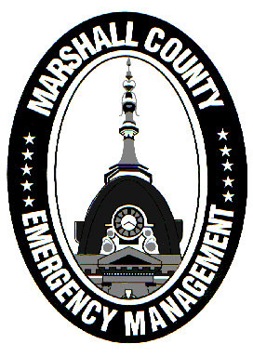
Marshall County Emergency Management Agency
Jack Garner, Director
112 W. Jefferson Street Room 207
Plymouth, Indiana 46563
Phone: 574-936-3740
E-mail: ema@co.marshall.in.us

NEWS RELEASE
November 29, 2025

Marshall County Under Travel Advisory

The Marshall County Emergency Management Agency has placed Marshall County under a “Travel Advisory” effective at 8 AM on November 29, 2025.
A Travel Advisory is the lowest level of local travel restrictions. It means that routine travel or activities may be restricted in areas because of hazardous situations, and individuals should use caution or avoid those areas. Travel advisories are signified with yellow on statewide travel status maps.
A system snow event is overspreading the region and bringing heavy snowfall rates and an expected 6+ inches of accumulation to the county. Some areas may receive over a foot of snow. Wind gusts of 25 to 35 mph will only make issues worse.
Marshall County officials will continually assess road conditions and determine if another travel status upgrade is needed. Expect hazardous travel through at least Sunday night. If drifting occurs, the Monday morning commute may also be disrupted.
Additionally, a Winter Storm Warning has been issued by the National Weather Service from 7 AM Saturday morning until 7 PM Sunday evening.
The Marshall County Highway Department is on full call-out and will be plowing and treating county roads. INDOT is also maxed out for both plowing and treating state and federal highways.
Please avoid traveling if at all possible to allow crews safe operating conditions. Staying home will also help our public safety officials more efficiently respond to emergencies.
Stay tuned to local media and the Marshall County EMA for future updates – including an eventual return to normal travel status.
- Jack Garner, EMA Director, Marshall County

