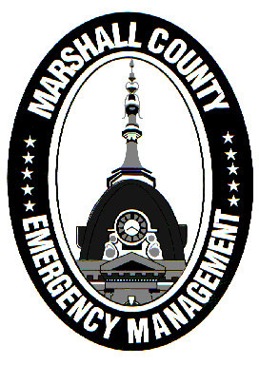
Marshall County Emergency Management Agency
Jack Garner, Director
112 W. Jefferson Street Room 207
Plymouth, Indiana 46563
Phone: 574-936-3740
E-mail: ema@co.marshall.in.us

NEWS RELEASE
November 11, 2025

Marshall County Ends Travel Advisory
The Marshall County Emergency Management Agency has returned Marshall County to a normal travel status effective immediately.
A Travel Advisory was issued on November 9th due to a lake effect snow event that dumped up to a foot of snow in some portions of the county. Slick roads resulted due to the snowfall and black ice from a rapid freeze. Marshall County Central Dispatch was flooded with slideoff calls, particularly on Monday morning.
Conditions have improved today and the snow has come to an end. There is a potential for snowmelt to refreeze on untreated roads overnight but that depends on a number of factors that may prevent refreezing. County and state highway crews will keep an eye on the roads just in case.
Continue to drive with caution just in case some slick spots linger.
Thank you to INDOT, the Marshall County Highway Department, and municipal street departments for their hard work during this frustrating weather period. Also, thank you to public safety officials who responded to the numerous traffic incidents over the last 48 hours.
- Jack Garner, EMA Director, Marshall County

