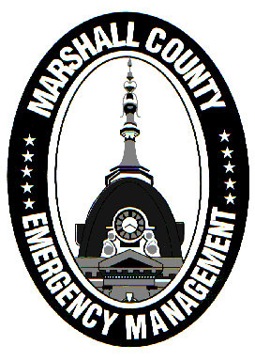
Marshall County Emergency Management Agency
Jack Garner, Director
112 W. Jefferson Street Room 207
Plymouth, Indiana 46563
Phone: 574-936-3740
E-mail: ema@co.marshall.in.us

NEWS RELEASE
May 1, 2025

State Disaster Relief Fund Open for Applications From 3/30 and 4/2 Storm Damage
A media advisory from the Indiana Department of Homeland Security (IDHS) has announced that the State Disaster Relief Fund (SDRF) has opened applications for Marshall County residents or property owners who incurred damage to their homes or property from the severe storm events on March 30th or April 2nd, 2025.
Marshall County became eligible for SDRF funds due to its issuance of a local disaster declaration on April 2nd, just a few hours after the second EF1 tornado in four days struck the county. On April 11th, Governor Mike Braun issued a statewide disaster declaration that included Marshall County. Initial damage assessments conducted by the Marshall County Emergency Management Agency (EMA) and IDHS found significant damage and helped validate the declarations.
Applications to help with immediate needs will be capped at $2,000 initially, although eligible homeowners could receive additional assistance after a complete damage assessment is finished.
The State Disaster Relief Fund applies only to individuals who are uninsured or underinsured. State funding cannot replace insurance coverage, which is the primary and best source of protection from storm damage. The maximum payout from the SDRF for an individual is $25,000. The fund only addresses the costs of repairing, replacing or restoring property that is the primary residence of the applicant.
The SDRF is not currently accepting applications for the Public Assistance program. Local jurisdictions will be notified when Public Assistance becomes available.
If eligible, apply for funds at the following link: app.smartsheet.com/b/form/f75ca97d5deb4e789290c1ed1c389223
For more information on the SDRF, visit https://www.in.gov/dhs/emergency-management-and-preparedness/state-disaster-relief-fund/
If you have any further questions on your eligibility or application, please reach out to the Marshall County EMA by emailing ema@co.marshall.in.us.

