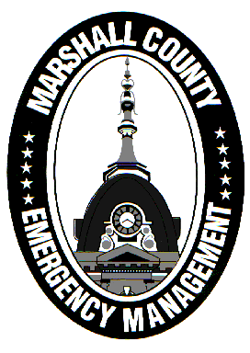
Marshall County Emergency Management Agency
Jack Garner, Director
112 W. Jefferson Street Room 207
Plymouth, Indiana 46563
Phone: 574-936-3740
E-mail: ema@co.marshall.in.us

NEWS RELEASE
May 14, 2026

Marshall County EMA Partners With RDPC to Offer Two National-Level Trainings This Summer

The Marshall County Emergency Management Agency (EMA) has secured two training courses from the Rural Domestic Preparedness Consortium (RDPC) to be hosted in Plymouth this July.
On July 21, “Disaster Recovery in Rural Communities” (MGT-415) will be held at the Purdue Extension of Marshall County office. This course explores the realities that rural areas like Marshall County experience after disasters strike. MGT-415 is a highly recommended training for elected/government officials, public safety leadership, nonprofit organizations, and those involved in economic development.
On July 30, “Mass Fatalities Planning and Response for Rural Communities” (AWR-232) will be held at Plymouth Community School Corporation. The Marshall County Coroner’s Office is partnering with EMA to bring this course to the county. AWR-232 prepares first responders, coroners, public health, and others to better manage a mass fatality incident, specifically in rural areas.
“The EMA has made enhancing training opportunities a top priority moving forward,” said Agency Director Jack Garner. “Bringing two national-level courses like these to Marshall County is a huge step in making sure EMA and its community partners are prepared to face all hazards that threaten the life, safety, and property of Marshall County residents.”
Both courses run from 8 AM – 5 PM and are provided at no cost to participants. Dual registration through the Acadis Portal and the RDPC website is required. For registration information, please contact the Marshall County EMA by emailing ema@co.marshall.in.us and we will help get you signed up!
NOTE: The Mass Fatalities course was previously scheduled for April 28 but was moved to July 30 due to the recent federal funding lapse at the Department of Homeland Security.

