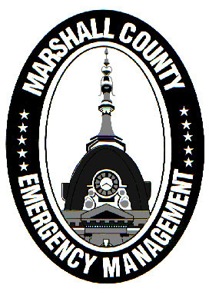
Marshall County Emergency Management Agency
Jack Garner, Director
112 W. Jefferson Street Room 207
Plymouth, Indiana 46563
Phone: 574-936-3740
E-mail: ema@co.marshall.in.us

NEWS RELEASE
July 30, 2025

Marshall County Included in Federal Disaster Declaration
On July 22, 2025, President Donald Trump granted a Major Disaster Declaration for 23 counties in Indiana, including Marshall County, due to the severe weather and flooding that occurred statewide between March 30 and April 9.
Two tornadoes hit Marshall County during this time period. On March 30th, an EF1 tornado caused damage in and around Marian University’s Ancilla College. On April 2nd, another EF1 tornado struck the county, causing a path of damage from northeast of Culver to Bourbon.
Following the tornadoes, the Marshall County Emergency Management Agency conducted damage assessments and coordinated with public safety officials to evaluate the scope of the damage. A list of affected structures (both residential and public) was submitted to FEMA for review, as well as estimated costs of damage to public buildings and resources.
At this time, only FEMA’s public assistance program was approved for Marshall County. This means that eligible government applicants, such as Marshall County, the Town of Bourbon, and fire departments will be able to apply for financial reimbursement.
FEMA’s individual assistance program, which provides financial support to affected residents, was denied by the President. The Indiana Department of Homeland Security is currently reviewing appeal options, and any updates will be shared by the EMA.
Over the next few weeks, a joint partnership between the public assistance applicants, Marshall County EMA, Indiana Department of Homeland Security, and FEMA will take place to ensure fair reimbursement for our county. EMA Director Jack Garner will also be out this week conducting new damage assessments on affected properties with hopes of collecting enough data to justify an individual assistance program appeal.
For any questions or concerns regarding the disaster declaration and the ongoing recovery period, please direct your thoughts to ema@co.marshall.in.us and we will assist to the best of our abilities.
- Jack Garner, Director, Marshall County Emergency Management Agency

