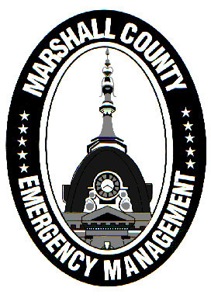
Marshall County Emergency Management Agency
Jack Garner, Director
112 W. Jefferson Street Room 207
Plymouth, Indiana 46563
Phone: 574-936-3740
E-mail: ema@co.marshall.in.us

NEWS RELEASE
February 3, 2026

Marshall County Ends Travel Advisory

The Marshall County Emergency Management Agency has returned the county to a normal travel status, ending the Travel Advisory that was issued January 14th.
This Advisory was upgraded to a Watch twice while conditions were at their worst. Thankfully, warmer and dryer weather has settled in, allowing road conditions to improve substantially.
The EMA would like to express our thankfulness to everyone who played a part in keeping the public safe over the last few weeks. The Marshall County Highway Department, INDOT, and municipal street departments worked tirelessly to keep the roads as clear as possible. Thank you to our first responders; law enforcement officers, dispatchers, firefighters, and EMS workers, for braving the conditions to respond to calls.
While Punxsutawney Phil isn’t always right, it does appear that winter won’t be going away anytime soon. Long term forecasts favor a colder than normal February, increasing the likelihood for future snowfall events. Continue to follow EMA for updates this winter!
- Jack Garner, EMA Director, Marshall County

