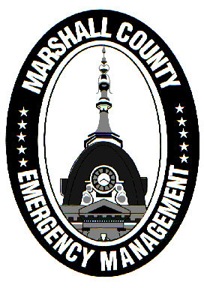
Marshall County Emergency Management Agency
Jack Garner, Director
112 W. Jefferson Street Room 207
Plymouth, Indiana 46563
Phone: 574-936-3740
E-mail: ema@co.marshall.in.us

NEWS RELEASE
December 3, 2025

Marshall County Ends Travel Advisory
The Marshall County Emergency Management Agency has returned Marshall County to a normal travel status effective immediately.
A Travel Advisory was issued on November 29th due to a system snow event that dumped up to a foot of snow in some portions of the county. The Advisory was also briefly elevated to a Watch. Slick roads resulted due to the snowfall and black ice from a rapid freeze. Gusty winds made plowing the back roads an incredibly difficult task. Numerous slideoffs were reported over the Thanksgiving weekend.
Conditions have improved considerably thanks to the work of the Marshall County Highway Department and other road crews.
Continue to drive with caution just in case some slick spots linger. There are still a few chances for light snow accumulation over the next couple days – drive slow on ice and snow!
Thank you to INDOT, the Marshall County Highway Department, and municipal street departments for their hard work during this frustrating weather period. Also, thank you to public safety officials who responded to the numerous traffic incidents over the last week.
- Jack Garner, EMA Director, Marshall County

