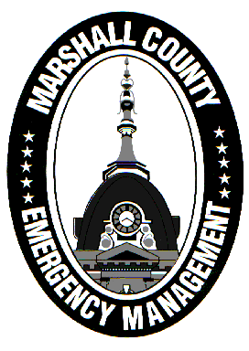
Marshall County Emergency Management Agency
Jack Garner, Director
112 W. Jefferson Street Room 207
Plymouth, Indiana 46563
Phone: 574-936-3740
E-mail: ema@co.marshall.in.us

NEWS RELEASE
August 19, 2026

Assistance Available for August Storm Recovery

As Indiana continues to respond and recover from last week’s record severe weather and flooding, disaster assistance is being made available to help residents in need.
The Indiana Department of Homeland Security (IDHS) has created a webpage that is constantly updated with new resources for Hoosiers. That can be found at in.gov/dhs/emergency-management-and-preparedness/august-2026-disaster.
Here are a few sources of disaster assistance that are already available to Marshall County residents impacted by high winds or areal flooding:
- The State Disaster Relief Fund (SDRF) allows up to $5,000 to primary residences that suffered uninsured damages of eligible items, such as home repairs, essential appliances/furnishings, debris removal, medical devices, and essential transportation. Qualified residents can apply at app.smartsheet.com/b/form/01a019f5a4457f0495bbef680cff9c75
- Households that receive SNAP benefits who lost food due to storm damage or power outages may be eligible for replacement benefits. Affected individuals will need to submit an affidavit for replacement benefits. The affidavit must be submitted by August 21 (for Marshall County residents) and the cause of loss must be verified. The document may be uploaded to the FSSA Benefits Portal, faxed to 888-436-9199, or dropped off at any Division of Family Resources’ office. The link to download the affidavit can be found under “I am a resident and need assistance” at in.gov/dhs/emergency-management-and-preparedness/august-2026-disaster.
- Other resources on the IDHS webpage include the Red Cross, Indiana 211, and USDA.
FEMA is NOT assisting residents through the Individual Assistance (IA) program at this time. IDHS and Marshall County EMA are working closely to seek a presidential disaster declaration that will bring additional relief to impacted county residents. That process is more extensive and requires Joint Preliminary Damage Assessments (JPDAs) between the federal, state, and local governments, which have already begun in some parts of the state.
The Marshall County Commissioners declared a local disaster on August 17th which qualifies Marshall County residents for SDRF funding and keeps the door open for FEMA assistance. While storm damage locally was not as severe as other counties across Indiana, Marshall County EMA has received several damage reports caused by trees through homes and flooded homes. We encourage residents to continue submitting damage reports to help the county understand who needs assistance.
Damage reports can be emailed to ema@co.marshall.in.us, called into 211, or submitted online at in.accessgov.com/marshall-county-ema/Forms/Page/marshall-county-ema/damage-reporting-form/.
As more information and assistance become available, EMA will continue to keep the public updated through our Facebook page and other forms of communication.
- Jack Garner, EMA Director, Marshall County

