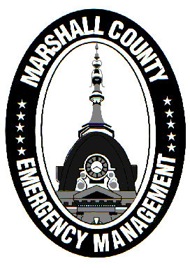
Marshall County Emergency Management Agency
Jack Garner, Director
112 W. Jefferson Street Room 207
Plymouth, Indiana 46563
Phone: 574-936-3740
E-mail: ema@co.marshall.in.us

NEWS RELEASE
April 3, 2025

EF1 Tornado Confirmed in Marshall County, More Information Available for Residents
The National Weather Service has confirmed an EF1 tornado hit Marshall County on the evening of Wednesday, April 2.
The tornado began near Rutland at 7:52 PM and lifted near Etna Green (in Kosciusko County) at 8:10 PM. The impact was most heavily concentrated in Bourbon where at least 50 homes or commercial buildings suffered some type of damage. A map of the tornado’s path can be seen below:
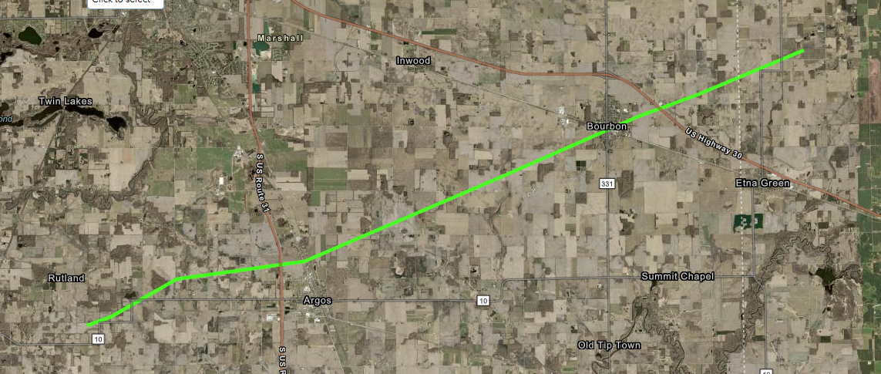
The tornado was on the ground for a total of 18 minutes and 17.91 miles, with a peak width of 175 yards and peak wind speeds of 105 mph.
Immediately following the tornado, first responders conducted search and rescue operations on effected properties. A central command center was established in Bourbon and the Emergency Operations Center was opened at the county building. Operations continued well into the night before picking up again this morning.
Marshall County residents who saw structural damage from the tornado are encouraged to call 211 or visit 211’s website to report their damage to EMA. The damage reports will be compiled and could help Marshall County reach disaster thresholds to initiate additional financial assistance for property owners.
For those who are cleaning up from the storm, please make sure you are properly separating your debris. There are environmental standards that must be followed. More information on how to separate debris is available in the graphic below:
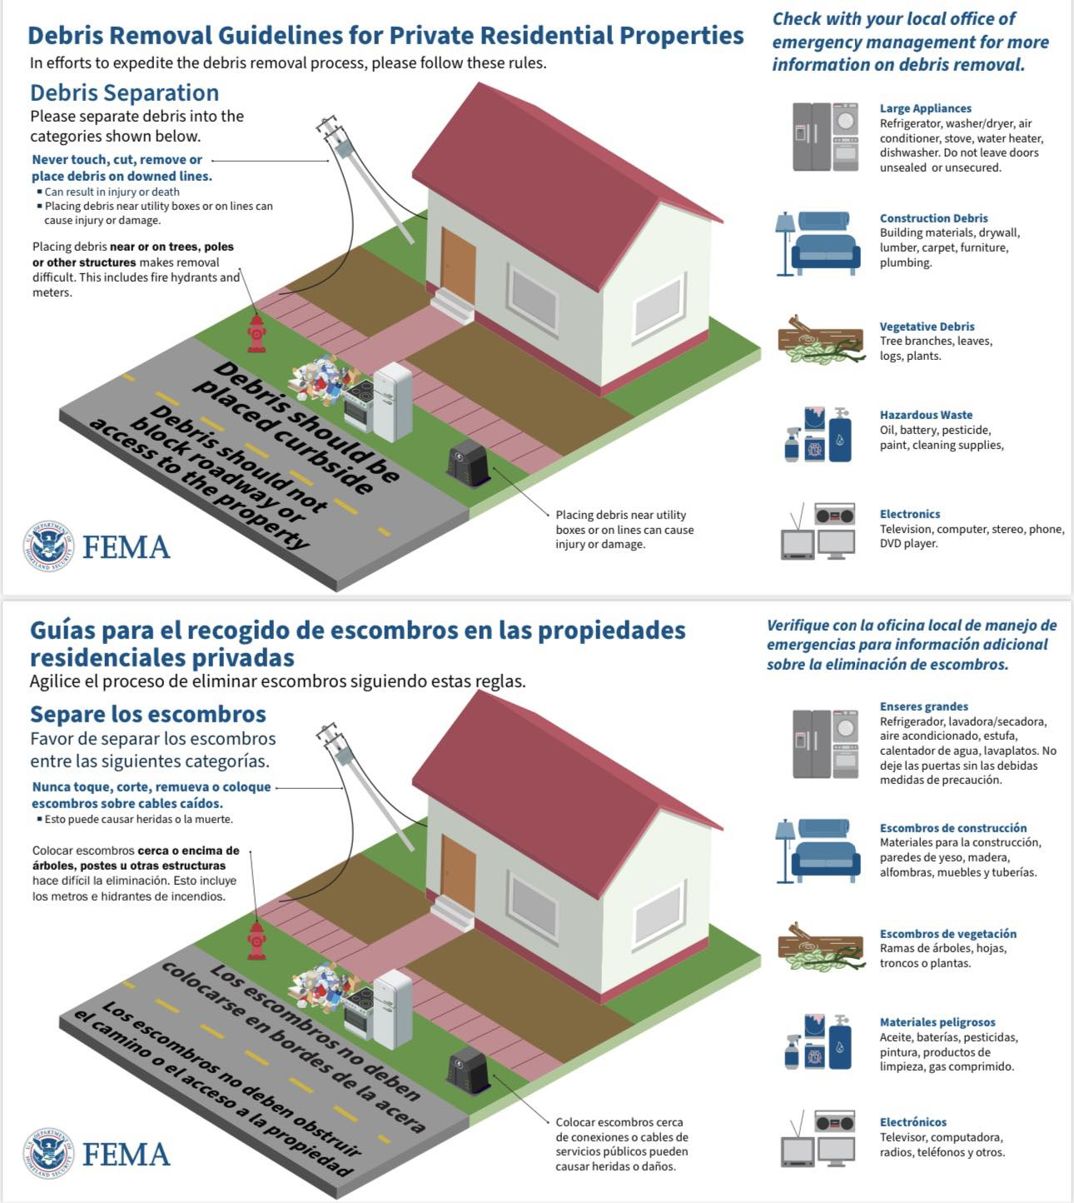
The EMA urges the public to stay away from Bourbon if they have no need to be there. Do not clog the roadways with unnecessary traffic! First responders and victims need space to be able to do their job effectively. Be cautious of scammers who may try to take advantage of disaster survivors and try to verify all your contacts with insurance companies and contractors.
The EMA sends its thanks to everyone who has been involved in operations and clean-up. Volunteers have stepped up for the town and their help is also greatly appreciated.
If you are interested in volunteering your time or resources, please call the Bourbon Clerk’s Office at 574-342-4755.
- Jack Garner, EMA Director, Marshall County

