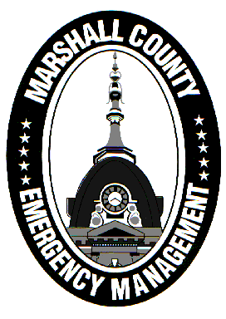
Marshall County Emergency Management Agency
Jack Garner, Director
112 W. Jefferson Street Room 207
Plymouth, Indiana 46563
Phone: 574-936-3740
E-mail: ema@co.marshall.in.us

NEWS RELEASE
September 22, 2026

September is National Preparedness Month!
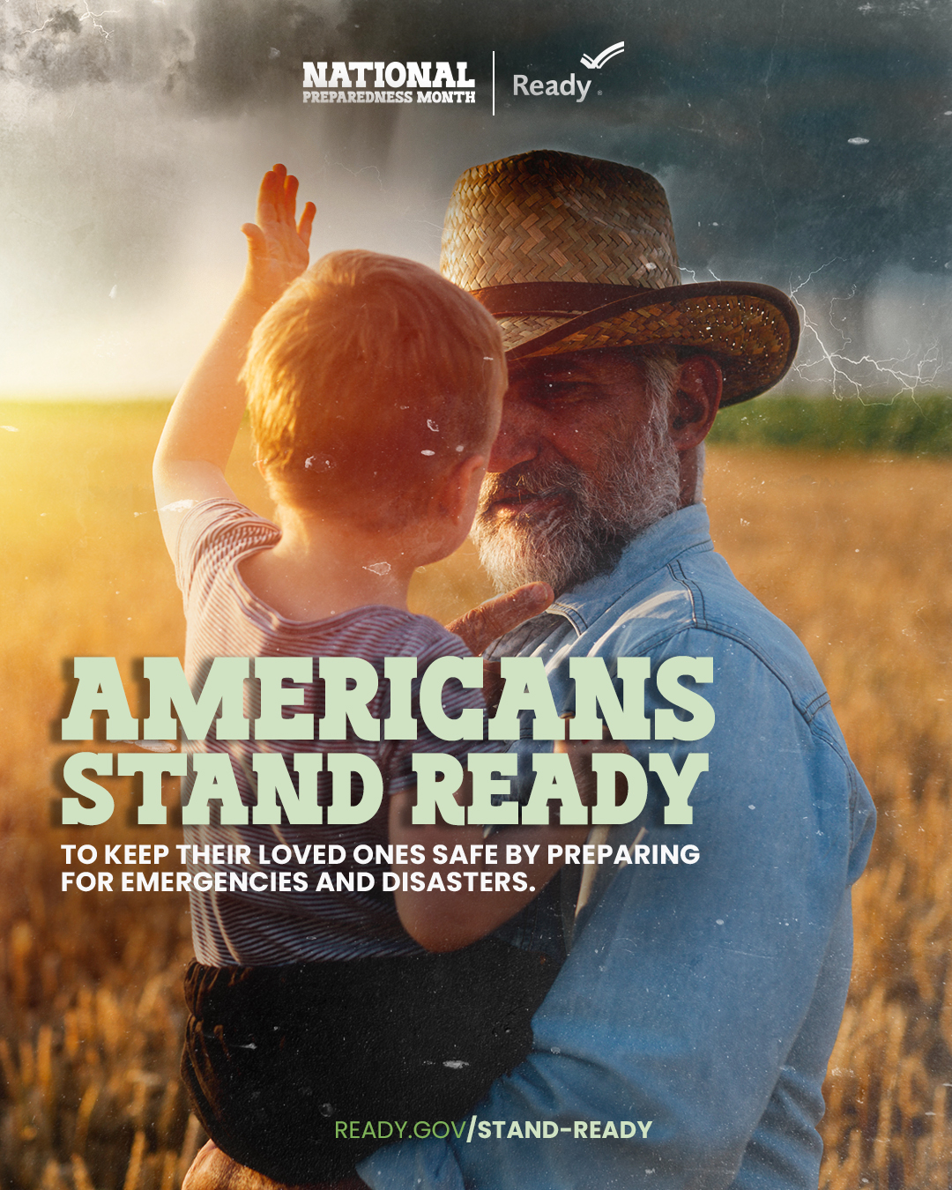
FEMA’s Ready Campaign is celebrating National Preparedness Month, an annual time for EVERYONE to take preparedness seriously.
2026’s theme is “Americans Stand Ready”, which captures how Americans take pride in their ability to protect themselves and their families and work together to recover from disasters.
The Marshall County Emergency Management Agency (EMA) will continue to take its own large-scale preparedness and mitigation efforts to ensure our county and its communities are resilient and able to prepare, respond, and recover from all types of emergencies. But YOU can make the jobs of emergency management and first responders much easier by keeping you and your neighbors safe.
Here are a few tips from the Ready Campaign to help make you and your loved ones more prepared in case of emergency:
- Be in the know
  - Make sure you know where to get information when you need it most. Follow your local first response agencies on social media and stay up to date on potential threats and hazards.
- Make a plan
  - Make a plan to keep you and your family safe and prepared. The plan should include emergency contact information, emergency meeting places, and medical information. Practice the plan regularly!
- Build an emergency supply kit
  - Build a kit with all the essentials items your family needs to stay safe and comfortable if something happens. Find a list of supplies at ready.gov/kit
- Be there for your community
  - From volunteering in your community to learning skills like first aid and CPR, you can take steps to prepare for disasters and keep your family safe and make your neighborhood and community more resilient. Take a training course through FEMA’s Training and Education Program, the American Red Cross, or local public safety agencies to build or gain skills to protect yourself, family, friends, and the community.
Marshall County EMA is committed to preparedness through its mission of planning for, responding to, and recovering from all threats and hazards that impact Marshall County. Current preparedness efforts include a giveaway of free NOAA Weather Radios through an AARP grant, a full revision of the county’s emergency plans, and bringing free public safety trainings to Marshall County.
Follow Marshall County EMA on Facebook or visit in.gov/counties/marshall-county-ema to learn more about our agency.
- Jack Garner, Director, Marshall County Emergency Management Agency

