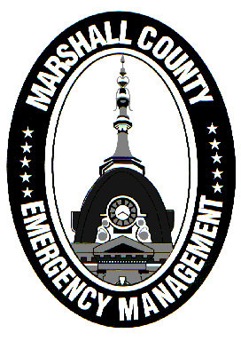
Marshall County Emergency Management Agency
Jack Garner, Director
112 W. Jefferson Street Room 207
Plymouth, Indiana 46563
Phone: 574-936-3740
E-mail: ema@co.marshall.in.us

NEWS RELEASE
September 26, 2025

September is National Preparedness Month!
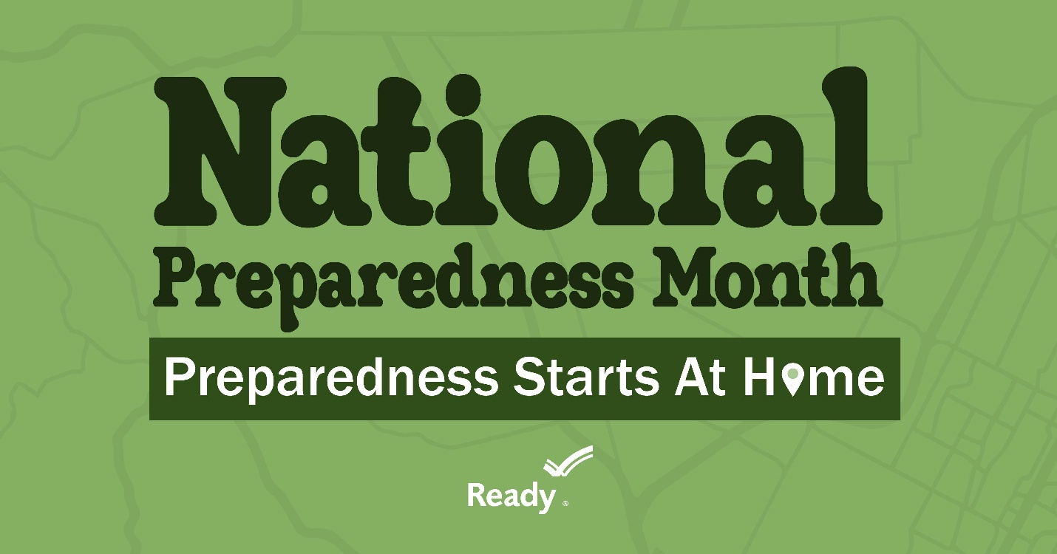
FEMA’s Ready Campaign is celebrating National Preparedness Month, an annual time for EVERYONE to take preparedness seriously.
2025’s theme is “Preparedness Starts at Home”, which focuses on getting back to the essentials of preparedness. Before there was ever emergency management, families took the lead in preparing themselves for disasters. Every individual should still be taking steps to keep themselves safe when disaster strikes.
The Marshall County Emergency Management Agency will continue to take its own large-scale preparedness and mitigation efforts to ensure our county and its communities are resilient and able to prepare, respond, and recover from all types of emergencies. But YOU can make the jobs of emergency management and first responders much easier by keeping yourself safe.
Here are a few tips from the Ready Campaign to help make you and your loved ones more prepared in case of emergency:
- Know your risk
  - Know what could happen where you and your family live. This helps you figure out what you need to do to stay safe. You can explore various disasters and emergencies on Ready.gov.
- Make a family emergency plan
  - Making a plan early helps you reduce stress and save time and money. Follow four easy steps and create a free Family Emergency Plan quickly and easily with our fillable form.
  - Disasters are costly but preparing for them doesn’t have to be. Taking time to prepare now can help save you thousands of dollars and give you peace of mind when the next disaster or emergency occurs. Visit Ready.gov’s low and no-cost tip page to see how you can be better prepared without spending a lot of money.
- Build an emergency supply kit
  - Having enough food, water and medicine can help you stay safe and comfortable until help arrives. Having what you need can also prevent injury and damage to your home.
  - Build a go-bag with all the essentials you might need, so you don’t need to scramble in an evacuation situation. Find a list of supplies at Build A Kit.
- Get involved in your community by taking action to prepare for emergencies
  - Emergencies can happen fast, and emergency responders aren’t always nearby. You may be able to save a life by taking simple actions immediately. You can learn these steps when you take a first aid class through many organizations in your community.
- Jack Garner, Director, Marshall County Emergency Management Agency

