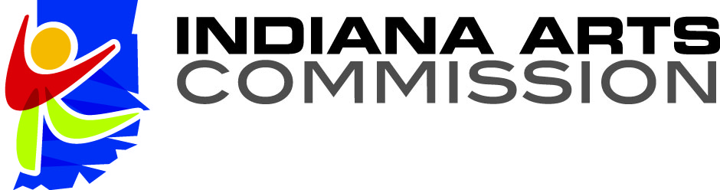

Advisory Panel Meeting
Audience Information

OPEN MEETINGS
Per the Indiana Open Public Meeting Law, IC5-14-1.5, all Indiana Arts Commission business meetings, including advisory panel sessions, are open to the public for observation and may be recorded. There is no provision for public comment or questions during the grant advisory panel session.
IAC supports the open panel process because it provides all Hoosiers an opportunity to observe the process by which public funds for the arts are distributed. It also allows applicants to directly hear panelists’ comments regarding grant proposals, clarifies the review process, provides an opportunity for applicants to learn about proposed projects in other areas of the state and strengthens future projects.
ABOUT THE PANEL AND REVIEW PROCESS
Each advisory panel is composed of individuals from within and outside the region who are experienced artists, knowledgeable in the arts and/or arts management, arts educators, and arts administrators whose credentials have been approved by the Regional Arts Partner or Indiana Arts Commission, and who volunteer their time and expertise.
Panelists will review and assess each Arts Organizational Support (AOS) application in the areas of Organizational Excellence (25), Community Engagement (25), Arts Education (25) and Artistic Quality (25) with numerical points to each. The maximum number of points is 100.
Panelists will review and assess each Arts Project Support (APS) grant application in the areas of Artistic Quality (30), Community Engagement (40), and Project Management (30) with numerical points to each. The maximum number of points is 100.
NO CONTACT BETWEEN APPLICANTS AND PANELISTS
Applicants and panelists will have no direct contact or conversation about the evaluation and disposition of applications, before, during, or after the advisory panel meeting.

