988 National Day of Action
September 15, 2020

Please see below for sample social posts and an alert that you can send to your members in support of #988CantWait.
Social Posts
Following every post, please provide a disclaimer that help is available now as part of a thread or as a comment. For example, you can use this text: Help is available now if you or somebody you know is in mental health crisis. Text “NAMI” to 741741 or call the Suicide Prevention Lifeline at 1-800-273-8255. This bill will make the Suicide Prevention Lifeline phone number an easy-to-remember 3 digits. #988CantWait
Here is how it would look on Facebook and Twitter:
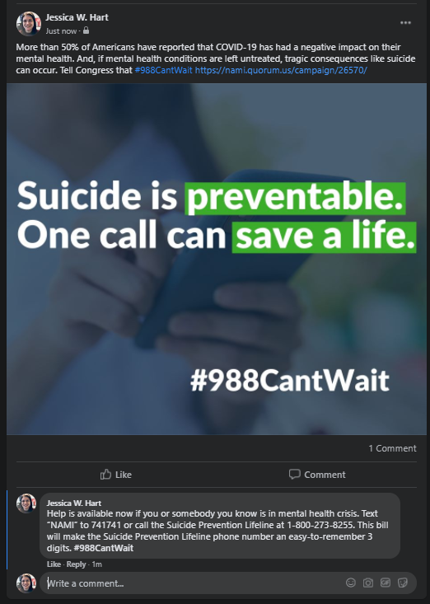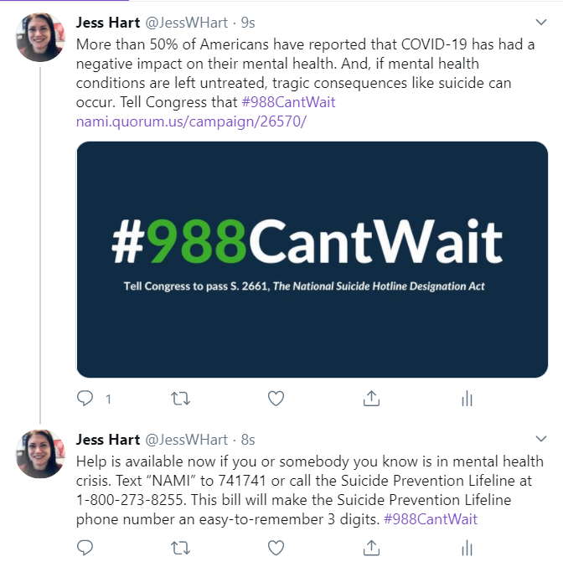

More than 50% of Americans have reported that COVID-19 has a negative impact on their mental health. If mental health conditions are left untreated, tragic consequences like suicide can occur. Tell Congress that #988CantWait [link to your alert]
The overall suicide rate in the U.S. has increased by 31% since 2001. We must reverse this trend. Tell Congress that #988CantWait [link to your alert]
Suicide is the 2nd leading cause of death for people ages 10-34—we cannot sacrifice our future to suicide. Tell Congress that #988CantWait [link to your alert]
Suicide is the #1 cause of death for Asian Americans, ages 15-24. This must change. Tell Congress that #988CantWait [link to your alert]
Suicide is the 2nd leading cause of death for American Indian/Alaska Natives between the ages of 10-34. This must change. Tell Congress that #988CantWait [link to your alert]
Suicide is the 2nd leading cause of death for African Americans, ages 15-24. This must change. Tell Congress that #988CantWait [link to your alert]
Suicide is the 2nd leading cause of death for Hispanic people in the U.S., ages 15-34. This must change. Tell Congress that #988CantWait [link to your alert]
Lesbian, gay and bisexual youth are four times more likely to attempt suicide than straight youth. Tell Congress that #988CantWait [link to your alert]
Transgender people are 12 times more likely to attempt suicide than the general population. Tell Congress that #988CantWait [link to your alert]

