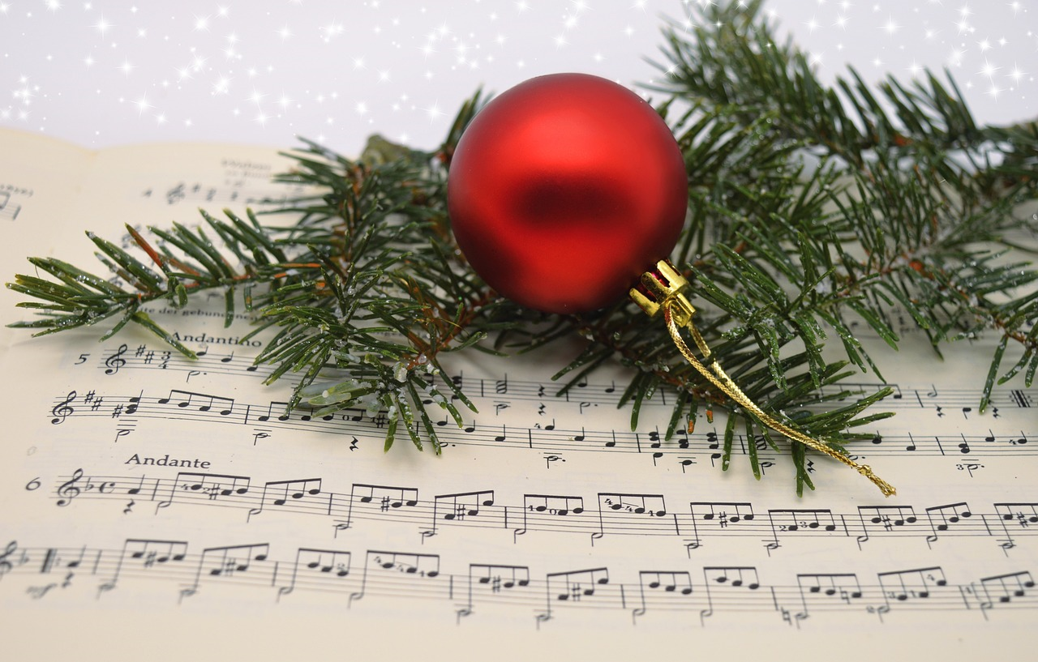
Image courtesy of Pixabay

Navigating the Musical Wonderland of Christmas Songs and Copyright
By Sylvia Watson
'Tis the season to be jolly, and nothing sets the festive mood quite like Christmas music. From classics like "Jingle Bells" to contemporary hits like "All I Want for Christmas Is You," these melodies are an integral part of the holiday experience. However, behind the joyous tunes lie complex copyright implications that shape the way we enjoy and share these festive songs.
Christmas songs are more than just music; they are a cultural phenomena that evoke nostalgia and bring people together. Many of these songs have been passed down through generations, becoming timeless classics that artists continue to reinterpret and reimagine.
While many Christmas songs are in the public domain, allowing for unrestricted use and adaptation, others are protected by copyright. This means that the creators or rights holders have exclusive rights to reproduce, distribute, and perform the songs, subject to some exceptions set out in the Copyright Act. As a result, navigating the musical wonderland of Christmas songs involves understanding the copyright status of each tune.
Many of the so-called “classic” Christmas songs are in the public domain, which means everyone may use and enjoy them without fear of copyright infringement. Classics like "Jingle Bells," "Deck the Halls," “Up on the Housetop,” “Twelve Days of Christmas,” “We Wish You a Merry Christmas,” and “O Christmas Tree,” as well as others, have transcended their original copyright protection and can be freely shared and adapted.
However, keep in mind that the public domain status can vary depending on the specific arrangement or adaptation of a song. For instance, a traditional version of a Christmas carol may be in the public domain, but a new arrangement by a contemporary artist could still be under copyright protection.
Many popular Christmas songs are still under copyright protection and using them without permission can lead to legal consequences. For example, if you plan to use a copyrighted Christmas song in a commercial project, such as a film, advertisement, or holiday event, you may need to obtain a license from the rights holder. Additionally, cover versions of copyrighted songs require a mechanical license, allowing artists to reproduce and distribute their own rendition.
Playing copyrighted Christmas music in the background at your home among a small audience of family and friends is likely not a copyright violation because you are likely streaming from a commercial service or the radio that permits such private use. However, piping copyright protected music publicly over a speaker for background music at the library or other public place would require a license.
Understanding the copyright implications of Christmas songs is crucial for musicians, content creators, and anyone looking to share the joy of the season. Here are a few tips for navigating the legal copyright landscape:
- Familiarize yourself with the public domain status of Christmas songs. Traditional carols and older compositions are more likely to be in the public domain, but it's essential to verify the status of specific versions.

- If you plan to use a copyrighted Christmas song in a commercial project or performance, or to play publicly in a public space, obtain the necessary licenses. This ensures that you have legal permission to use the music and supports the artists and rights holders.

- Consider creating original holiday music to avoid copyright complications. This allows you to share your festive spirit without navigating the legal intricacies of existing Christmas songs.

As we celebrate the season with joyous melodies and festive cheer, it's essential to be mindful of the copyright implications surrounding Christmas songs. Whether a timeless classic or a contemporary hit, each melody carries its own legal considerations that shape how we can enjoy and share the magic of the holidays. So, as you deck the halls with boughs of holly, remember to deck your playlists with awareness of copyright rights, ensuring a harmonious and legal celebration of the most wonderful time of the year.

