

Data Submission Guide for Dispensers

Indiana Prescription Monitoring Program



March 2022

Version 3.0

Table of Contents

1 Document Overview 1

2 Data Collection and Tracking 2

2.1 Data Collection Overview 2

2.2 Data Collection Requirements 2

2.3 Reporting Requirements 2

2.4 Subsequent Reporting 3

3 Data Submission 4

3.1 Timeline and Requirements 4

3.2 Upload Specifications 4

4 Accessing Clearinghouse 5

4.1 Creating Your Account 5

4.2 Logging In to PMP Clearinghouse 10

5 Data Delivery Methods 12

5.1 Secure FTP 12

5.2 Web Portal Upload 13

5.3 Manual Entry (UCF) 14

5.4 Zero Reports 17

5.4.1 Submit a Single-Click Zero Report 18

5.4.2 Create a New Zero Report 21

6 Data Compliance 23

6.1 File Listings 23

6.2 UCF Listings 24

6.3 Error Correction 26

6.3.1 View Records with Errors 26

6.3.2 Error Correction via PMP Clearinghouse 26

7 Email Reports 28

7.1 File Failed Report 28

7.2 File Status Report 28

7.3 Zero Report Confirmation 32

8 Managing Your Upload Account 33

8.1 Adding Users to Your Upload Account 33

8.1.1 Changing Another User’s Password 34

8.2 Adding PMPs to Your Upload Account 36

8.3 Adding SFTP Access to an Upload Account 37

8.4 Editing Your Upload Account 39

9 Managing Your User Profile 42

9.1 Editing Your Profile 42

9.2 Changing Your Password 43

9.3 Resetting Your Password 44

10 Assistance and Support 47

10.1 Technical Assistance 47

10.2 Administrative Assistance 47

11 Document Information 48

11.1 Disclaimer 48

11.2 Change Log 48

Appendix A: ASAP 4.2 Specifications 49

Appendix B: ASAP Zero Report Specifications 55

Appendix C: SFTP Configuration 57

# Document Overview

This document serves as a training guide and support manual for dispensers of Schedule II through Schedule V controlled substances in Indiana who use Bamboo Health’s PMP Clearinghouse repository to report their dispensations. It includes such topics as:

* Reporting requirements for dispensers in or into the State of Indiana
* Data file submission guidelines and methods
* Creating a PMP Clearinghouse account
* Creating a data file
* Uploading or reporting data
* Understanding and correcting errors

This guide is intended for use by all dispensers in or into the State of Indiana required to report the dispensing of controlled substances.

# Data Collection and Tracking

## Data Collection Overview

In accordance with Indiana Code IC 35-48-7, the Indiana Board of Pharmacy (Board) has established an electronic prescription monitoring program (PMP) for the purpose of compiling records of all scheduled controlled substances dispensed in or into Indiana.

The Indiana Scheduled Prescription Electronic Collection and Tracking (INSPECT) program collects and monitors controlled substance prescription data. All pharmacies licensed to do business in Indiana must report all controlled substance prescription data to INSPECT within twenty-four (24) hours (or next business day) from the date on which a drug is dispensed to an Indiana resident. Under certain conditions, as defined by Indiana law, that prescription information is then made available upon request to licensed healthcare practitioners and sworn law enforcement officials in the form of a patient Rx History report.

An INSPECT patient Rx History Report provides users with a summary of the Schedule II, III, IV, and V controlled substances a patient has been dispensed. It also lists the practitioners who have prescribed to the patient and the pharmacies that have dispensed to them. Registered INSPECT users may request Rx History Reports 24/7 from any computer with internet access. For information on how to register, please see the FAQs or visit [www.inspect.in.gov](http://www.inspect.in.gov).

## Data Collection Requirements

All dispensers of controlled substances must meet the reporting requirements set forth by state law in a secure methodology and format. Information about controlled substance dispensing activities must be reported on regular intervals to the Indiana PMP through the authorized data collection vendor, Bamboo Health, Inc.

## Reporting Requirements

**Effective October 11, 2017, the Indiana PMP began requiring pharmacies and dispensers to report controlled substance dispensations to the Indiana PMP via PMP Clearinghouse. Dispensations must be reported at least** within **twenty-four (24) hours** (or next business day) from the date on which a drug is dispensed to ~~an Indiana resident.~~

**The laws and regulations for reporting to the Indiana PMP are continuously subjected to amendments; it is the responsibility of dispensers to be aware of such updates as they are enacted and promulgated.**

All dispensers of Schedule II–V controlled substance prescriptions are required to collect and report their dispensing information. Such reporting without individual authorization by the patient is allowed under HIPAA, 45CFR § 164.512, paragraphs (a) and (d). The Indiana Professional Licensing Agency is a health oversight agency and Bamboo Health, Inc., acts as an agent of Indiana Professional Licensing Agency in the collection of this information.

Certain elements are required by law to be reported. For additional details on these elements and others of ASAP 4.2, please see Appendix A: ASAP 4.2 Specifications.

## Subsequent Reporting

Submissions of controlled substance data must occur within twenty-four (24) hours (or next business day) of the dispensation of that controlled substance. Submissions must occur daily if the facility is dispensing at least one (1) controlled substance prescription per week.

Effective January 1, 2016, all errant records must be corrected and resubmitted within twenty- four (24) hours. All controlled substances dispensed, including zero reports, must be reported within twenty-four (24) hours (or next business day).

**Note:** Hospital pharmacies with zero reporting must report every 30 days.

# Data Submission

This chapter provides information and instructions for submitting data to the PMP Clearinghouse repository.

## Timeline and Requirements

* Pharmacies and software vendors can establish submission accounts and begin submitting data upon receipt of this guide. See Creating Your Account for more information.
* As of October 11, 2017, dispensers are required to transmit their data using PMP Clearinghouse in accordance with the guidelines outlined under Reporting Requirements.
* If a pharmacy does not dispense any controlled substances for the preceding reporting period, it must file a zero reportfor that reporting period, or it will be considered noncompliant. See Zero Reports for additional details.

## Upload Specifications

Files should be in the ASAP 4.2 format, which was released in September 2011, as defined in Appendix A: ASAP 4.2 Specifications. Files for upload should be named in a unique fashion, with a prefix constructed from the date (YYYYMMDD) and a suffix of “.dat”. An example file name would be “20220415.dat”. All of your upload files will be kept separate from the files of others.

Reports for multiple pharmacies can be in the same upload file in any order.

# Accessing Clearinghouse

This chapter describes how to create your PMP Clearinghouse account and how to log in to the PMP Clearinghouse web portal.

## Creating Your Account

Prior to submitting data, you must create an account. **If you are currently registered with the Bamboo Health PMP Clearinghouse system, you *do not* need to register for a new account—you will be able to add Indiana to your existing account for data submissions.** If you have an existing PMP Clearinghouse account, please refer to Adding PMPs to Your Upload Account to add PMPs to your account.

**Notes**:

* Data from multiple pharmacies can be uploaded in the same file. For example, chain pharmacies may send in one file containing controlled substance dispensing information for all their pharmacies licensed in the State of Indiana. Therefore, chains with multiple stores need only to set up one account to upload a file.
* PMP Clearinghouse allows users to submit data through the web portal via manual entry (UCF) or upload of ASAP files. For users who prefer an encrypted transfer method, SFTP access is also available. You may set up your SFTP account during the account creation process.
* If you need to make changes to an existing PMP Clearinghouse upload account, please refer to Managing Your Upload Account.

Perform the following steps to create an account:

1. Open an internet browser window and navigate to the PMP Clearinghouse Account Registration page located at <https://pmpclearinghouse.net/registrations/new>.

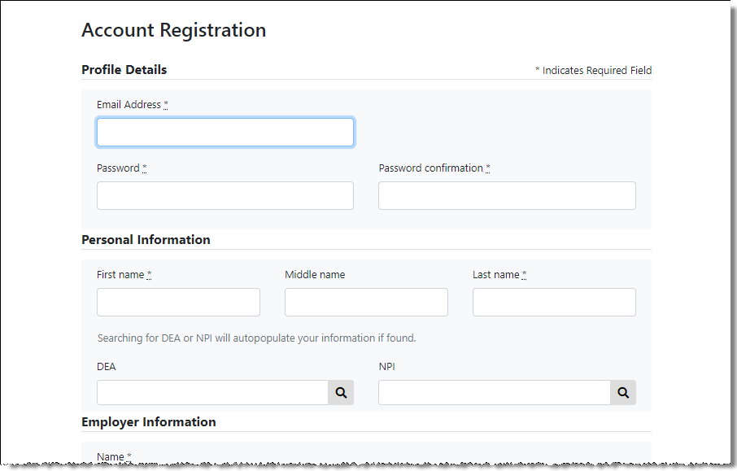

1. Complete your Profile Details.

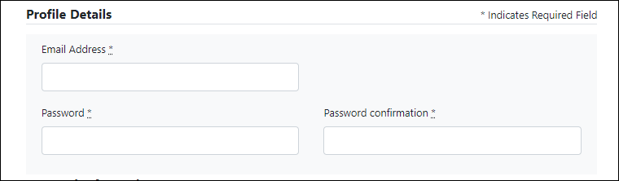

1. Enter your current, valid email address in the **Email Address** field.

**Note:** The email address you provide here will act as your user name when logging into the PMP Clearinghouse system.

1. Enter a password for your account in the **Password** field, then re-enter it in the **Password Confirmation** field. The password requirements are provided below.

Passwords must contain:

* At least eight (8) characters
* One (1) uppercase letter
* One (1) lowercase letter
* One (1) number
* One (1) special character, such as !, @, #, $, etc.

1. Complete your Personal and Employer information, noting the following:

Required fields are marked with an asterisk (**\***).

You may be able to auto-populate your Personal and/or Employer information by entering your (or your employer’s) **DEA**, **NPI**, and/or **NCPDP** number, then clicking the search icon (). If the number you entered is found, your information will automatically be populated.

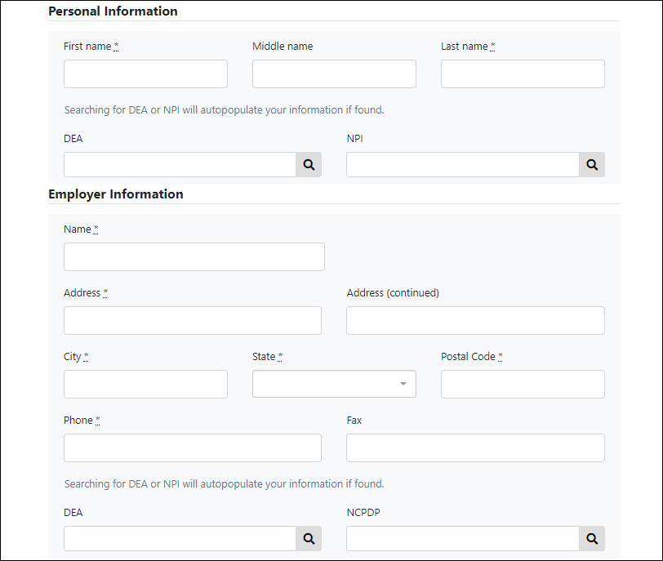

1. If secure file transfer protocol (SFTP) is required, complete the Data Submission section of the page.

**Notes**:

* If SFTP access is not required, you do not need to complete the Data Submission section and you may continue to step 5.
* You may add SFTP access to an existing account. Please refer to Adding SFTP Access to an Upload Account for complete instructions.

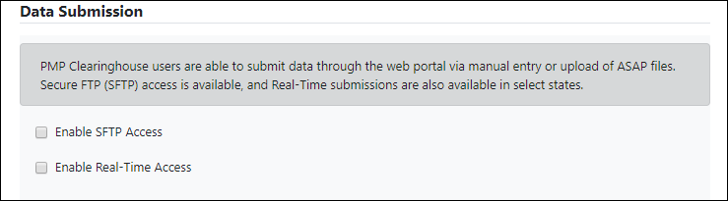

1. Click to select the **Enable SFTP Access** checkbox.

The SFTP access fields are displayed.

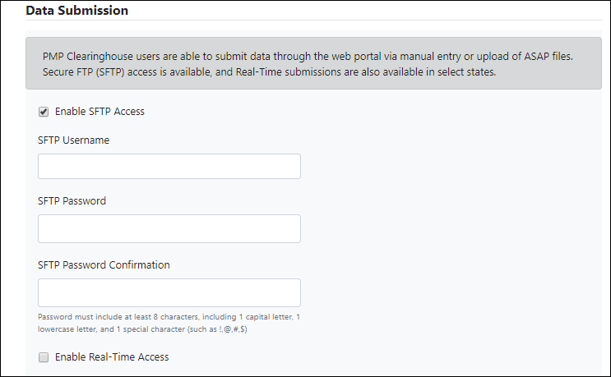

1. Your **SFTP Username** is automatically generated using the first five characters of your employer’s name + your employer’s phone number + @prodpmpsftp. For example, if you entered “Test” as your employer’s name and “555-555-5555” as your employer’s phone number, your SFTP username would be *test5555555555@prodpmpsftp*.
2. Enter a password for your SFTP account in the **SFTP Password** field, then re-enter it in the **SFTP Password Confirmation** field. The password requirements are provided below.

Passwords must contain:

* At least eight (8) characters
* One (1) uppercase letter
* One (1) lowercase letter
* One (1) number
* One (1) special character, such as !, @, #, $, etc.

This password will be input into the pharmacy software so that submissions can be automated.

**Notes:**

* This password can be the same as the one previously entered under Profile.
* Unlike the Profile password (i.e., your user account password), the SFTP password does not expire.
* The URL to connect via SFTP is <sftp://sftp.pmpclearinghouse.net>.
* Additional details on SFTP configuration can be found in Appendix C: SFTP Configuration.

1. In the Submission Destinations section of the page, select the PMP(s) for which you will be submitting data.
2. Click **Submit**.

The request is submitted to the PMP administrator for each of the PMPs you selected for data submission, and the Registration Information Overview page is displayed.

1. Click **Continue**.

The PMP Clearinghouse Login page is displayed; however, you will not be able to log in until your account has been approved. Once your account is approved, you will receive a welcome email instructing you to confirm your account. Follow the instructions in the email to confirm your account and begin submitting data to PMP AWARxE.

## Logging In to PMP Clearinghouse

1. Open an internet browser window and navigate to the PMP Clearinghouse Login page located at <https://pmpclearinghouse.net/users/sign_in>.

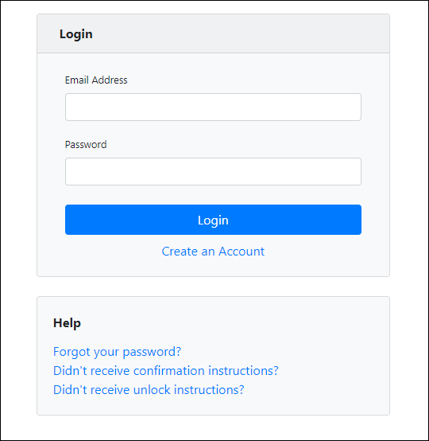

1. Enter the email address you used to create your account in the **Email Address** field.
2. Enter your password in the **Password** field.

**Note:** If you have forgotten your password, have completed your registration but did not receive the account confirmation email, or your account has been locked and you did not receive the email with instructions for unlocking your account, please refer to the links in the Help section of the page. For detailed instructions on resetting your password, refer to Resetting Your Password.

1. Click **Login**.

The PMP Clearinghouse home page is displayed.

# Data Delivery Methods

This chapter provides information about data delivery methods you can use to upload your controlled substance reporting data file(s) to PMP Clearinghouse.

For quick reference, you may click the desired hyperlink in the following table to view the step-by-step instructions for your chosen data delivery method:

|  |  |
| --- | --- |
| Delivery Method | Page |
| Secure FTP | 11 |
| Web Portal Upload | 12 |
| Manual Entry (UCF) | 13 |
| Zero Reports | 16 |

## Secure FTP

If you are submitting data to PMP Clearinghouse using SFTP, you must configure individual subfolders for the PMP systems to which you are submitting data. These subfolders must be created in the *homedir/directory* folder, which is where you are directed once authenticated, and **should be named using the PMP abbreviation (e.g., AK, DC, GA, GU, IN, PR, etc.).** Data files not submitted to a PMP subfolder will be required to have a manual PMP assignment made on the File Listings page. Please refer to PMP Subfolders for additional details on this process.

1. If you do not have a PMP Clearinghouse account, perform the steps in Creating Your Account.

Or

1. If you have a PMP Clearinghouse account but have not enabled SFTP access, perform the steps in Adding SFTP Access to an Upload Account.
2. Prepare the data file(s) for submission, using the ASAP specifications described in Appendix A: ASAP 4.2 Specifications.
3. SFTP the file to <sftp://sftp.pmpclearinghouse.net>.
4. When prompted, enter the username and password you created when setting up the SFTP account.
5. Place the file in the appropriate PMP-abbreviated directory.
6. You can view the results of the transfer/upload on the Submissions page in PMP Clearinghouse.

**Note:** If you place the data file in the root directory and not a PDMP sub-folder, a symbol with a mouse over hint of “**Determine PMP**” is displayed on the **File Status** page, and you will be prompted to select a destination PMP to which the data should be sent.

## Web Portal Upload

1. If you do not have an account, perform the steps in Creating Your Account.
2. Prepare the data file(s) for submission, using the ASAP specifications described in Appendix A: ASAP 4.2 Specifications.
3. Log in to PMP Clearinghouse.
4. From the home page, click the **File Upload** tab.

The File Upload page is displayed.

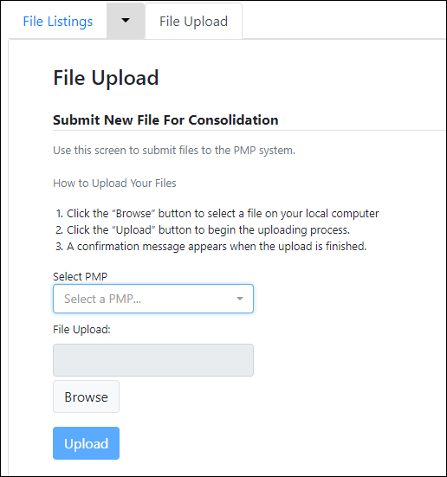

1. Select the PMP to which you are submitting the file from the drop-down list in the **Select PMP** field.
2. Click the **Browse** button, located next to the **File Upload** field, and select the file you created in step 2.
3. Click **Upload**.

A message is displayed prompting you to confirm the submission.

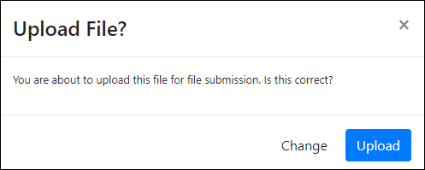

1. Click **Upload** to continue with the file submission.

Your file is uploaded and you can view the results of the upload on the File Listings page.

**Note:** When uploading a file, the file name must be unique. If the file name is not unique, a message is displayed indicating that the file name has already been taken.

## Manual Entry (UCF)

You can manually enter your prescription information into the PMP Clearinghouse system using the Universal Claim Form (UCF) within the PMP Clearinghouse web portal. This form allows you to enter patient, prescriber, dispenser, and prescription information.

Please refer to Reporting Requirements for the complete list of reporting requirements.

1. If you do not have an account, perform the steps in Creating Your Account.
2. Log in to PMP Clearinghouse.
3. Click **UCF Submissions**.

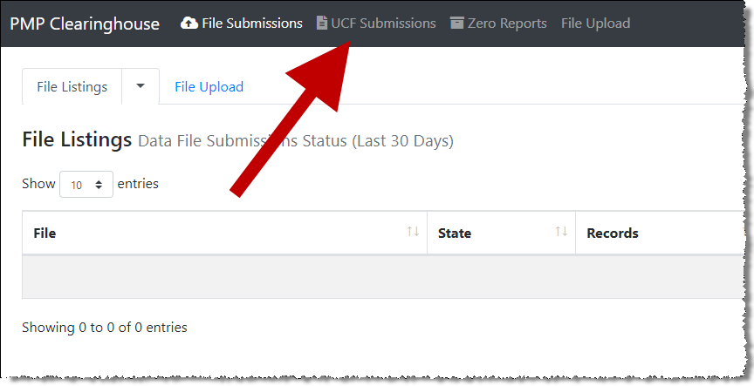

The UCF Listings page is displayed.

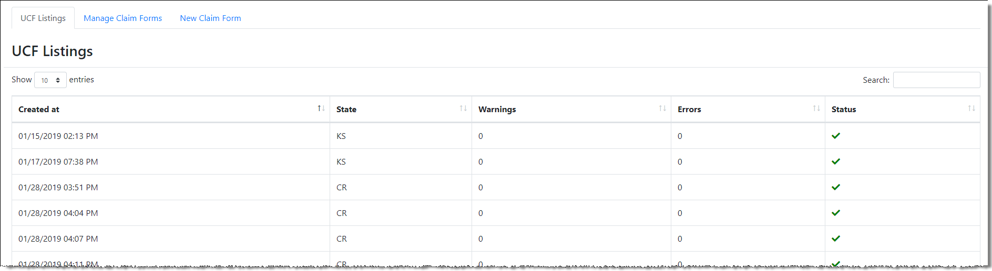

1. Click the **New Claim Form** tab, located at the top of the page.

The Create Universal Claim Form page is displayed.

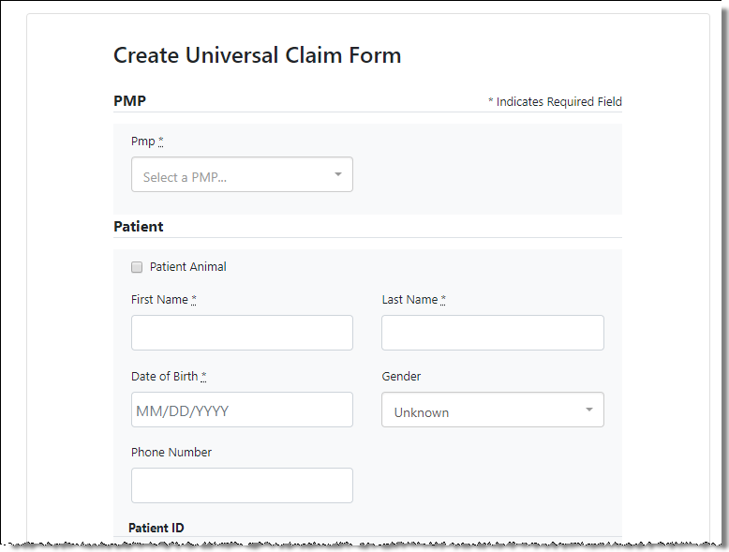

1. Select the PMP to which you are submitting data from the drop-down list in the **Select PMP** field.
2. Complete the required fields.

**Notes:**

* An asterisk (**\***) indicates a required field.
* **If you are entering a compound**, click the **Compound** checkbox in the Drug Information section of the page, complete the required fields for the first drug ingredient, then click **Add New** to add additional drug ingredients.  
  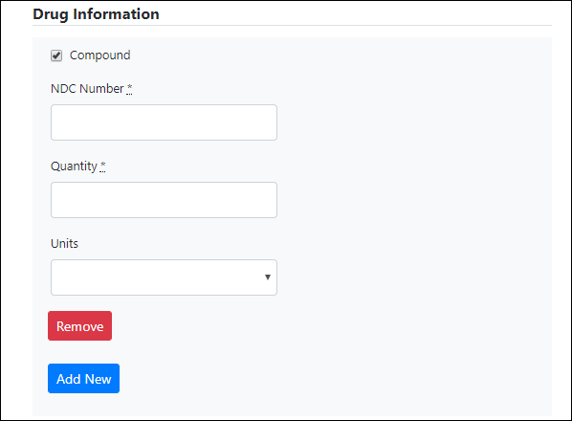

1. Once you have completed all required fields, click **Save**.

The **Submit Now** button is displayed at the top of the page.

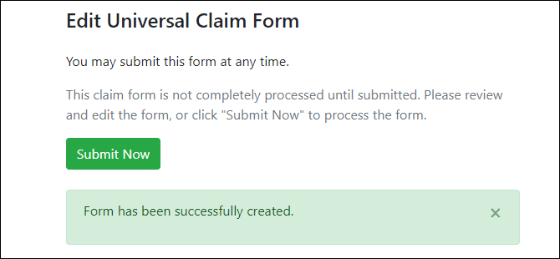

1. Click **Submit Now** to continue with the data submission process.

A message is displayed prompting you to confirm the data submission.

1. Click **OK**.

Your data will be validated upon submission. If there are any errors on the UCF form, they are displayed at the top of the page.

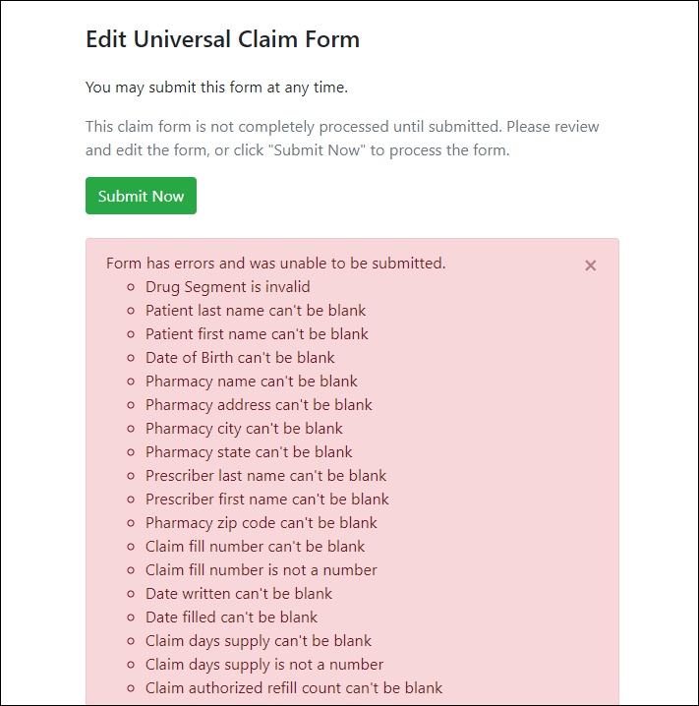

**Note:** If there are no errors, you are returned to the Submitted Claim Forms page and your report is listed there.

1. Correct the indicated errors, then repeat steps 7–9.
2. Once your data has been successfully submitted, your report is listed on the UCF Listings page.



## Zero Reports

If you have no dispensations to report for the preceding reporting period, you must report this information to the Indiana PMP.

You may submit your zero report through the PMP Clearinghouse web portal by following the steps below or via SFTP using the ASAP Standard for Zero Reports. For additional details on submitting via SFTP, please refer to Appendix B: ASAP Zero Report Specifications.

You may submit zero reports through the PMP Clearinghouse web portal using one of the following methods:

* Submit a single-click zero report
* Create a new zero report

### Submit a Single-Click Zero Report

Single-click zero reporting allows you to create a profile for the pharmacy that includes its identifiers (e.g., DEA, NPI, NCPDP), so you do not have to enter it each time you submit a zero report.

To create a pharmacy profile and begin submitting single-click zero reports:

1. If you do not have an account, perform the steps in Creating Your Account.
2. Log in to PMP Clearinghouse.
3. Click **Zero Reports**.

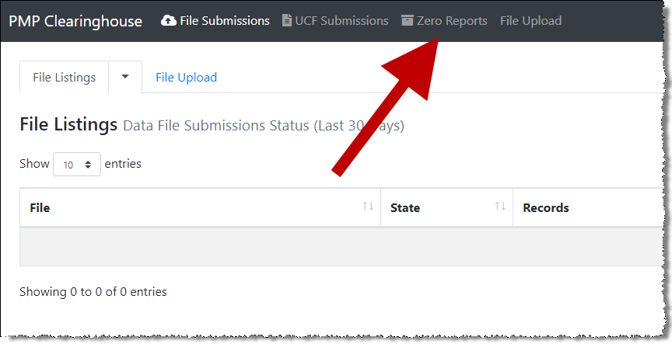

The Zero Report Listings page is displayed.

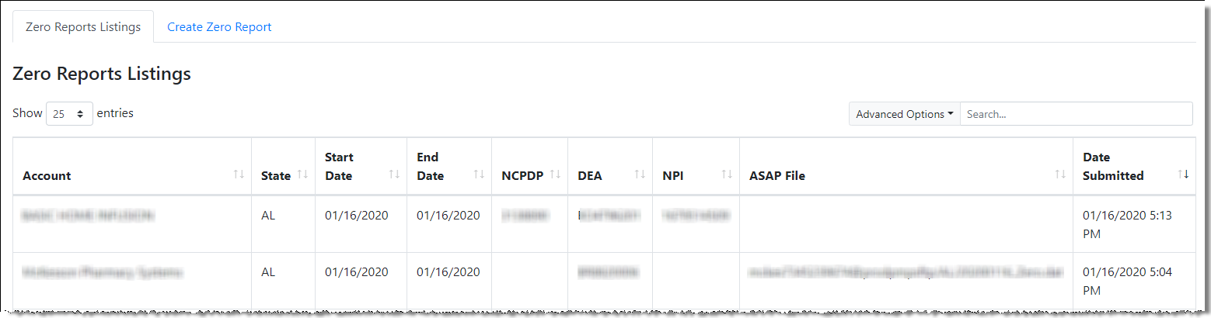

1. Click the **Create Zero Report** tab.

The Create Zero Report page is displayed. *Note that* ***Submit a Single Click Zero Report*** *is selected by default.*

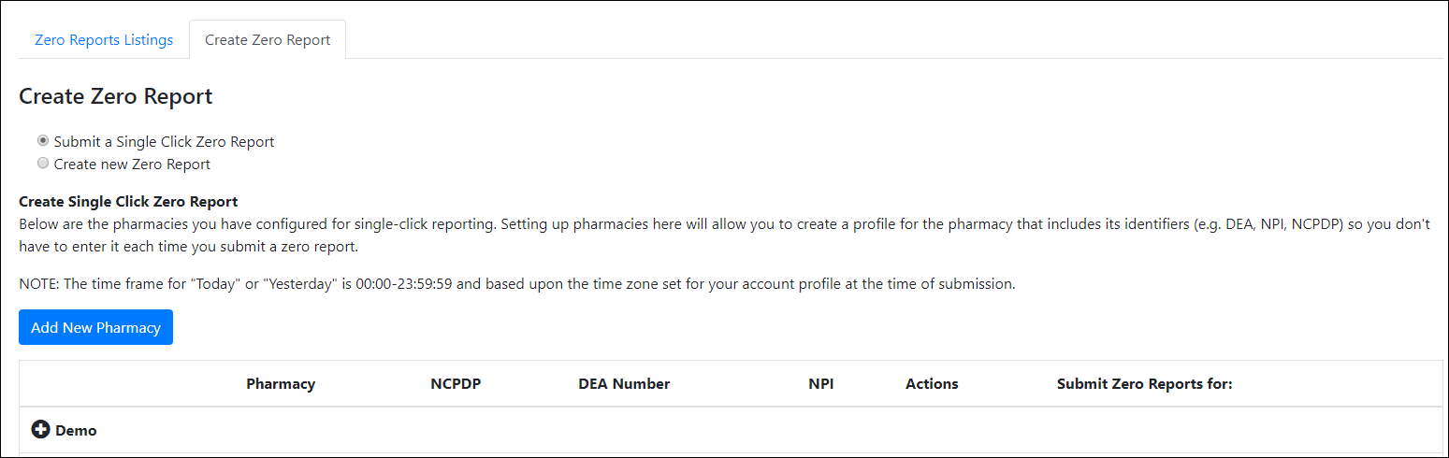

Any pharmacies you have already configured for single-click zero reporting are displayed at the bottom of the page. Continue to step 10 to submit a zero report for those pharmacies.

If you have not configured your pharmacy for single-click zero reporting, continue to step 5.

1. Click **Add New Pharmacy**.

The New Pharmacy page is displayed.

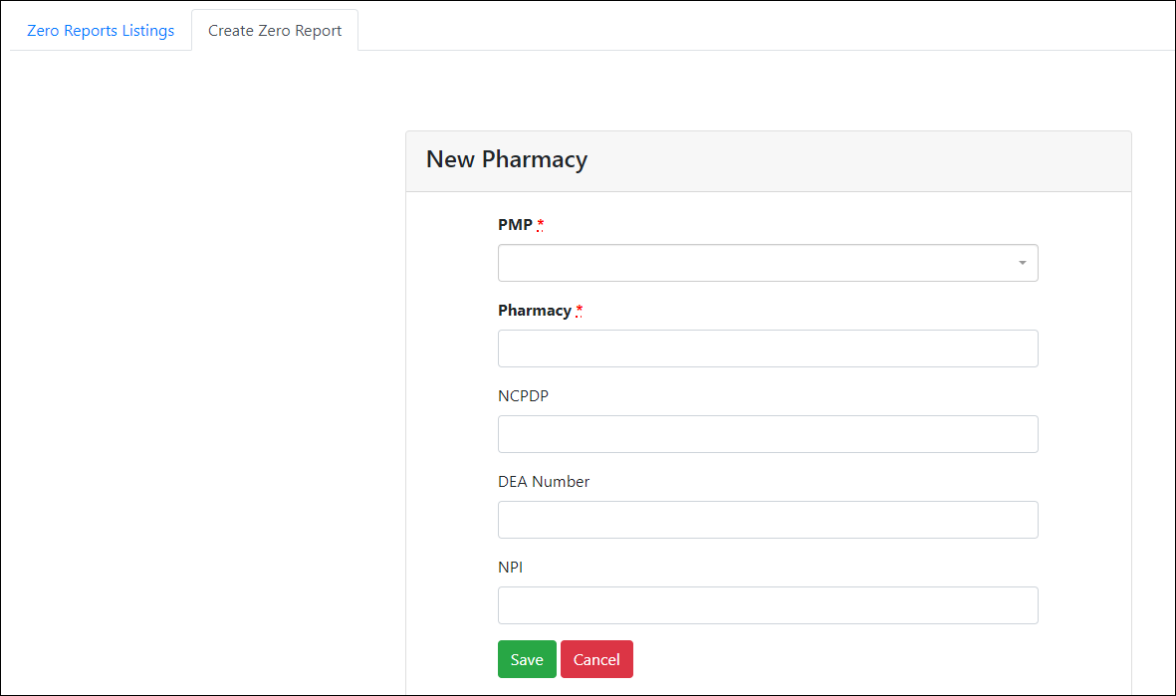

1. Select the PMP for which you are submitting a zero report from the drop-down list in the **PMP** field.
2. Enter the pharmacy’s name in the **Pharmacy** field.
3. Populate the **NCPDP**, **DEA Number**, and/or **NPI** fields as required by the PMP you selected in step 6. If any of these fields are required, a red asterisk (**\***) will be displayed next to that field once you have selected a PMP.
4. Click **Save**.

The pharmacy is saved and will be listed under the drop-down for the selected PMP, which is located at the bottom of the page.

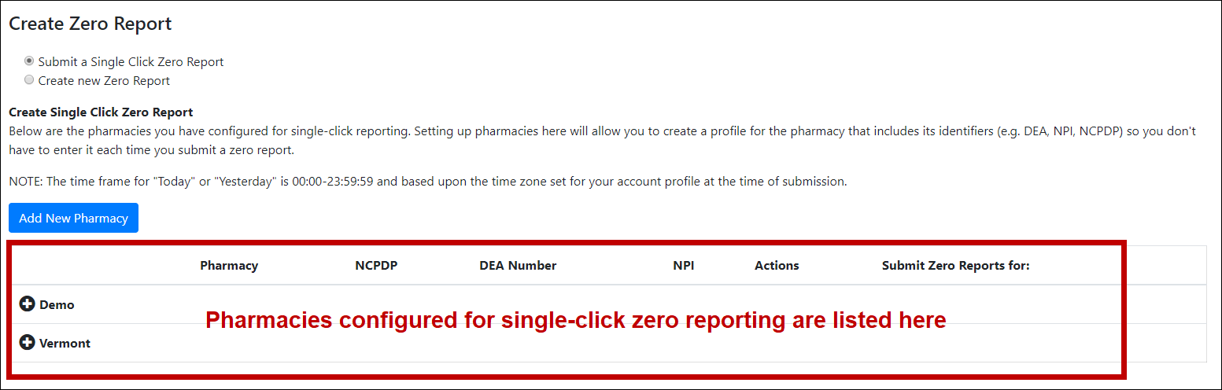

1. Click the plus sign (“+”) next to the PMP for which you wish to submit a zero report.

The list of pharmacies you have configured for single-click zero reporting for that PMP is displayed. *Note that this page allows you to submit a zero report for the current date (****Today****) or the previous day (****Yesterday****).*

1. Click **Today** to submit a zero report for the current date;

Or

1. Click **Yesterday** to submit a zero report for the previous date.

Once the report is submitted, the submission is indicated on the screen, and the zero report is displayed on the **Zero Report Listings** tab.

**Note:** You may edit or delete a pharmacy from this page.

* To edit a pharmacy, click **Edit** to display the Edit Pharmacy page and make any necessary changes. Refer to steps 6–9 for guidance on entering pharmacy information.
* To delete a pharmacy, click **Delete**. You will be prompted to confirm the deletion. Once you confirm the deletion, the pharmacy configuration will be removed.

### Create a New Zero Report

1. If you do not have an account, perform the steps in Creating Your Account.
2. Log in to PMP Clearinghouse.
3. Click **Zero Reports**.



The Zero Report Listings page is displayed.



1. Click the **Create Zero Report** tab.

The Create Zero Report page is displayed. *Note that* ***Submit a Single Click Zero Report*** *is selected by default.*



1. Click the button to select **Create new Zero Report**.

The Create Zero Report page is displayed.

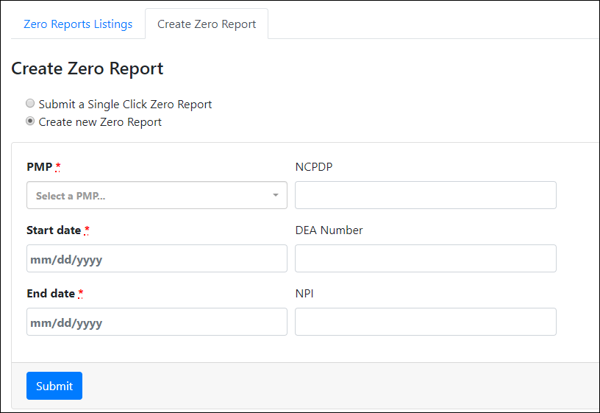

1. Select the PMP for which you are submitting a zero report from the drop-down list in the **PMP** field.
2. Enter the start date and end date for the zero report in the **Start date** and **End date** fields using the *MM/DD/YYYY* format. You may also select the dates from the calendar that is displayed when you click in these fields.

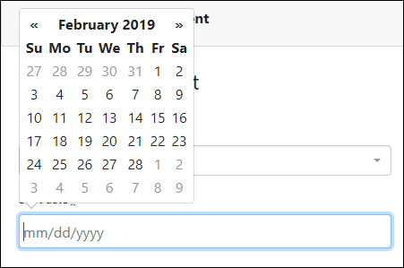

1. Enter your NCPDP, DEA, and/or NPI numbers, if required by your PMP.

**Note:** If any of these fields are required by your state’s PMP, they will be marked with a red asterisk (*).

1. Click **Submit**.

Your zero report is submitted to PMP Clearinghouse and will be displayed on the **Zero Report Listings** tab.

# Data Compliance

This chapter describes how to view the status of your submitted data files and how to correct errors.

## File Listings

The File Listings page displays information extracted from the data files submitted to PMP Clearinghouse, including the file name, number of records identified within the data file, number of records that contain warnings, number of records that contain errors, and the date and time of submission. The File Listings page is displayed upon logging in to Clearinghouse; you may also click **File Submissions** from the menu at any time to access this page.

You may sort the File Listings page by account name, file name, PMP, number of records, warning count, error count, and date submitted. You may also click the account name to display the account details.

* The **Status** column, located at the end of each row, displays the file status via color-coded icon. Hovering over the icon will display the status message.
* The **Status Report** column, located next to the **Status** column, contains a link to the status report for that file. Please refer to File Status Report for more information on how to read and interpret this report.

If a file contains errors, it will have a  symbol with a mouse over hint of “**Pending Dispensation Error**” within the status column. You can click the error icon in the **Status** column to display the Error Correction page, which allows you to view the records containing errors (see View Records for more information). Please refer to Error Correction for instructions on how to correct errors.

If a file is unable to be parsed into the PMP Clearinghouse application, it will have an  symbol with a mouse over hint of “**ASAP Errors**.” Clicking the icon will display the detailed error, which indicates what element was missing or malformed. To correct these errors, a new file must be submitted to PMP Clearinghouse. It is not necessary to void a file that failed parsing since it was not successfully submitted to PMP Clearinghouse.

If you submitted a file via SFTP without using a PMP-specific sub-folder, the file will be displayed, and  symbol will be displayed in the status column with a mouse over hint of “**Determine PMP.**” Clicking the icon will prompt you to select a destination PMP to which the data file will be transferred.

If you submitted a zero report via file upload or SFTP that is malformed or missing information, the file will be displayed, and an exclamation mark icon inside a red triangle will be displayed in the status column. Hovering over the icon will display the “Invalid Zero Report” error. Clicking on the icon will display the detailed error message. To correct these errors, a new zero report must be submitted. Error example:

## UCF Listings

The UCF Listings page displays information about the UCFs submitted to PMP Clearinghouse, including the number of warnings and errors. Click **UCF Submissions** to access this page.

You may sort the UCF Listings page date created, PMP, warning count, error count, and status.

The **Status** column, located at the end of each row, displays the UCF’s status. Data entered into the UCF is validated upon submission; therefore, successfully submitted UCFs should not contain errors. However, if you have attempted to submit a UCF with errors and did not immediately correct those errors and submit the record, you have 30 days to make updates to these records in Clearinghouse.

1. To view pending or incomplete submissions, click the **Manage Claim Forms** tab on the UCF Listings page.

The Pending Claim Forms page is displayed.

1. Click **Edit** next to the form you wish to update.

**Note:** If it has been longer than 30 days, the **Edit** option will not be available. You must click **Delete** to delete the record and start over.

The Edit Universal Claim Form page is displayed.

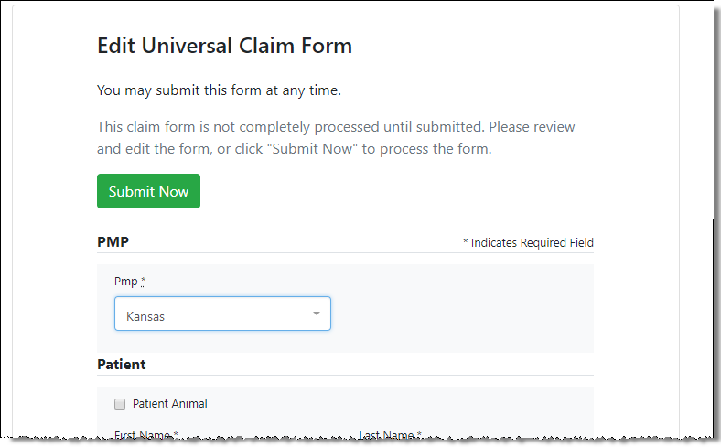

1. Make the necessary corrections or changes, and then click **Submit Now**, located at the top of the page.

A message is displayed prompting you to confirm the data submission.

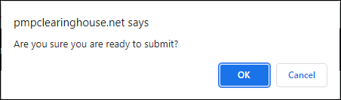

1. Click **OK**.

Your data will be validated upon submission. If there are any remaining errors on the UCF form, they are displayed at the top of the page.

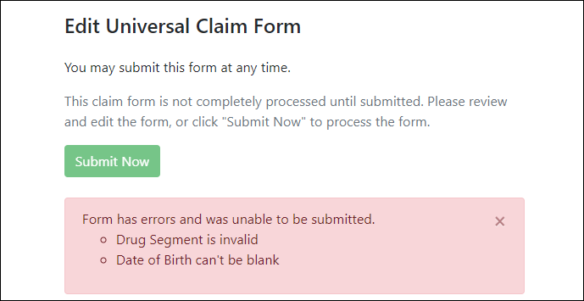

**Note:** If there are no errors, you are returned to the UCF Listings page and your report is listed there.

1. Correct the indicated errors, then repeat steps 3-4.
2. Once your data has been successfully submitted, your report is listed on the UCF Listings page.

## Error Correction

### View Records with Errors

The Error Correction page displays more information about the records within a selected data file that need correcting, including **Prescription Number**, **Segment Type**, **Warning Count**, and **Error Count**. To access this page, click the “**Pending Dispensation Error**” message in the **Status** column of the File Listings page.

The **Correct** button, located at the end of each row, allows you to make corrections to the record.

### Error Correction via PMP Clearinghouse

Once you click **Correct** on the Error Correction page, the Errors page is displayed. This page displays detailed information about the records within a selected data file that need correcting, including all the fields contained within the record and the originally submitted value, and allows you to correct those records.

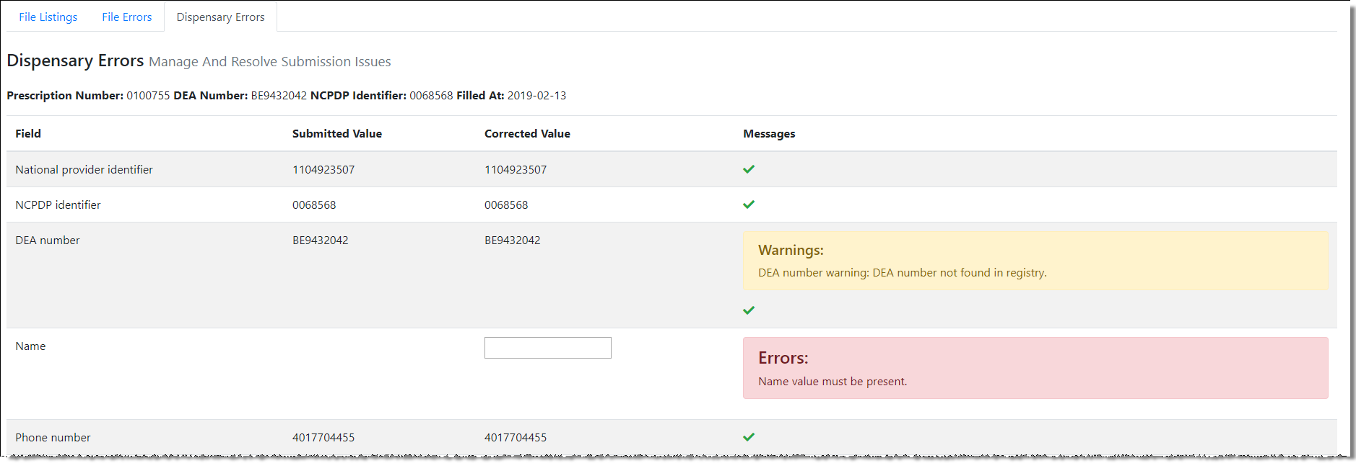

* The **Corrected Value** column allows you to enter a new value to correct the error.
* The **Messages** column displays the relevant error message explaining why the value entered in that field did not pass the validation rules.

**For files that failed to parse, the error identified is "best effort" and any information we could not parse is listed as "unparseable" in the file. In this case, you must submit a corrected file.**

**To correct records:**

1. Identify the fields that require corrections. Fields containing errors are highlighted in red, as shown in the screenshot above.
2. Enter the corrected value in the **Corrected Value** column.
3. Click **Submit**.

The error is processed through the validation rules.

1. If the changes pass the validation rules, the record is valid and a message is displayed indicating that the errors have been corrected. The File Listings and Error Correction pages are also updated.
2. If the changes fail the validation rules, a message is displayed indicating that there was a problem correcting the errors, and the **Message** column is updated with any new error message. Repeat steps 2–3 until the errors have been corrected and the file can be successfully submitted.

# Email Reports

Email status reports are automatically sent to all users associated with a specific data submitter account. These reports are used to identify errors in files that have been submitted and to confirm zero report submissions. This chapter describes the status reports you may receive via email.

## File Failed Report

You will receive the *File Failed* *Report* if a submitted file was not able to be parsed and was not processed into PMP Clearinghouse. The report contains a description of the error encountered within the file. In the event of a failed file, a new file should be submitted with the necessary corrections.

**Note:** Failed files are not parsed into Clearinghouse and do not require a voided ASAP file to remove it from the system.

An example *File Failed Report* is provided below.

SUBJ: Indiana ASAP file: fake-test3.txt - Parse Failure

BODY:

Error Message

-----------------------------------------------------------------------------

Failed to decode the value '04' for the bean id 'transactionControlType'.

Summary:

* File Name: fake-test3.txt

* ASAP Version: 4.2

* Transaction Control Number: unparseable

* Transaction Control Type: unparseable

* Date of Submission: January 30, 2022

NOTE: This file could not be received into the system because the system could not recognize its content as a valid ASAP format. Action is required to resolve the issues and a subsequent file should be submitted. As such the information provided in this report is "best effort" and any information we could not parse is listed as "unparseable" in the fields above.

## File Status Report

The *File Status Report* serves as notification that a data file is currently being parsed by the PMP system.

This report identifies specific records in the submitted data file and returns identifying information about the record, including specific errors identified during the validation process. It uses fixed-width columns and contains a summary section after the error listings. Each column contains a blank two-digit pad at the end of the data.

The columns are set to the following lengths:

|  |  |
| --- | --- |
| Column | Length |
| DEA | 11 (9 + pad) |
| NCPDP | 9 (7 + pad) |
| NPI | 12 (10 + pad) |
| Prescription | 27 (25 + pad) |
| Filled | 10 (8 + pad) |
| Segment | 18 (16 + pad) |
| Field | 18 (16 + pad) |
| Type | 9 (7 + pad) |
| Message | Arbitrary |

The *File Status Report* notifies you of the following scenarios:

* **Total records**: The total number of records contained in the submitted data file.
* **Duplicate records**: The number of records that were identified as already existing within the PMP system. Duplicate records are not imported to prevent improper patient information.
* **Records in process**: The number of records remaining to be processed into the system (usually only displays a number if the file has not finished loading at the time the report is sent out).

**Note:** Records remaining to be processed will continue to be processed even after the status report is sent.

* **Records with errors**: The number of records that contain errors. These errors must be corrected for the record to be imported into the system. If a zero (0) is displayed, there are no errors in the data. Please refer to Error Correction for instructions on correcting errors.
* **Records with warnings**: The number of records that contain warnings. These warnings do not need to be corrected for the record to be imported into the system. If a zero (0) is displayed, there are no warnings in the data.
* **Records imported with warnings**: The number of records with warnings that were imported. If a record contains both warnings and errors, the errors must be corrected to be submitted to the system. Please refer to Error Correction for instructions on correcting errors.
* **Records imported without warnings**: The number of records without warnings that were imported.

**Note:** The initial File Status Report is sent out two (2) hours after the file has been submitted to the system. Additional reports will be sent out every 24 hours if errors continue to be identified within a submitted data file.

An example *File Status Report* is provided on the following page.

SUBJ: Indiana ASAP file: fake-test3.txt - Status Report

BODY:

DEA NCPDP NPI Prescription Filled Segment Field Type Message

---------------------------------------------------------------------------------------------------------------------------------------------------

BE1234567 1347347 9034618394 123486379596-0 20220129 Dispensation refill_number WARNING message example

DE9841394 3491849 4851947597 357199504833-345 20220129 Dispensation days_supply ERROR message example

Summary:

* File Name: fake-test3.txt

* ASAP Version: 4.2

* Transaction Control Number: 23489504823

* Transaction Control Type: send

* Date of Submission: January 30, 2022

* Total Record Count: ###

* Duplicate Records: ###

* In Process Count: ###

* Records with Error Count: ###

* Imported Records Count: ###

* Records Imported with Warning Count: ###

## Zero Report Confirmation

You will receive a *Zero Report* *Confirmation* after successfully submitting a zero report to PMP Clearinghouse. This report displays the PMP to which the zero report was submitted, date range for the zero report, date the zero report was submitted to PMP Clearinghouse, and date the report was originally created.

An example *Zero Report Confirmation* is provided below.

SUBJ: ASAP Zero Report: zero_reports_20220306KSMCPS.DAT

BODY:

Summary:

* File Name: zero_reports_20220306KSMCPS.DAT

* PMP Name: Indiana

* Date Range: 2022-03-06 - 2022-03-06

* Submission Date: 2022-03-07

* ASAP Creation Date: 2022-03-07

# Managing Your Upload Account

The **Account** menu option allows you to manage the information associated with your organization’s upload account, including adding users, PMPs, and SFTP access to your account as well as editing your organization’s account information.

**Note:** This chapter contains information for managing the upload account with which your user account is associated. For information about editing and managing your individual user account, including how to change your password, please refer to Managing Your User Profile.

## Adding Users to Your Upload Account

PMP Clearinghouse allows data submitters to add new users to the system who have the same rights and access to submitting data and viewing file status. This practice allows you to create an account to be used for a backup individual.

1. Log in to PMP Clearinghouse.
2. Click **Account**.

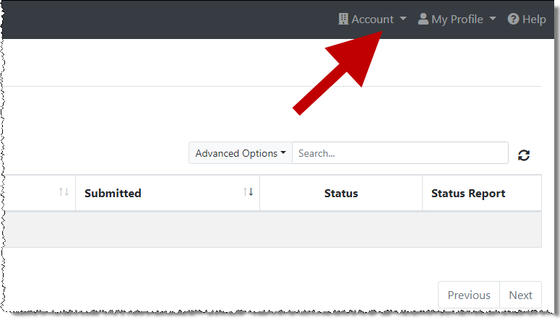

1. Select **Users** from the **Account** drop-down menu.

The Account Users page is displayed.

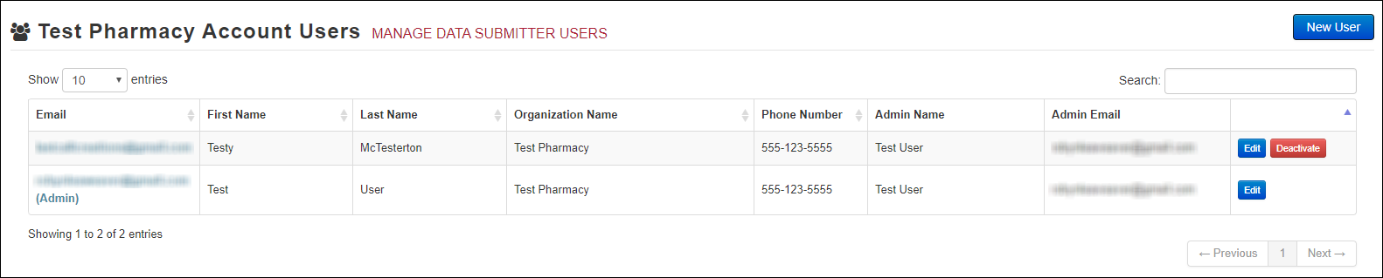

1. Click **New User**, located in the top right corner of the page.

The New Data Submitter User page is displayed.

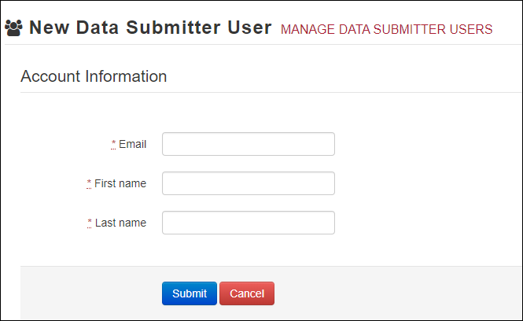

1. Enter the new data submitter’s email address, first name, and last name in the appropriate fields. *Note that all fields are required.*
2. Click **Submit**.

The user is added to the list of data submitters for your organization, and you are returned to the Account Users page.

1. Please inform the new user of the account creation.
2. The user will receive an email with a link for them to confirm their account.
3. Once the account has been confirmed, the user will need to navigate to the PMP Clearinghouse Login page and click **Forgot your password?** to create a password for their account and log in.
4. Upon logging in, the user will be able to view all files submitted for your organization’s upload account.

### Changing Another User’s Password

1. Log in to PMP Clearinghouse.
2. Click **Account**.



1. Select **Users** from the **Account** drop-down menu.

The Account Users page is displayed.



1. Click the **Edit** button, located to the right of the user’s information.

The Edit Data Submitter User page is displayed.

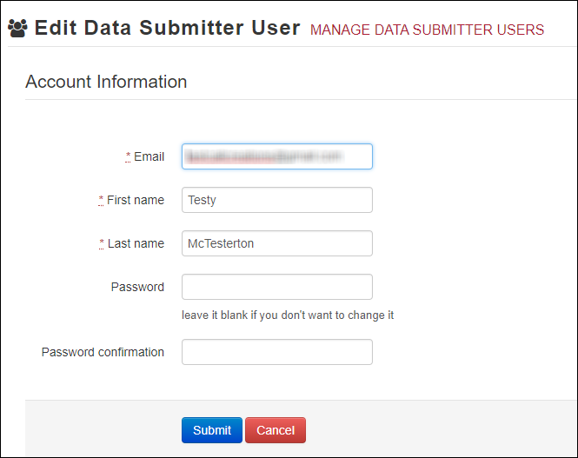

1. Enter a new password for the user in the **Password** field, then re-enter it in the **Password confirmation** field. The password requirements are provided below.

Passwords must contain:

* At least eight (8) characters
* One (1) uppercase letter
* One (1) lowercase letter
* One (1) number
* One (1) special character, such as !, @, #, $, etc.

1. Click **Submit**.

The password is changed.

## Adding PMPs to Your Upload Account

If your organization needs to submit data files to an additional PMP that uses PMP AWARxE, you can submit the request through PMP Clearinghouse.

1. Log in to PMP Clearinghouse.
2. Click **Account**.



1. Select **Multi State Approval** from the **Account** drop-down menu.

The **Multi State Approval** page is displayed. This page displays all PMPs currently using the PMP AWARxE system as well as your data sharing status with each PMP.

1. To request to submit data to another PMP, click to select the checkbox next to that PMP.

PMP Clearinghouse automatically saves your changes, and your request is submitted to the PMP administrator for review and approval. Once the request has been approved, the status for that PMP will change from “Pending” to “Approved,” and you may begin submitting data to that PMP.

**Notes:**

* If you are submitting data via SFTP, the file must be located in the proper subfolder to ensure delivery to the desired PMP.
* To cancel data submission to a PMP, uncheck the box for that PMP. Note that if you need to submit data to that PMP again in the future, you will have to go through the approval process again.

## Adding SFTP Access to an Upload Account

If a registered upload account did not request an SFTP account during the account creation process, you can request one at any time using the **Account** menu option.

1. Log in to PMP Clearinghouse.
2. Click **Account**.



1. Select **SFTP Details**.

The SFTP Account page is displayed.

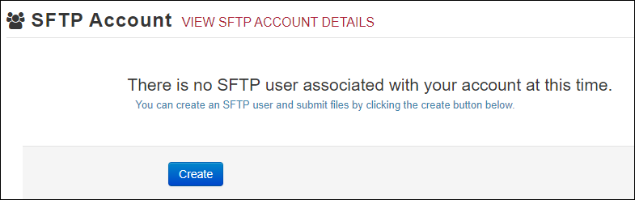

**Note:** If an SFTP account already exists for the upload account, the username is displayed on the SFTP Account page.

You cannot change the SFTP account username; however, you can update the password by clicking **Edit**.

1. Click **Create**.

The Create a New SFTP Account page is displayed.

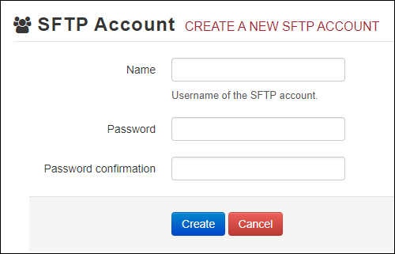

1. Enter a username for the account in the **Name** field.

**Notes:**

* The username must contain a minimum of eight (8) characters.
* Once the SFTP account has been created, you cannot change the username.

1. Enter a password for the account in the **Password** field, then re-enter it in the **Password confirmation** field. The password requirements are provided below.

Passwords must contain:

* At least eight (8) characters
* One (1) uppercase letter
* One (1) lowercase letter
* One (1) number
* One (1) special character, such as !, @, #, $, etc.

Once the account has been successfully created, this password will be input into the pharmacy software so that submissions can be automated.

**Notes:**

* This password can be the same as the one used when the upload account was created.
* Unlike your Profile password (i.e., your user account password), the SFTP password does not expire.
* The URL to connect via SFTP is <sftp://sftp.pmpclearinghouse.net>.
* Additional details on SFTP configuration can be found in Appendix C: SFTP Configuration.

1. Click **Create**.

The account is created, and the username is displayed.

## Editing Your Upload Account

**Note:** This function only allows you to edit your organization’s upload account. If you need to edit your individual profile information, please refer to Editing Your Profile.

1. Log in to PMP Clearinghouse.
2. Click **Account**.



1. Select **Account Details**.

The Account page is displayed as shown on the following page.

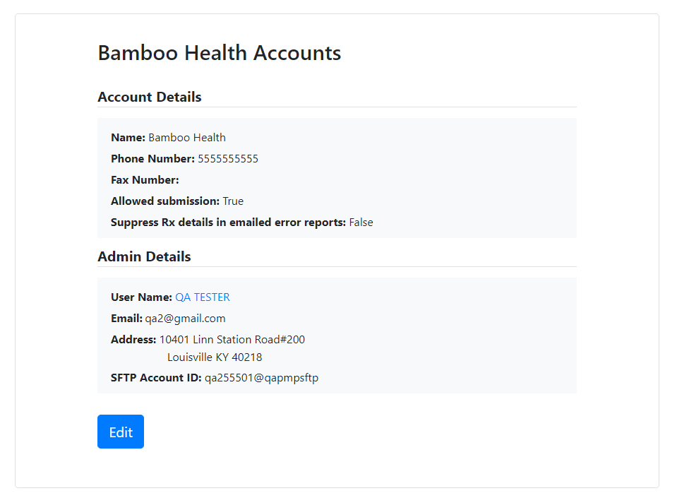

1. Click **Edit**.

The Edit Account page is displayed.

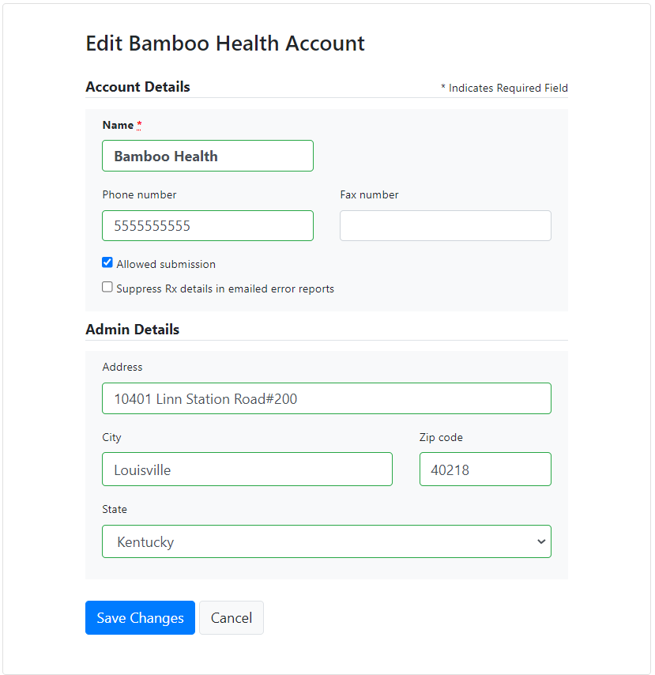

1. Update the information as necessary, then click **Save Changes**.

The account information is updated.

# Managing Your User Profile

This chapter describes how to manage your individual user profile, including how to edit your profile and manage your password.

**Note:** This chapter contains information for managing your individual user profile. For information about managing your organization’s upload account, including how to add users, please refer to Managing Your Upload Account.

## Editing Your Profile

1. Log in to PMP Clearinghouse.
2. Click **My Profile**.

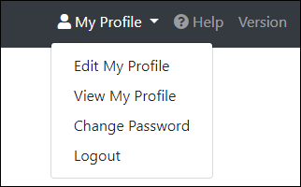

1. Select **Edit My Profile**.

1. Update your information as necessary, then click **Save Changes**.

**Note:** This function only allows you to edit your individual profile information. If you need to edit the Organization Information, please refer to Editing Your Upload Account.

Your changes are saved, and your updated profile is displayed.

## Changing Your Password

**Note:** Clearinghouse passwords expire every 90 days. You can use this function to proactively change your password before it expires. If your password has already expired, or you have forgotten your password, navigate to the PMP Clearinghouse Login page and click **Forgot your password?** to reset it. Please refer to Resetting Your Password for more information.

1. Log in to PMP Clearinghouse.
2. Click **My Profile**.



1. Select **Change Password**.

1. Enter your current password in the **Current Password** field.
2. Enter your new password in the **Password** field, then re-enter it in the **Password confirmation** field. The password requirements are provided below.

**Passwords must contain:**

* At least eight (8) characters
* One (1) uppercase letter
* One (1) lowercase letter
* One (1) number
* One (1) special character, such as !, @, #, $, etc.

1. Click **Update**.

Your password is updated, and you will use it the next time you log in to PMP Clearinghouse.

## Resetting Your Password

If you have forgotten your password or your password has expired, perform the following steps to reset it.

1. Open an internet browser window and navigate to the PMP Clearinghouse Login page located at <https://pmpclearinghouse.net/users/sign_in>.



1. Click the **Forgot your password?** link, located in the Help section of the page.

The Forgot your password page is displayed.

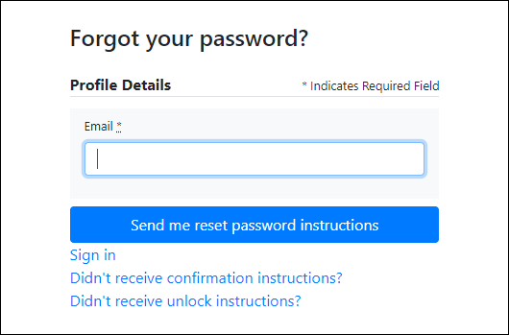

1. Enter the email address associated with your user account, then click **Send me reset password instructions**.
2. Once you receive the reset password email, click the **Change my password** link within the email.

The Change your password page is displayed.

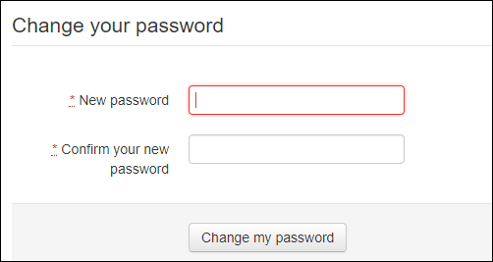

1. Enter your new password in the **New password** field, then re-enter it in the **Confirm your new password** field. The password requirements are provided below.

Passwords must contain:

* At least eight (8) characters
* One (1) uppercase letter
* One (1) lowercase letter
* One (1) number
* One (1) special character, such as !, @, #, $, etc.

1. Click **Change my password**.

Your password is changed, and you can now use it to log in to PMP Clearinghouse.

# Assistance and Support

## Technical Assistance

If you need additional help with any of the procedures outlined in this guide, you can:

* Contact Bamboo Health at 1-844-446-4767;

**OR**

* Create a support request at the following URL:

<https://pmpclearinghouse.zendesk.com/hc/en-us/>

* Technical assistance is available 24 hours per day, 7 days per week, 365 days per year.

## Administrative Assistance

If you need additional help with INSPECT policy, please contact INSPECT at:

(317) 234-4458; or  
[inspect@pla.in.gov](mailto:inspect@pla.in.gov)

Assistance is available on weekdays from 8:00 a.m. to 4:30 p.m.

# Document Information

## Disclaimer

Bamboo Health has made every effort to ensure the accuracy of the information in this document at the time of printing. However, information is subject to change.

## Change Log

| Version | Date | Chapter/Section | Change Made |
| --- | --- | --- | --- |
| 1.0 | 07/24/2017 | N/A | N/A; initial publication |
| 1.1 | 08/16/2017 | Technical Assistance | Updated availability |
| 1.2 | 10/09/2017 | Administrative Assistance | Updated contact information |
| 2.0 | 02/11/2020 | Global | Updated to current document template |
| Updated screenshots to reflect updated user interface (note that this is only a cosmetic change; no functionality changes are included) |
| 5.4/Zero Reports | Separated into two sections (Submit a Single-Click Zero Report and Create a New Zero Report) to reflect the addition of the single-click zero report submission functionality |
| 5.4.1/Submit a Single-Click Zero Report | Added new section with instructions for submitting a single-click zero report |
| 6.2/UCF Listings | Added clarification on correcting UCF errors |
| 3.0 | 03/09/2022 | Global | Updated guide to reflect Bamboo Health branding |

1. ASAP 4.2 Specifications

The information on the following pages contains the required definitions for the specific contents required of uploaded records in the American Society for Automation in Pharmacy (ASAP) format to comply with the Indiana PMP requirements.

The following table lists the Segment, Element ID, Element Name, and Requirement.

**Note**: For more information, contact the American Society for Automation in Pharmacy for the full *Implementation Guide for the ASAP Standard for Prescription-Monitoring Programs*. That guide includes field lengths, acceptable attributes, and examples.

| Segment | Element ID | Element Name | Requirement |
| --- | --- | --- | --- |
| **TH: Transaction Header (required)**  Used to indicate the start of a transaction. It also assigns the data element separator, segment terminator, and control number. | | | |
|  | **TH01** | **Version/Release Number**  Code uniquely identifying the transaction.  Format = xx.x | **Yes** |
| **TH02** | **Transaction Control Number**  Sender assigned code uniquely identifying a transaction. | **Yes** |
| **TH05** | **Creation Date**  Date the transaction was created.  Format: CCYYMMDD. | **Yes** |
| **TH06** | **Creation Time**  Time the transaction was created.  Format: HHMMSS or HHMM. | **Yes** |
| **TH07** | **File Type**   * P = Production * T = Test | **Yes** |
| **TH09** | **Segment Terminator Character**  This terminates the TH segment and sets the actual value of the data segment terminator for the entire transaction. | **Yes** |
| **IS: Information Source (required)**  Used to convey the name and identification numbers of the entity supplying the information. | | | |
|  | **IS01** | **Unique Information Source ID**  Reference number or identification number.  (Example: phone number) | **Yes** |
| **IS02** | **Information Source Entity Name**  Entity name of the Information Source. | **Yes** |
| **PHA: Pharmacy Header (required)**  Used to identify the pharmacy.  **Note:** It is required that information be provided in at least one of the following fields: PHA01, PHA02, or PHA03. | | | |
|  | **PHA02** | **NCPDP Provider ID**  Identifier assigned to pharmacy by the National Council for Prescription Drug Programs. | **Yes** |
| **PAT: Patient Information (required)**  Used to report the patient’s name and basic information as contained in the pharmacy record. | | | |
|  | **PAT02** | **ID Qualifier**  Code to identify the type of ID in PAT03. If PAT02 is used, PAT03 is required.   * 01 Military ID * 02 State Issued ID * 03 Unique System ID * 05 Passport ID * 06 Driver’s License ID * 07 Social Security Number * 08 Tribal ID * 99 Other (agreed upon ID) | **Yes** |
| **PAT03** | **ID of Patient**  Identification number for the patient as indicated in PAT02.  An example would be the driver’s license number. | **Yes** |
| **PAT07** | **Last Name**  Patient’s last name. | **Yes** |
| **PAT08** | **First Name**  Patient’s first name. | **Yes** |
| **PAT09** | **Middle Name**  Patient’s middle name or initial if available. | **Optional** |
| **PAT12** | **Address Information – 1**  Free-form text for street address information. | **Yes** |
| **PAT13** | **Address Information – 2**  Free-form text for additional address information. | **Optional** |
| **PAT14** | **City Address**  Free-form text for city name. | **Yes** |
| **PAT15** | **State Address**  U.S. Postal Service state code or other regional jurisdiction code. | **Yes** |
| **PAT16** | **ZIP Code Address**  Postal code.  Populate with zeros if patient address is outside the U.S. | **Yes** |
| **PAT18** | **Date of Birth**  Date patient was born.  Format: CCYYMMDD | **Yes** |
| **PAT19** | **Gender Code**  Code indicating the sex of the patient.   * F Female * M Male * U Unknown | **Yes** |
| **PAT20** | **Species Code**  Used if required by the PMP to differentiate a prescription for an individual from one prescribed for an animal.   * 01 Human * 02 Veterinary Patient | **Yes** |
| **DSP: Dispensing Record (required)**  Used to identify the basic components of a dispensing of a given prescription order including the date and quantity. | | | |
|  | **DSP01** | **Reporting Status**  DSP01 requires one of the following codes, and an empty or blank field no longer indicates a new prescription transaction:   * 00 New Record (indicates a new prescription dispensing transaction) * 01 Revise (indicates that one or more data element values in a previously submitted transaction are being revised) * 02 Void (message to the PMP to remove the original prescription transaction from its data, or to mark the record as invalid or to be ignored). | **Yes** |
| **DSP02** | **Prescription Number**  Serial number assigned to the prescription by the pharmacy. | **Yes** |
| **DSP03** | **Date Written**  Date the prescription was written (authorized).  Format: CCYYMMDD | **Yes** |
| **DSP04** | **Refills Authorized**  The number of refills authorized by the prescriber. | **Yes** |
| **DSP05** | **Date Filled**  Date prescription was filled.  Format: CCYYMMDD | **Yes** |
| **DSP06** | **Refill Number**  Number of the fill of the prescription.  0 indicates New Rx; 01-99 indicates any additional fills after the original fill. | **Yes** |
| **DSP07** | **Product ID Qualifier**  Used to identify the type of product ID contained in DSP08.   * 01 NDC * 06 Compound (indicates a compound; if used, the CDI segment becomes a required segment) | **Yes** |
| **DSP08** | **Product ID**  Full 11-digit NDC number as indicated in DSP07, including leading zeros in the appropriate segment to create a 5-4-2 format, without punctuation. If “06 Compound” is indicated in DSP07, use 99999 as the first five characters and another 6 digits as appropriate; the CDI segment then becomes required. | **Yes** |
| **DSP09** | **Quantity Dispensed**  Number of metric units dispensed in metric decimal format.  Example: 2.5  **Note:** For compounds, show the first quantity in CDI04. | **Yes** |
| **DSP10** | **Days’ Supply**  Estimated number of days the medication will last. | **Yes** |
| **DSP11** | **Drug Dosage Units Code**  Identifies the unit of measure for the quantity dispensed in DSP09.   * 01 Each * 02 Milliliters (ml) * 03 Grams (gm) | **Yes** |
| **DSP16** | **Classification Code for Payment Type**  Code identifying the type of payment (i.e., how it was paid for).   * 01 Private Pay * 02 Medicaid * 03 Medicare * 04 Commercial Insurance * 05 Military Installations and VA * 06 Workers’ Compensation * 07 Indian Nations * 99 Other | **Yes** |
| **PRE: Prescriber Information (required)**  Used to identify the prescriber of the prescription. | | | |
|  | **PRE02** | **DEA Number**  Identifying number assigned to a prescriber or an institution by the Drug Enforcement Administration (DEA). | **Yes** |
| **PRE03** | **DEA Number Suffix**  Identifying number assigned to a prescriber by an institution when the institution’s number is used as the DEA number. | **Situational** |
| **CDI: Compound Drug Ingredient Detail (situational)**  Use of this segment is required when medication dispensed is a compound and one of the ingredients is a PMP reporting drug. If more than one ingredient is for a prescription monitoring program reporting drug, then this would be incremented by one for each compound ingredient being reported.  If CDI is filled in, the NDC of DSP08 must be 99999999999. | | | |
|  | **CDI01** | **Compound Drug Ingredient Sequence Number**  First reportable ingredient is 1; each additional reportable ingredient is incremented by 1. | **Required for compound prescription** |
| **CDI02** | **Product ID Qualifier**  Code to identify the type of product ID contained in CDI03.   * 01 NDC | **Required for compound prescription** |
| **CDI03** | **Product ID**  Full 11-digit NDC number as indicated in CDI02, including leading zeros in the appropriate segment to create a 5-4-2 format, without punctuation. | **Required for compound prescription** |
| **CDI04** | **Compound Ingredient Quantity**  Metric decimal quantity of the ingredient identified in CDI03.  Example: 2.5 | **Required for compound prescription** |
| **CDI05** | **Compound Drug Dosage Units Code**  Identifies the unit of measure for the quantity dispensed in CDI04.   * 01 Each (used to report as package) * 02 Milliliters (ml) (for liters, adjust to the decimal milliliter equivalent) * 03 Grams (gm) (for milligrams, adjust to the decimal gram equivalent) | **Required for compound prescription** |
| **AIR: Additional Information Reporting (situational)**  Used when serialized Rx pads are used, the PMP requires information on the person dropping off or picking up the prescription, or for data elements not included in other detail segments.  **Note:** If this segment is used, at least one of the data elements (fields) will be required. | | | |
| **TP: Pharmacy Trailer (required)**  Used to identify the end of data for a given pharmacy and provide the count of the total number of detail segments reported for the pharmacy, including the PHA and TP segment. | | | |
|  | **TP01** | **Detail Segment Count**  Number of detail segments included for the pharmacy including the pharmacy header (PHA) and the pharmacy trailer (TP) segments. | **Yes** |
| **TT: Transaction Trailer (required)**  Used to indicate the end of the transaction and provide the count of the total number of segments included in the transaction. | | | |
|  | **TT01** | **Transaction Control Number**  Identifying control number that must be unique.  Assigned by the originator of the transaction.  Must match the number in TH02. | **Yes** |
| **TT02** | **Segment Count**  Total number of segments included in the transaction including the header and trailer segments. | **Yes** |

1. ASAP Zero Report Specifications

The following table contains the required definitions for submitting zero reports via SFTP or manual upload to the IN PMP. It lists the **Segment** and **Element ID** with pre-populated data to be used as an example for constructing a zero report. For more details regarding these Segment or Elements IDs, or for details on reporting actual dispensations, please refer to Appendix A: ASAP 4.2 Specifications.

|  |  |  |  |
| --- | --- | --- | --- |
| Segment | Element ID | Element Name | Requirement |
| **TH: Transaction Header (required)** | | | |
|  | **TH01** | 4.2 | **Yes** |
| **TH02** | 123456 | **Yes** |
| **TH05** | 20220101 | **Yes** |
| **TH06** | 223000 | **Yes** |
| **TH07** | P | **Yes** |
| **TH09** | \\ | **Yes** |
| **IS: Information Source (required)** | | | |
|  | **IS01** | 7705555555 | **Yes** |
| **IS02** | PHARMACY NAME | **Yes** |
| **IS03** | Date Range of Report  #CCYYMMDD#-#CCYYMMDD# | **Yes** |
| **PHA: Pharmacy Header (required)** | | | |
|  | **PHA02** | NABP Number | **Yes** |
| **PAT: Patient Information (required)** | | | |
|  | **PAT07** | REPORT | **Yes** |
| **PAT08** | ZERO | **Yes** |
| **DSP: Dispensing Record (required)** | | | |
|  | **DSP05** | 20220101 | **Yes** |
| **PRE: Prescriber Information (required; can be null as follows: PRE*******\)** | | | |
| **CDI: Compound Drug Ingredient Detail** | | | |
| **AIR: Additional Information Reporting** | | | |
| **TP: Pharmacy Trailer (required)** | | | |
|  | **TP01** | 7 | **Yes** |
| **TT: Transaction Trailer (required)** | | | |
|  | **TT01** | 123456 | **Yes** |
| **TT02** | 10 | **Yes** |

Sample Zero Report

The following example illustrates a zero report using the above values.

TH*4.2*123456*01**20220108*223000*P**\\

IS*7705555555*PHARMACY NAME*#20220101#-#20220107#\

PHA*** ZZ1234567\

PAT*******REPORT*ZERO************\

DSP*****20220108******\

PRE*\

CDI*\

AIR*\

TP*7\

TT*123456*10\

1. SFTP Configuration

This appendix describes the SFTP configurations required to upload your data to PMP Clearinghouse.

**Note:** Submitting data via SFTP requires that you have an existing PMP Clearinghouse account with SFTP access.

* If you need to create a PMP Clearinghouse account, please refer to Creating Your Account. You will be able to set up your SFTP account during the account creation process.
* If you have an existing PMP Clearinghouse account but do not have SFTP access, please refer to Adding SFTP Access to an Upload Account.

SFTP Connection Details

***Hostname: sftp.pmpclearinghouse.net***

Bamboo Health recommends that you use the hostname when configuring the connection rather than the IP address, as the IP address is subject to change.

**Port: 22**

**Note:** The port will always be 22.

* **Credentials:** Your SFTP account credentials (username and password) can be found within the PMP Clearinghouse website. To locate your credentials, log in to PMP Clearinghouse, then click ***Account*** *>* ***SFTP Details*** *>* ***Edit***.
* Your username cannot be modified; however, you can update your password.

**Note:** Your current SFTP password cannot be seen or recovered. If you have forgotten or lost it, you will need to create a new one. For more information on changing the SFTP password, please refer to Adding SFTP Access to an Upload Account.

* **Once you have established SFTP access, you can test the SFTP connection but you will not be able to submit data to a PMP until your account has been approved by the PMP administrator.**

PMP Subfolders

PMP Clearinghouse is the data repository for numerous PMPs. As such, data submitted via SFTP must be placed in the appropriate folder for the PMP for which you are submitting data so that it can be properly imported to that PMP. The creation of subfolders must be done outside of the PMP Clearinghouse website using third-party software, such as an SSH client or a command line utility. Files placed in the root/home directory of the SFTP server will not be imported, as this will cause the dispensing entity to appear as noncompliant/delinquent.

Your pharmacy software will need to be configured to place files in the appropriate PMP folder when submitting. You may need to contact your software vendor for additional assistance with this process.

**NOTE**: Capitalization of the abbreviated PMP folders’ names has no bearing on whether or not Clearinghouse processes the files; however, some pharmacy systems, especially *nix-based systems, will require that the exact case is used when specifying the target folder.

There are two methods by which to create PMP subfolders for SFTP submissions:

1. **Via SSH client** (e.g., WinSCP, FileZilla, etc.)
2. Log in to your SFTP account.
3. Create the required directories under ***/homedir***.

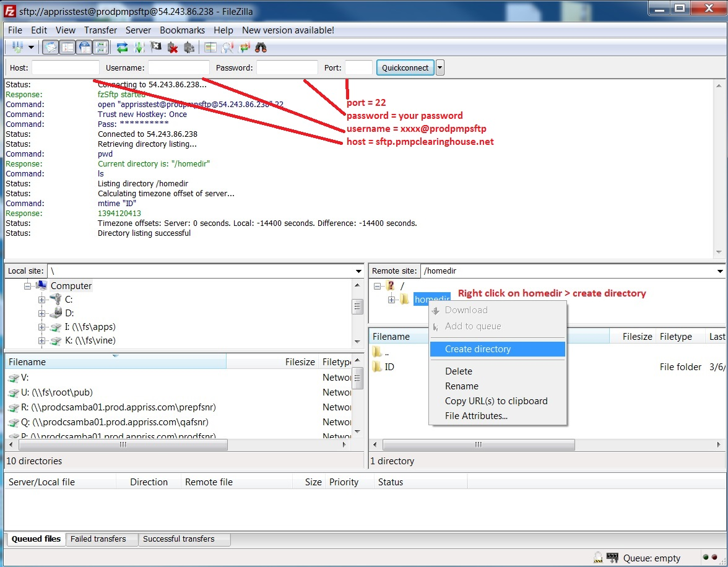

1. **Via command prompt**
2. Log in to your SFTP account using command prompt.
3. Type “**mkdir**” followed by a space and then the PMP abbreviation you are using (e.g., ***mkdir IN***).

**NOTE:** The PMP folder must be titled with the two-letter abbreviation as specified above.

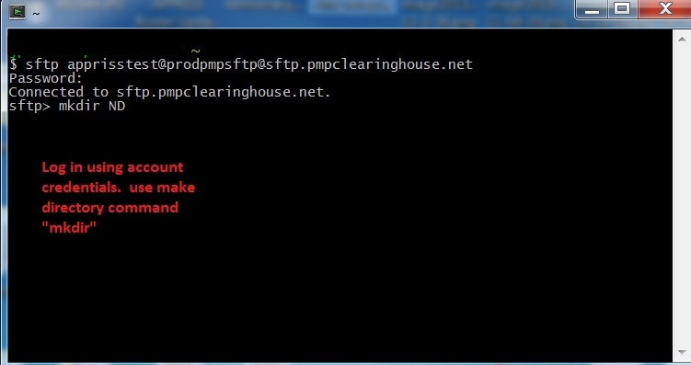

Public (SSH/RSA) Key Authentication

PMP Clearinghouse supports SSH key authentication. The generation of the key is outside the scope of this document; however, general guidelines about the key, along with how to import/load it, are provided below.

**Note: PGP Encryption** is not supported.

* **Supported Key Types:**
* SSH-2 RSA 2048 bit length
* **Unsupported Key Types:**
* SSH-1 RSA
* SSH-2 DSA
* **Correct Public Key Format:** If opened in a text editor, the key should look like the screenshot below.

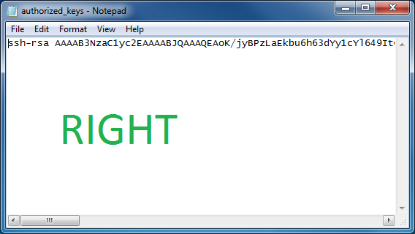

* **Incorrect Public Key Format:** If opened in a text editor, the key SHOULD NOT look like the screenshot below.

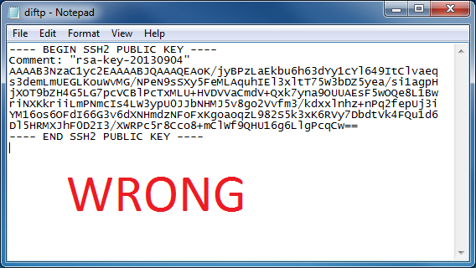

* Once the key has been generated, it should be named “***authorized_keys***”.

**Notes:**

There is no file extension.

There is an underscore between the words **authorized** and **keys**.

* A *.ssh* subfolder needs to be created in the SFTP account’s home directory. The “***authorized_keys***” file must be placed in the *.ssh* folder. The creation of this folder follows the same process as creating a PMP subfolder. Please refer to PMP Subfolders for steps on creating subfolders.