ANNUAL REPORT FOR PROGRAMS IN NURSING
Guidelines: An Annual Report prepared and submitted by the faculty of the school of nursing, will provide the Indiana State Board of Nursing with a clear picture of how the nursing program is currently operating and its compliance with the regulations governing the professional and/or practical nurse education program(s) in the State of Indiana. The Annual Report is intended to inform the Education Subcommittee and the Indiana State Board of Nursing of program operations during the academic reporting year. This information will be posted on the Board’s website and will be available for public viewing.
Purpose: To provide a mechanism to provide consumers with information regarding nursing programs in Indiana and monitor complaints essential to the maintenance of a quality nursing education program.
Directions: To complete the Annual Report form attached, use data from your academic reporting year unless otherwise indicated. An example of an academic reporting year may be: August 1, 2012 through July 31, 2013. Academic reporting years may vary among institutions based on a number of factors including budget year, type of program delivery system, etc. Once your program specifies its academic reporting year, the program must utilize this same date range for each consecutive academic reporting year to insure no gaps in reporting. You must complete a SEPARATE report for each PN, ASN and BSN program.
This form is due to the Indiana Professional Licensing Agency by the close of business on October 1st each year. The form must be electronically submitted with the original signature of the Dean or Director to: PLA2@PLA.IN.GOV. Please place in the subject line “Annual Report (Insert School Name) (Insert Type of Program) (Insert Academic Reporting Year). For example, “Annual Report ABC School of Nursing ASN Program 2013.” The Board may also request your most recent school catalog, student handbook, nursing school brochures or other documentation as it sees fit. It is the program’s responsibility to keep these documents on file and to provide them to the Board in a timely manner if requested.
Indicate Type of Nursing Program for this Report: PN_____ ASN__X____ BSN______
Dates of Academic Reporting Year: May 28, 2013 – May 10, 2014 (Date/Month/Year) to (Date/Month/Year)
Name of School of Nursing: Ivy Tech Community college Richmond
Address: 2357 Chester Blvd Richmond IN 47374
Dean/Director of Nursing Program Name and Credentials: Glenda Cline, RN, MSN
Title:_Dean School of Nursing Email: gcline@ivytech.edu
Nursing Program Phone #: 765-966-2656-ext 1152 Fax: 765-962-8741
Website Address:_ http://www.ivytech.edu/richmond _____________________________________________________________________
Social Media Information Specific to the SON Program (Twitter, Facebook, etc.): N/A___
Please indicate last date of NLNAC or CCNE accreditation visit, if applicable, and attach the outcome and findings of the visit: NLNAC 2010 - please see attached notification of outcomes and findings; ACEN Follow-Up Report Letter
If you are not accredited by NLNAC or CCNE where are you at in the process? ____N/A
SECTION 1: ADMINISTRATION
Using an “X” indicate whether you have made any of the following changes during the preceding academic year. For all “yes” responses you must attach an explanation or description.
1) Change in ownership, legal status or form of control Yes_____ No___X__
2) Change in mission or program objectives Yes_____ No___X__
3) Change in credentials of Dean or Director Yes_____ No_ _X__
4) Change in Dean or Director Yes _____ No _ X__
5) Change in the responsibilities of Dean or Director Yes _____ No __X__
6) Change in program resources/facilities Yes _____ No __X__
7) Does the program have adequate library resources? Yes __X__No _____
8) Change in clinical facilities or agencies used (list both Yes _____ No __X__
additions and deletions on attachment)
9) Major changes in curriculum (list if positive response) Yes_____No __X__
SECTION 2: PROGRAM
1A.) How would you characterize your program’s performance on the NCLEX for the most recent academic year as compared to previous years? Increasing ______ Stable ___X____ Declining ______
1B.) If you identified your performance as declining, what steps is the program taking to address this issue? _______N/A__
2A.) Do you require students to pass a standardized comprehensive exam before taking the NCLEX? Yes__ ____ No X__
2B.) If not, explain how you assess student readiness for the NCLEX: All students are required to take the ATI Comprehensive predictor and attend an ATI live review course.
2C.) If so, which exam(s) do you require? ___________N/A_________________________
2D.) When in the program are comprehensive exams taken: Upon Completion____________ As part of a course ___X_____ Ties to progression or thru curriculum___________________
2E.) If taken as part of a course, please identify course(s):__NRSG 208 Practice Issues for ASN
3.) Describe any challenges/parameters on the capacity of your program below:
A. Faculty recruitment/retention: We continue to have difficulty recruiting faculty because there is only one MSN educational program in the area and we are in competition with other schools.

B. Availability of clinical placements: We have two hospitals in our service area, both will allow no more than 6 students in OB at a time.
C. Other programmatic concerns (library resources, skills lab, sim lab, etc.): N/A
4.) At what point does your program conduct a criminal background check on students?
Criminal background checks, through CertifiedBackground.com may be done either before enrollment in the professional courses or just prior to the first day of clinical. Students who are not continuously enrolled in a program until completion may be required to complete additional checks upon re-entry to a program or admission to a different nursing program. Clinical sites or the College may request additional background checks or drug screenings at their discretion.

5.) At what point and in what manner are students apprised of the criminal background check for your program?
Students receive results online by directly accessing through CertifiedBackground.com using a password assigned by the background search company. They have full access to their background search data within the website and are encouraged to review the background search findings and appeal any issues that they determine are incorrect.

SECTION 3: STUDENT INFORMATION
1.) Total number of students admitted in academic reporting year:
Summer: 10 Fall: 30 Spring: __0__
2.) Total number of graduates in academic reporting year:
Summer: __0__ Fall________2__________ Spring: _______38___________
3.) Please attach a brief description of all complaints about the program, and include how they were addressed or resolved. For the purposes of illustration only, the CCNE definition of complaint is included at the end of the report. None
4.) Indicate the type of program delivery system:
Semesters: __ X Quarters_________ Other (specify):__________________________
SECTION 4: FACULTY INFORMATION
A. Provide the following information for all faculty new to your program in the academic reporting year (attach additional pages if necessary):
Faculty Name: | Heather N Wierzbinski-Cross
Indiana License Number: | 28173369A
Full or Part Time: | Full time
Date of Appointment: | July 2014
Highest Degree: | MSN
Responsibilities: | Fundamental lab and class; OB/peds, medical surgical

Faculty Name: | Tina Pugh
Indiana License Number: | 28110462A
Full or Part Time: | Part time
Date of Appointment: | August 2014
Highest Degree: | MSN
Responsibilities: | clinical

Faculty Name: | Jo Ann Bond
Indiana License Number: | 28141159A  71003212A Clinical Nurse Specialist APN Prescriptive Authority
Full or Part Time: | Part time
Date of Appointment: | September 2014
Highest Degree: | MSN; Clinical Nurse Specialists
Responsibilities: | Lab

B. Total faculty teaching in your program in the academic reporting year:
1. Number of full time faculty: ______ 7_includes Dean_______
2. Number of part time faculty: _________2______
3. Number of full time clinical faculty: ____6_of 7 full time faculty_____________
4. Number of part time clinical faculty: ____2_of 2 part time faculty___________
5. Number of adjunct faculty: N/A (see above – we refer to our adjuncts as PT faculty)
C. Faculty education, by highest degree only:
1. Number with an earned doctoral degree: __________0__________
2. Number with master’s degree in nursing: 7 full time and 2 part time
3. Number with baccalaureate degree in nursing: ________0_________
4. Other credential(s). Please specify type and number: ______0_______

D. Given this information, does your program meet the criteria outlined in 848 IAC 1-2-13 or 848 IAC 1-2-14?
Yes____X____ No___________
E. Please attach the following documents to the Annual Report in compliance with 848 IAC 1-2-23:
1. A list of faculty no longer employed by the institution since the last Annual Report;
Mary Eversole, RN, MSN, FT faculty
2. An organizational chart for the nursing program and the parent institution.

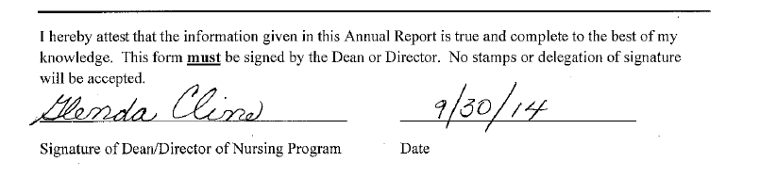
Statewide School of Nursing Organizational Chart
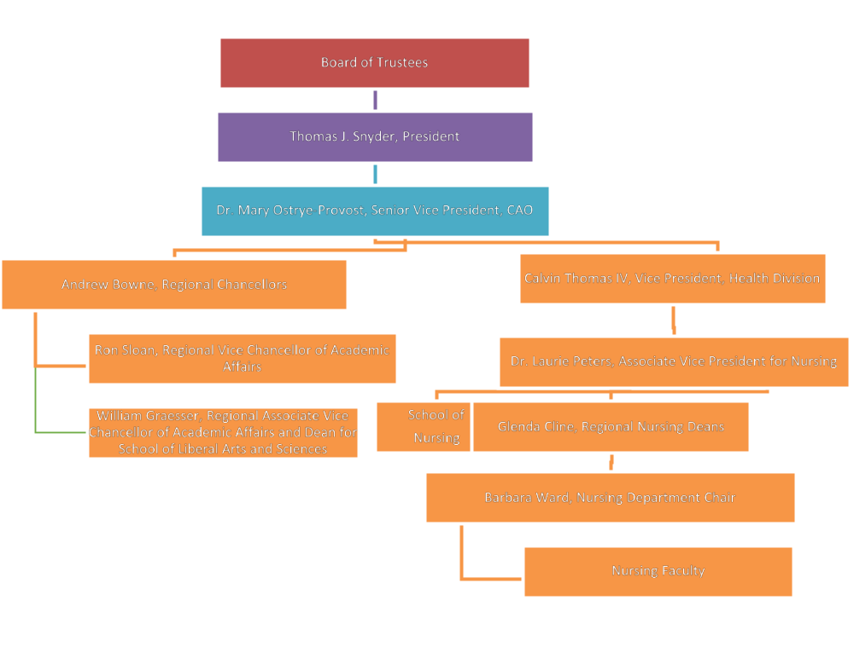

Organizational Chart for Nursing Program Richmond
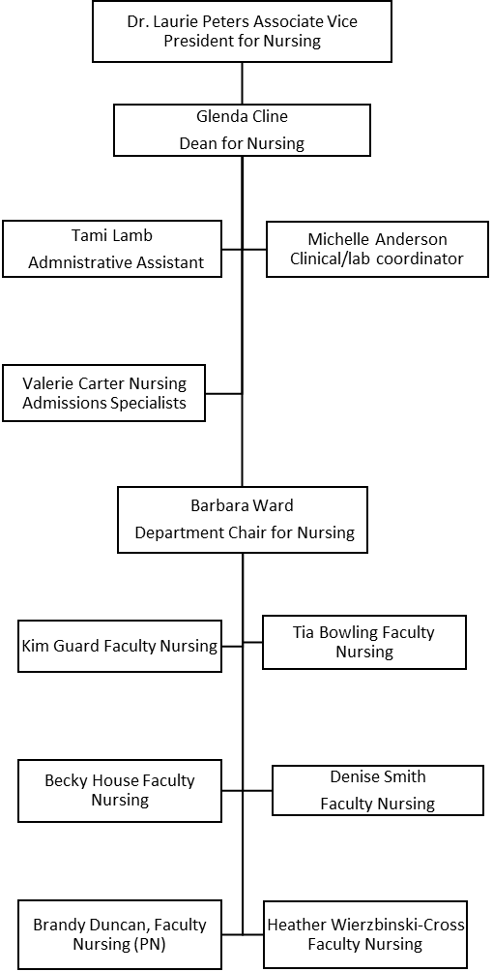
Definitions from CCNE:
Potential Complainants
A complaint regarding an accredited program may be submitted by any individual who is
directly affected by the actions or policies of the program. This may include students,
faculty, staff, administrators, nurses, patients, employees, or the public.
Guidelines for the Complainant
The CCNE Board considers formal requests for implementation of the complaint process
provided that the complainant: a) illustrates the full nature of the complaint in writing,
describing how CCNE standards or procedures have been violated, and b) indicates
his/her willingness to allow CCNE to notify the program and the parent institution of the
exact nature of the complaint, including the identity of the originator of the complaint.
The Board may take whatever action it deems appropriate regarding verbal complaints,
complaints that are submitted anonymously, or complaints in which the complainant has
not given consent to being identified.



