ANNUAL REPORT FOR PROGRAMS IN NURSING
Guidelines: An Annual Report prepared and submitted by the faculty of the school of nursing, will provide the Indiana State Board of Nursing with a clear picture of how the nursing program is currently operating and its compliance with the regulations governing the professional and/or practical nurse education program(s) in the State of Indiana. The Annual Report is intended to inform the Education Subcommittee and the Indiana State Board of Nursing of program operations during the academic reporting year. This information will be posted on the Board’s website and will be available for public viewing.
Purpose: To provide a mechanism to provide consumers with information regarding nursing programs in Indiana and monitor complaints essential to the maintenance of a quality nursing education program.
Directions: To complete the Annual Report form attached, use data from your academic reporting year unless otherwise indicated. An example of an academic reporting year may be: August 1, 2012 through July 31, 2013. Academic reporting years may vary among institutions based on a number of factors including budget year, type of program delivery system, etc. Once your program specifies its academic reporting year, the program must utilize this same date range for each consecutive academic reporting year to insure no gaps in reporting. You must complete a SEPARATE report for each PN, ASN and BSN program.
This form is due to the Indiana Professional Licensing Agency by the close of business on October 1st each year. The form must be electronically submitted with the original signature of the Dean or Director to: PLA2@PLA.IN.GOV. Please place in the subject line “Annual Report (Insert School Name) (Insert Type of Program) (Insert Academic Reporting Year). For example, “Annual Report ABC School of Nursing ASN Program 2013.” The Board may also request your most recent school catalog, student handbook, nursing school brochures or other documentation as it sees fit. It is the program’s responsibility to keep these documents on file and to provide them to the Board in a timely manner if requested.
Indicate Type of Nursing Program for this Report: PN__X___ ASN______ BSN______
Dates of Academic Reporting Year:_ May 28, 2013 – May 16, 2014 _ (Date/Month/Year) to (Date/Month/Year)
Name of School of Nursing: _Ivy Tech Community College of Indiana - Columbus
Address:___4475 Central Avenue, Columbus, Indiana 47203
Dean/Director of Nursing Program
Name and Credentials: Janet L. Todd MSN, RN
Title: Dean, School of Nursing_____ Email:_jtodd@ivytech.edu_
Nursing Program Phone #:_812-374-5242_______Fax:__812-372-0311
Website Address:__www.ivytech.edu/columbus
Social Media Information Specific to the SON Program (Twitter, Facebook, etc.):_____N/A______
____________________________________________________________________________________
Please indicate last date of NLNAC or CCNE accreditation visit, if applicable, and attach the outcome and findings of the visit:_NLNAC 2010-please see attached notification of outcomes and findings: ACEN follow-up report letter.
If you are not accredited by NLNAC or CCNE where are you at in the process? N/A

SECTION 1: ADMINISTRATION
Using an “X” indicate whether you have made any of the following changes during the preceding academic year. For all “yes” responses you must attach an explanation or description.
1) Change in ownership, legal status or form of control Yes_____ No___X__
2) Change in mission or program objectives Yes_____ No___X_
3) Change in credentials of Dean or Director Yes_____ No___X___
4) Change in Dean or Director (Eloise Lewis retired/Janet Todd new Dean Yes __X__ No ____
Previously reported to ISBN).
5) Change in the responsibilities of Dean or Director Yes _____ No __X___
6) Change in program resources/facilities Yes _____ No __X___
7) Does the program have adequate library resources? Yes __X__ No _____
8) Change in clinical facilities or agencies used (list both Yes ____ No ___X__
additions and deletions on attachment)
9) Major changes in curriculum (list if positive response) Yes___ No__X___

SECTION 2: PROGRAM
1A.) How would you characterize your program’s performance on the NCLEX for the most recent academic year as compared to previous years? Increasing ______ Stable ___X____ Declining ______
1B.) If you identified your performance as declining, what steps is the program taking to address this issue? _____________________________N/A_________________________________________________________________________________________________________________________________________
2A.) Do you require students to pass a standardized comprehensive exam before taking the NCLEX? Yes___________ No____X_____
2B.) If not, explain how you assess student readiness for the NCLEX All students are required to complete the ATI comprehensive NCLEX-RN Predictor. Live or virtual ATI review course is presented after predictor that is based on Comp Predictor results. Students also create a plan for NCLEX study as part of the review course. NCLEX predictor and review are embedded into the curriculum_____________________
2C.) If so, which exam(s) do you require? N/A
2D.) When in the program are comprehensive exams taken: Upon Completion____________ As part of a course ____X____ Ties to progression or thru curriculum___________________
2E.) If taken as part of a course, please identify course(s):_NRSG 128 Practice Issues for PN
3.) Describe any challenges/parameters on the capacity of your program below:
A. Faculty recruitment/retention: Difficulty finding credentialed nursing faculty, however, hired three MSN credentialed faculty in summer 2013, one BSN credentialed faculty member (adjunct) accepted Full Time and will work with PN only, anticipate MSN Completion Summer 2014. The region and the college are actively implementing new recruitment initiatives.
B. Availability of clinical placements: Some clinical sites will only allow five students due to low census and are small rural hospitals. Other schools of nursing using same clinical sites as well, which interferes with clinical availability. However, sufficient number of clinical experiences are available to all students at this time.
C. Other programmatic concerns (library resources, skills lab, sim lab, etc.):__N/A___
4.) At what point does your program conduct a criminal background check on students? Criminal background checks, through CertifiedBackground.com may be done either before enrollment in the professional courses or just prior to the first day of clinicals. Students who are not continuously enrolled in a program until completion may be required to complete additional checks upon re-entry to a program or admission to a different nursing program. Clinical sites or the College may request additional background checks or drug screenings at their discretion.
5.) At what point and in what manner are students apprised of the criminal background check for your program? Students are informed of the need for background checks through the online or face to face nursing information meetings. Upon admission to the program students receive information on how to complete their background check prior to the start of their first semester.
Students receive results online by directly accessing through CertifiedBackground.com using a password assigned by the background search company. They have full access to their background search data within the website and are encouraged to review the background search findings and appeal any issues that they determine are incorrect.
SECTION 3: STUDENT INFORMATION
1.) Total number of students admitted in academic reporting year:
Summer____0_____ Fall___0____ Spring_________14___________
2.) Total number of graduates in academic reporting year:
Summer_____0____Fall____7______Spring______0________
3.) Please attach a brief description of all complaints about the program, and include how they were addressed or resolved. For the purposes of illustration only, the CCNE definition of complaint is included at the end of the report. N/A
4.) Indicate the type of program delivery system:
Semesters___X______ Quarters_________ Other (specify):__________________________

SECTION 4: FACULTY INFORMATION
A. Provide the following information for all faculty new to your program in the academic reporting year (attach additional pages if necessary):
Faculty Name: | Danielle Robinson
Indiana License Number: | 28147587A
Full or Part Time: | Full Time
Date of Appointment: | 5/28/2013
Highest Degree: | MSN
Responsibilities: | Didactic, Clinical ASN/PN
Faculty Name: | Lynnetta Loveland
Indiana License Number: | 28173516A
Full or Part Time: | Full Time
Date of Appointment: | 7/8/2013
Highest Degree: | MSN
Responsibilities: | Clinical and Didactic ASN/PN
Faculty Name: | Jackie Thurner
Indiana License Number: | 28184662A
Full or Part Time: | Full Time
Date of Appointment: | 7/8/2013
Highest Degree: | MSN
Responsibilities: | Clinical and Didactic ASN/PN
Faculty Name: | Laura Ruth Watson
Indiana License Number: | 28133411A
Full or Part Time: | Part Time
Date of Appointment: | 8/2013
Highest Degree: | MSN
Responsibilities: | ASN clinical only
Faculty Name: | Tina Hobbs
Indiana License Number: | 28111950A
Full or Part Time: | Part Time (accepted full time appointment July 2014)
Date of Appointment: | 8/2013
Highest Degree: | MSN
Responsibilities: | ASN clinical only
Faculty Name: | Cynthia Lynn Curry
Indiana License Number: | 28116608A
Full or Part Time: | Part Time (accepted full time appointment January, 2014)
Date of Appointment: | 1/2014
Highest Degree: | BSN (completed MSN at WGU July, 2014)
Responsibilities: | PN clinical only

B. Total faculty teaching in your program in the academic reporting year:
1. Number of full time faculty:_____10 (includes the dean)_ Ivy Tech Faculty teach in both ASN and PN programs if hold MSN and unless otherwise noted; BSN teach in PN program only
2. Number of part time faculty:_____3__________________________________
3. Number of full time clinical faculty: _9 of 10_________________________________
4. Number of part time clinical faculty: _3 of 3_________________________________
5. Number of adjunct faculty:_N/A (see above – we refer to our adjuncts as PT faculty)
C. Faculty education, by highest degree only:
1. Number with an earned doctoral degree:____________0____________________
2. Number with master’s degree in nursing:__ 12 (10 FT, 2 PT)
3. Number with baccalaureate degree in nursing:________1 ____________________
4. Other credential(s). Please specify type and number:___0___________________
D. Given this information, does your program meet the criteria outlined in 848 IAC 1-2-13 or 848 IAC 1-2-14?
Yes___X______ No___________
E. Please attach the following documents to the Annual Report in compliance with 848 IAC 1-2-23:
1. A list of faculty no longer employed by the institution since the last Annual Report;
Name | Credentials | Full-time (X) | Part-time (X)
Jackie Thurner- Resigned 1/14 | MSN | X
Janet Burton- Resigned 12/13 | MSN | X
Eloise Lewis-Early retirement 5/14 | MSN | X
Judy Breeding-Early Retirement 5/14 | MSN | X
Laura Watson – Resigned 8/14 | MSN |  | X

2. An organizational chart for the nursing program and the parent institution.

School of Nursing Organizational Chart - Columbus
Chris Lowery Chancellor

Dr. Steven Combs, PhD
Vice Chancellor of Academic Affairs
Dr. Laurie Peters, PhD, RN
Associate Vice President of Nursing Education

Cathy Woodward, BSN, RN Assistant Vice Chancellor of Academic Affairs
Janet Todd, MSN, RN
Dean School of Nursing, Assistant Professor

Danielle Robinson
MSN, RN
Nursing Chair
Assistant Professor

Lisa Krueger, Admin Assistant
Mary Shaffer, BSN, RN Nursing Advisor
Theresa Wirth
Simulation Lab Tech

Sandy Huntington, MSN, RN
Instructor

Lynnetta Loveland, MSN, RN Instructor

Cyndi Curry
MSN, RN
Instructor

Judy Wonning
MSN, RN
Associate Professor

Tina Hobbs MSN, RN Instructor

Ivy Tech Community College of Indiana – Statewide School of Nursing Organizational Chart
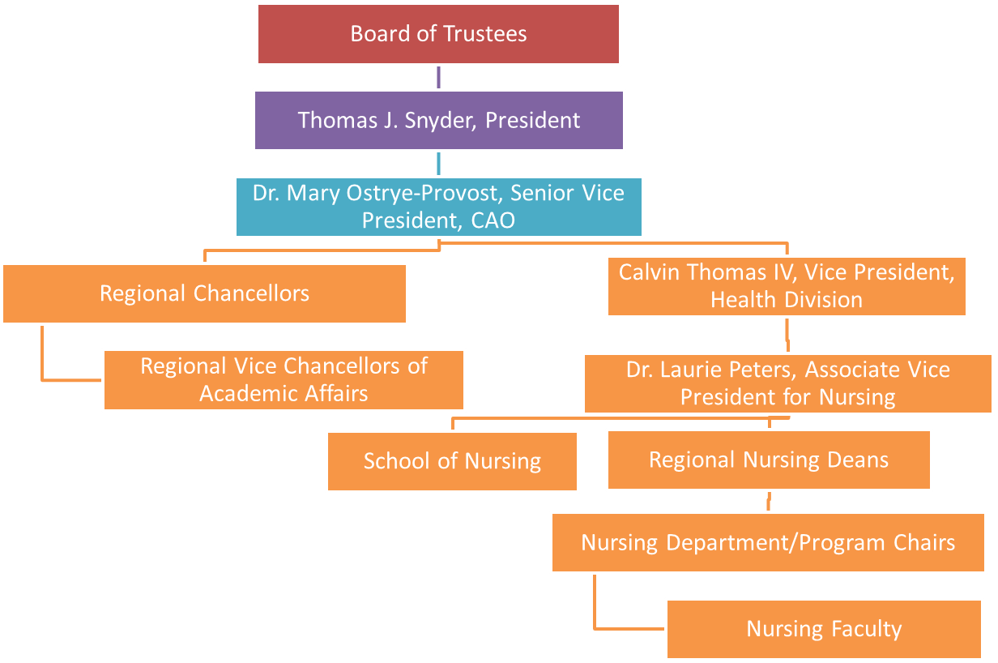

I hereby attest that the information given in this Annual Report is true and complete to the best of my knowledge. This form must be signed by the Dean or Director. No stamps or delegation of signature will be accepted.

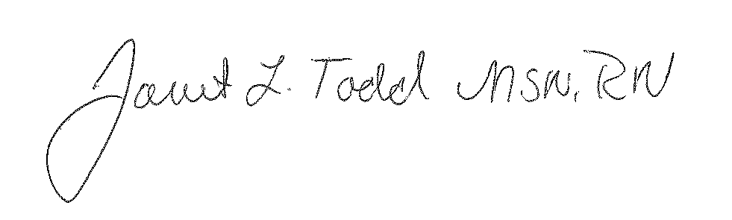
8/29/14

Signature of Dean/Director of Nursing Program Date
Janet L. Todd, MSN, RN
Printed Name of Dean/Director of Nursing Program
Please note: Your comments and suggestions are welcomed by the Board. Please feel free to attach these to your report.

Definitions from CCNE:
Potential Complainants
A complaint regarding an accredited program may be submitted by any individual who is
directly affected by the actions or policies of the program. This may include students,
faculty, staff, administrators, nurses, patients, employees, or the public.
Guidelines for the Complainant
The CCNE Board considers formal requests for implementation of the complaint process
provided that the complainant: a) illustrates the full nature of the complaint in writing,
describing how CCNE standards or procedures have been violated, and b) indicates
his/her willingness to allow CCNE to notify the program and the parent institution of the
exact nature of the complaint, including the identity of the originator of the complaint.
The Board may take whatever action it deems appropriate regarding verbal complaints,
complaints that are submitted anonymously, or complaints in which the complainant has
not given consent to being identified.



