Resolution No. [Insert Resolution Number]
In accordance with Indiana Code 36-1-7-1 et. Seq., [Insert municipality names], all of which entitles are located in [Insert County], Indiana, enter into this Interlocal Governmental Agreement (the “Agreement”) and agree as follows:
Whereas, The Indiana Stellar Pathways program is a multi-agency partnership designed to recognize smaller communities and regions to assist in community and economic development;
Whereas, through annual designation, the Stellar Pathways program provides resources for transformative quality of place, community and regional improvements by fostering regional collaborative behaviors and investments.
Whereas, the Stellar Pathways Designees have the opportunity to apply for funding and support from various Indiana agencies which funding includes, but is not limited to:
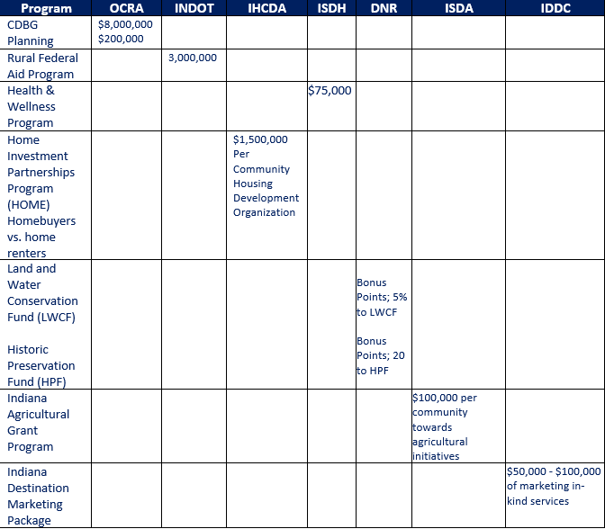
Whereas, [Insert Communities] (hereinafter referred to individually as a “regional partner” and collectively as “the Regional Team”) have come together as a region to apply for the Stellar Pathways program.
Whereas, the implementation of a successful Stellar Pathways program requires other resources including the sustained commitment of a staff and of the governing bodies of the Regional Team; and
Whereas, the Regional Team members now desire to enter into this Interlocal Governmental Agreement (“Agreement”) which will ensure that the sustained commitment exists to provide the support and structure necessary to successfully apply for and implement the Stellar Pathways program.
Now, therefore, be it resolved by the common council of [Insert Municipality Name] that:
- [Insert Municipality] has partnered with [Insert County Name, Regional Partner Name] for participation in the Stellar Pathways program creating [Insert Region Name]
- [Insert Region Name] has attended a mandatory Stellar Pathways program workshop.
- If chosen as a Stellar Pathway participant, develop a Strategic Investment Plan with a qualified consulting team.
- Present the Region’s Strategic Investment Plan to the Stellar Pathways Committee.
- If chosen as a Stellar Pathways Designee, implement Strategic Investment Plan projects and programs with the use of set-aside funding, bonus points, and annual funding rounds within five years of designation.
- Attend quarterly meetings during those -years to measure project completion, success, and obstacles.
Passed and Adopted on this [Insert date] of [Insert month], 2024
_______________________________ _____________________________
[Insert Name CEO Local Unit of Government, Title] [Date]

