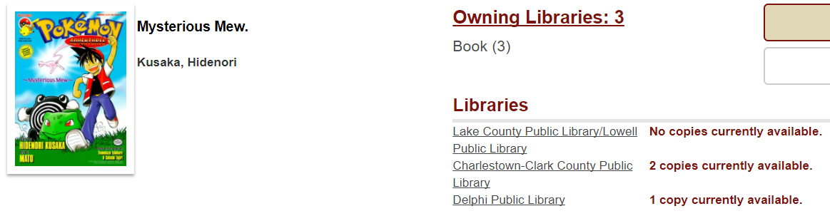

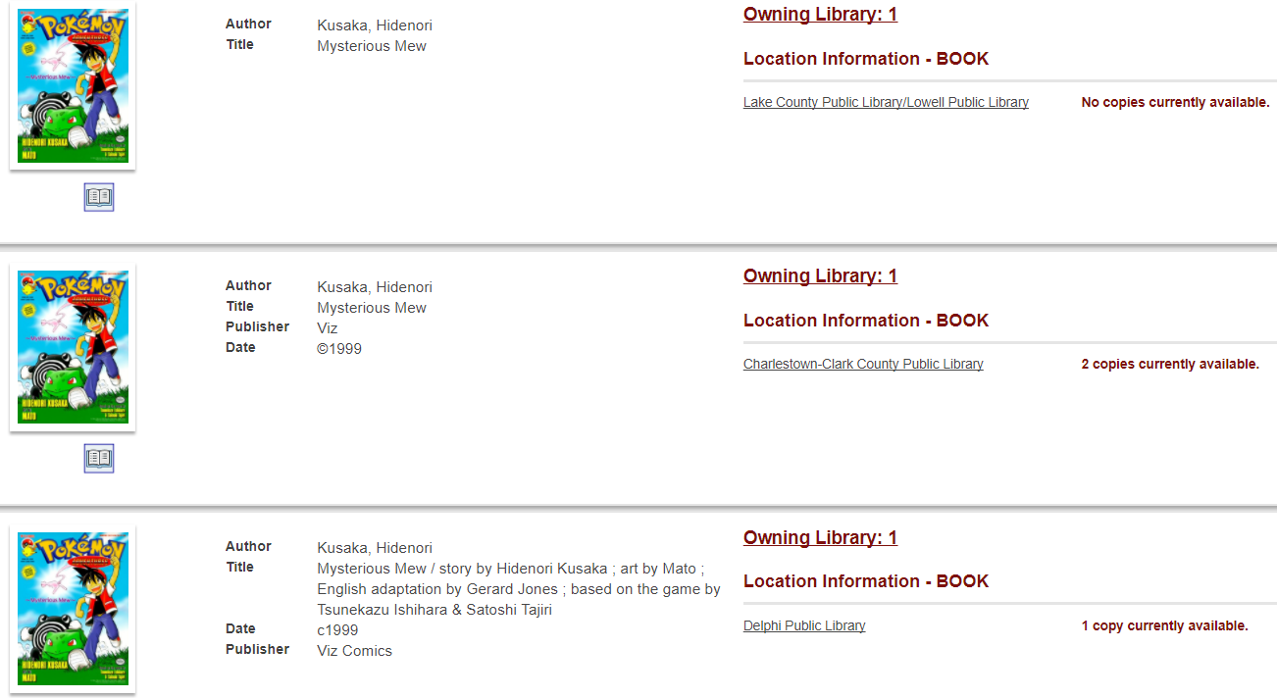

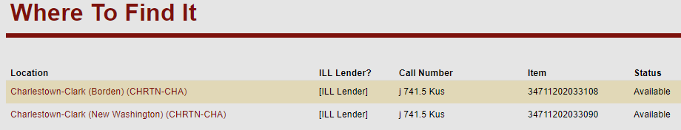
WRITE:
3-F*, Charlestown-Clark
*write F if any library listed in the “where to find it” section has it filled

