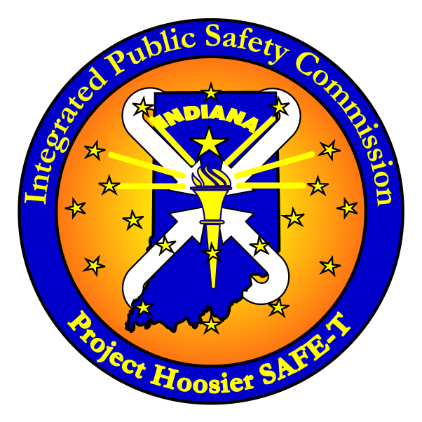
Integrated Public Safety Commission
Indiana Government Center North
100 North Senate Avenue, Room 340N
Indianapolis, Indiana 46204 2203
317-233-8624 voice
317-233-1082 fax

Meeting Minutes

Integrated Public Safety Commission

Tuesday, June 18, 2013

- Welcome
  - Chairman Douglas G. Carter, Indiana State Police Superintendent, called the Integrated Public Safety Commission meeting to order at 1:40 p.m., Tuesday, June 18, 2013. Commissioners present were: Sheriff Ken Fries, Allen County; Rick Linenburg, President, Knox County E-911 Board; Jason Carroll, Director of Public Safety - Ivy Tech Community College – Indianapolis Campus; Sgt. Darrel Healy, proxy for Chief Brett Sprinkle, Newburgh Police Dept.; Randy Fox, DeKalb County EMS; and Senator Tom Wyss. Chairman Carter welcomed all in attendance, and with a quorum attained, immediately turned to the agenda items.

- Adopt Minutes from March 19, 2013
  - Chairman Carter called for a motion to adopt the minutes of the March 19, 2013 meeting; so moved by Commissioner Fries, seconded by Commissioner Linenburg; unanimous adoption.

- Adoption of Memoranda of Understanding
  - None to adopt

- Statewide Interoperable Communications Executive Committee (SIEC)
  - SIEC member Adam Groupe presented the Commission with a brief SIEC update. April 15-16 was the Mobile Command Workshop which went well with 24 vehicles total. DHS provided training for standard operating procedures for those vehicles.
  - Mr. Groupe discussed SIEC’s plan for SOP reviews in the coming year and development of policies and best practices.
  - Mr. Vice added SIEC’s discussions on radio training and qualifying with it as is done with firearms; Commissioner Wyss inquired about frequencies used for specific incidents; Chairman Carter suggested cheat sheets for his troops with Commissioner Fries suggesting a phone app.

- Financial Report
  - Jeanne Corder, IPSC Controller, presented the Commission with a financial update: revenues are now coming in and IPSC is right on budget.

- Executive Director’s Report
  - Mr. Vice began with a P25 upgrade report – IPSC staff is continuing to work with the Office of Management and Budget to identify funding. Also, IPSC is communicating with local groups who are also considering the P25 upgrade on their own systems to see how we can all work together on this project. A consultant has been selected for this project, but no contract has been signed yet. Commissioner Linenburg asked about the time table for the P25 project, in which Mr. Vice explained we are a little behind the timeline we had presented the Commission.
  - Mr. Vice discussed the federal FirstNet LTE Broadband project that is to build out a nationwide public safety broadband system. Mr. Vice attended an APCO conference in Washington D.C. in May. Last week a delegation of ten (five local users/and five state users) attended the FirstNet Regional meeting in St. Louis. Next, there will be individual state meetings set up, with Indiana occurring the latter part of August. We were told that the Governor will have 15-24 months before the timeframe begins to opt in or out for this project. Sally Fay and Jeanne Corder have responded to the questions and/or clarifications for the SLIGP grant.
  - IPSC has been working with IDHS on local grant money that expires July 31. We have identified 8 counties that had radios on the state system that cannot be upgraded to P25 and these funds will replace a portion of those.
  - Mr. Vice and Kelly Dignin of IPSC both met with two members of the Iowa Statewide Interoperable Communications Board to discuss the radio system and CAD. Discussions included the IPSC organizational structure, buildout, maintenance, support and funding.

- Planning & Training (SWIC Report)
  - Ms. Fay provided a Statewide Interoperability Coordinator (SWIC) update. Efforts have been focused on training and radio maintenance. Communication unit leaders classes continue with a COML exercise coming up in August. DHS grant money is being used for additional communications technicians classes as well. Ms. Fay gave an overview of various upcoming classes and workshops.
  - IPSC has been approved for three new employees, two who will act as outreach coordinators with the different districts for interoperable issues.
  - The SIEC is working on the SCIP plan and IPSC is preparing for the fall exercise at Muscatatuck
  - IPSC Training Coordinator, Vivian Nowaczewski talked about additional training information. Training has focused on the 800 MHz radio system as well as dispatch. IPSC has also been involved with assisting INDOT to build their 800 MHz training program.

- Operations Report
  - John Asher briefed the Commission on IPSC operations: currently working with customers including writing new programming for ISP and INDOT.
  - Reprogramming at the different districts; reducing the number of talkgroups
  - Another IPSC group has been actively working on the microwave upgrade system and dish alignments.
  - IPSC currently has 16 communication technicians with two current openings.
  - Working on coverage issues with Warrick and Floyd counties, as well as rebanding cleanup.

- CAD/RMS System Implementation Report
  - CAD Administrator, Kelly Dignin updated the Commission on the Computer Aided Dispatch/Records Management system (CAD/RMS). There are 18 servers that run the program, with 7 applications: CAD, Mobile, AVL, Validation, AA, COMs & DEV. These servers were given a “clean bill of health” from IOT.
  - IOT performed a power outage on June 15th at the Indiana Government Center in which CAD responded very well. There were no complaints or issues with the CAD system.
  - Ms. Dignin provided the Commission with a list of state agencies that are currently on the system. Additional agencies that are interested are Greensburg P.D., Tipton County and Vanderburgh Sheriff.
  - A problem log was given to the Commission with 29 total issues. These issues are manageable: 6 have been fixed this week, 2 issues are duplicates and 4 are user issues.
  - Connectivity issues have occurred with how agencies want to connect to the mobile CAD application. InterAct is assisting with determining the best options for each agency.
  - CAD system trainees have shared training frustrations with InterAct and Ms.Dignin. 30 issues were reported in which 3 of these are actual bumps that need worked on, and the other 27 are due to lack of understanding by the users.

- Logistics Report
  - Doug Cochrane, IPSC Network Operations Center, presented a microwave map showing 20 site upgrades which was a 7 week project. All the cutovers are done with equipment installed, but the project is still not complete.
  - Alcatel will be providing training to 6 technicians on microwave monitoring software.

- System Growth & Statistics/Radio I.D. Reserve
- Dennis Eaton, IPSC Network Operations Center, (NOC Center) presented the Commission with an update on the system growth:
            - 3,528 remaining unreserved IDs –
              - 2,533 analog
              - 995 digital
            - Of the 2,533 analog IDs,, 2,100 are able to convert to digital
            - 433 IDs will not be convertible

- Under the Commission directive of January 14, 2010, the NOC Center has been actively encouraging agencies with un-used IDs, to return them or re-use them. Since that time, 3,133 ID’s have been returned or re-used. Without these efforts, there would only be 395 total ID’s remaining (analog and digital).
- There have from time to time been requests asking for special exemptions, but Mr. Eaton recommended the Commission review the directive for changes to handle these requests, possibly allowing the Director to approve the exemption request and report those to the Commission.
- During these efforts, the NOC Center has been sending replies to requests for additional ID’s, with listings of what ID’s have not been used in the past. The reply requests that the agency locate the radio, power it up, affiliate, and transmit with it. Performing this has lead to many radios being found programmed with incorrect ID’s in them. This means that two or more radios were attempting to use the same ID which likely resulted in poor communications for both users.
- The NOC Center also works to collect and distribute out-of-tune data from the two DiagnostX boxes deployed. The sharing of this data has proven to be very successful. A Hendricks County official recently stated that all 40-plus radios reported to them were in need of tuning.

- Other Discussion
  - No further discussion

- Hearing no other business, Chairman Carter called for a motion to adjourn; so moved by Commissioner Linenburg; seconded by Commissioner Fries. Chairman Carter adjourned the meeting of IPSC at 2:50 p.m.

Next Commission Meetings:
The dates of the remaining 2013 Commission meetings are as follows:
            - September 17th @ 1:30 p.m.
            - December 17th @ 1:30 p.m.
These meetings will be held at the CTC Training Center located at 8468 E. 21st St., Indianapolis, IN 46219. Please contact Julie Sheppard for additional information – jsheppard@ipsc.in.gov.

