Memorandum
To: Broadband Service Providers
From: Andrew Brelage-Director of Broadband Corridors
Date: May 10, 2021
Re: Broadband Corridor and Vertical Structure Price Changes!

Indiana Broadband Service Providers:

One year ago, who would have thought how our way of life would be forever etched into history. Today, INDOT and your company have persevered through the winds of change and are more robust than ever before. Through out those changes, the INDOT Broadband Corridors program has made some program adjustments to our pricing models to ensure our Indiana Broadband Service Providers are able to provide world class broadband services to all our Hoosiers that is both robust and economical.

Effective Immediately, the following changes in our access rates for placing fiber optic cable within a designated Broadband Corridor:
- Annual recurring rate of $500.00 per mile per year for each occupant
  - For I-465 will be $581 per mile per year for each occupant

- The one-time non-recurring administrative fee has been reduced to $1,000 will continue.

- A broadband access permit is still required when performing work within INDOT right of way. The $55.00 permit fee will be waived for work that is done within a designated Broadband Corridor.
  - Any longitudinal fiber installations that are less than one (1) mile will be pro-rated.

Effective Immediately the following changes in our access rates for the placement of small cell structures within a designated Broadband Corridor:

- Annual recurring rate of $270.00 per attachment per year within the Broadband Corridors

- The one-time non-recurring administrative fee for small cell will be reflective of the FCC recommendation of $500.00 for up to five (5) small cell wireless facilities with an additional $100 for each small cell installed beyond the initial five (5), or up to $1,000 for placement of a new pole intended to support one or more small cell facilities.

- A broadband access permit will still be required for small cell installations; however the $55.00 permit fee will be waived for those installation within a designated Broadband Corridor.

- Installations must all be within relative proximity and time.

INDOT will continue to allow attachments to a state-owned vertical structure such as cell towers or Intelligent Traffic Systems (ITS) towers with an approved structural analysis report and special provisions that will be included within the exhibits portion of the vertical structure agreement. Attachments to INDOT-owned structures including but not limited to bridges, gantries, light standards, etc. are not permittable.

If you have any questions, please feel free to reach out to me.

Thanks,
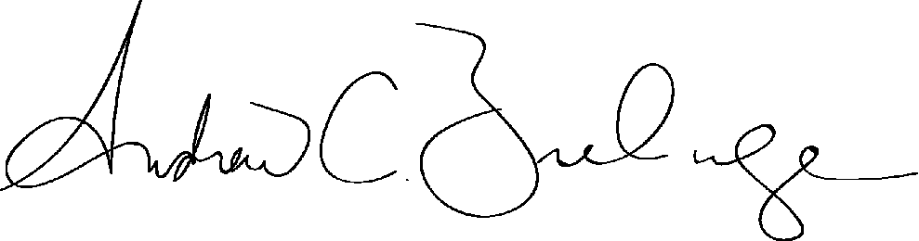
Andrew Brelage
Director of Broadband Corridors
Direct: 317-232-5174 Cell: 317-646-4655
abrelage@indot.in.gov

