Multiple Fiscal Year Procurement Contracts:

When entering a requisition please consider how receiving will be performed and payment will be made. If a receiving/payment needs to be made by dollar amount and not a set price per unit of measure, the requisition must have the line item set up with a quantity of one, the appropriate unit of measure (service, each, lot, etc.) and the corresponding unit pricing. Verify whether or not each line of the resulting purchase order should be set up for amount only.

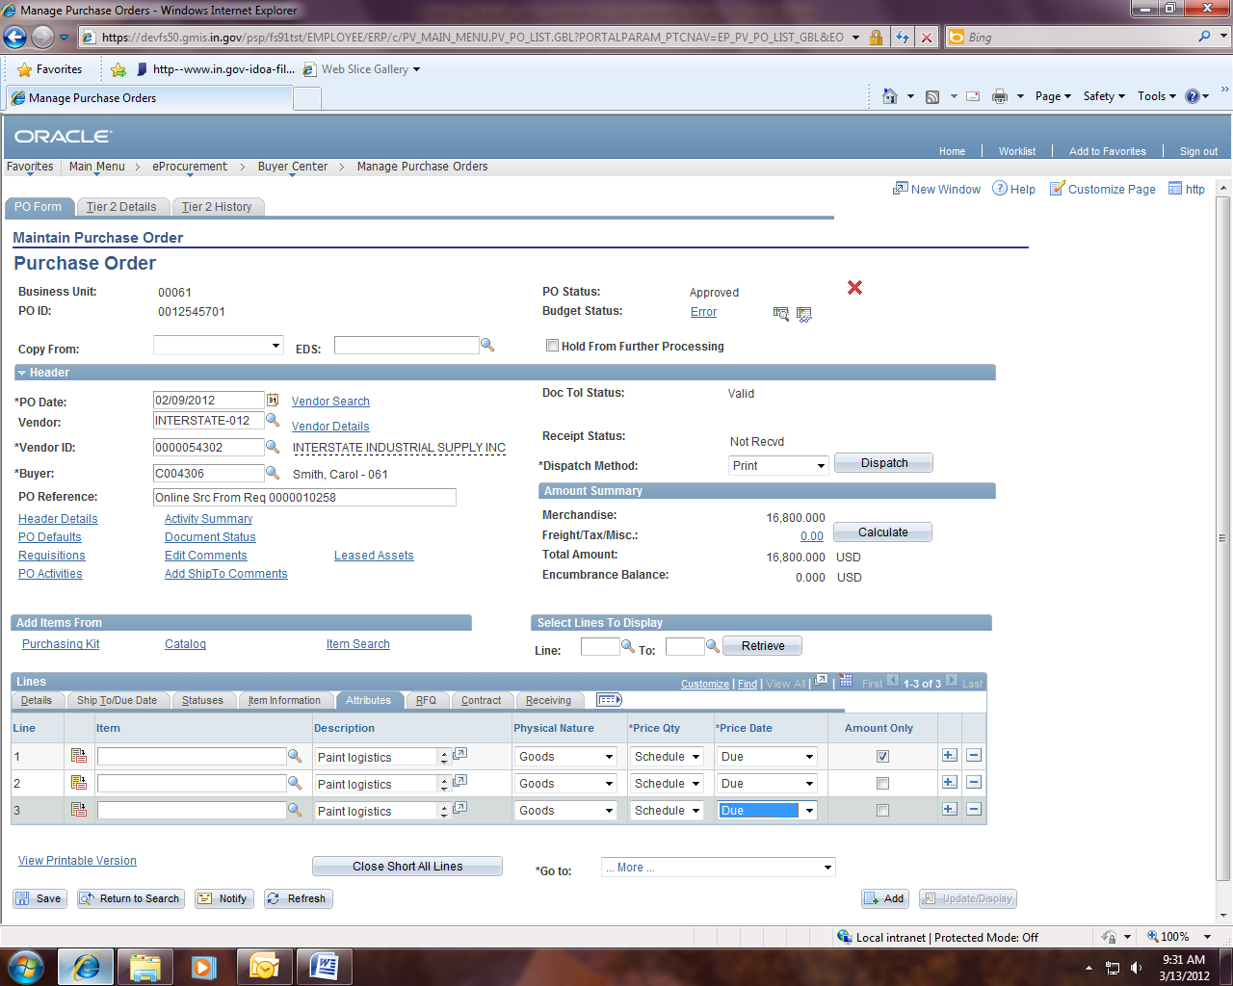

If your contract is a commitment for multiple years, for example a four year contract, you will enter a separate line for each fiscal year (for ease of issuing receipts and making corresponding payments). In order to enter budget lines for multiple fiscal years, you must submit a request to your agency Controller/Budget Analyst requesting that a $0 budget be opened for each of the future fiscal years you will need. Once the $0 Budgets are established and posted, you will select the appropriate accounting information including the budget ref and budget date for each requisition line. You will receive a budget check error on the zero dollar budget years that your Budget Analyst will be required to override. You will need to re-budget check the requisition until it becomes Valid. Since the Office of Management and Budget (OMB) is requesting that all commitments be put into PeopleSoft/ENCOMPASS this should not be a problem. It is our recommendation that you set up your purchase orders as amount only as it will make receiving much easier.

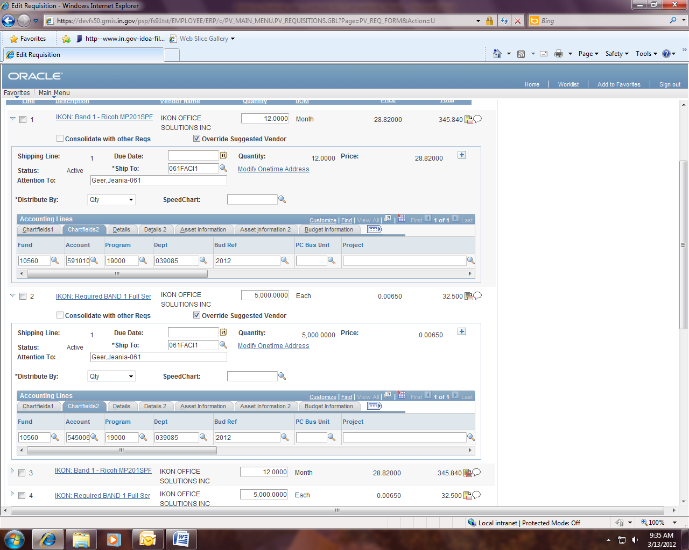

Once you have your requisition entered, approved and it has a valid budget check, you will print and sign the requisition and submit it along with your vendor signed contract and any documentation that you have to IDOA Procurement. Upon the full execution of the contract (i.e. signed by all parties including the Attorney General) it will be returned to the agency to issue the purchase order. If the po is above your delegation, then submit an email to poapprove@idoa.in.gov and identify your Business Unit, PO number and related EDS number and IDOA Procurement will verify and approve the purchase order. You may then finalize, budget check and dispatch the PO and send a copy to the vendor and a copy to your agency accounts payable area. If the PO fails the budget check, then your Budget Analyst will need to override it. The future years budgets will encumber in the negative to show the future year commitments. When the future year budgets are loaded, then the purchase orders will synchronize and will automatically be encumbered appropriately.

Multiple year contracts which contain projects - a directive from Marilyn Rudolph
- Prior to entering the PO, project administrator should create projects for the future years covered by the contract, regardless of the type of contract (service, lease, etc.).
- If future year project name uncertain, create ‘dummy’ projects; only Project ID and one Activity ID need to be set up.
- Set ‘dummy’ project Status to E-Reject-ACT/GLE/BUD/REV/PAY to avoid any accidental charges to this project.
- Enter PO, using multiple lines for future years, utilizing ‘dummy’ projects.
- When future year is to be activated, modify ‘dummy’ project to the correct project, setting status to active.

