The following process should be used when a contract renewal or amendment is being processed. Do not close/cancel the original purchase order. The new requisiton for the renewal or amendment will be copied to the existing PO. The intent is to keep all contract information on one purchase order. This allows the State Budget Agency to see that funds have been set aside for the renewal or amendment while the document is routing for signature/approval.
Then a new requistion covering the fiscal year(s) of the Amendment and/or Renewal document should be entered into PeopleSoft. Take the requistion to an “Approved” status with a “Valid” budget check.
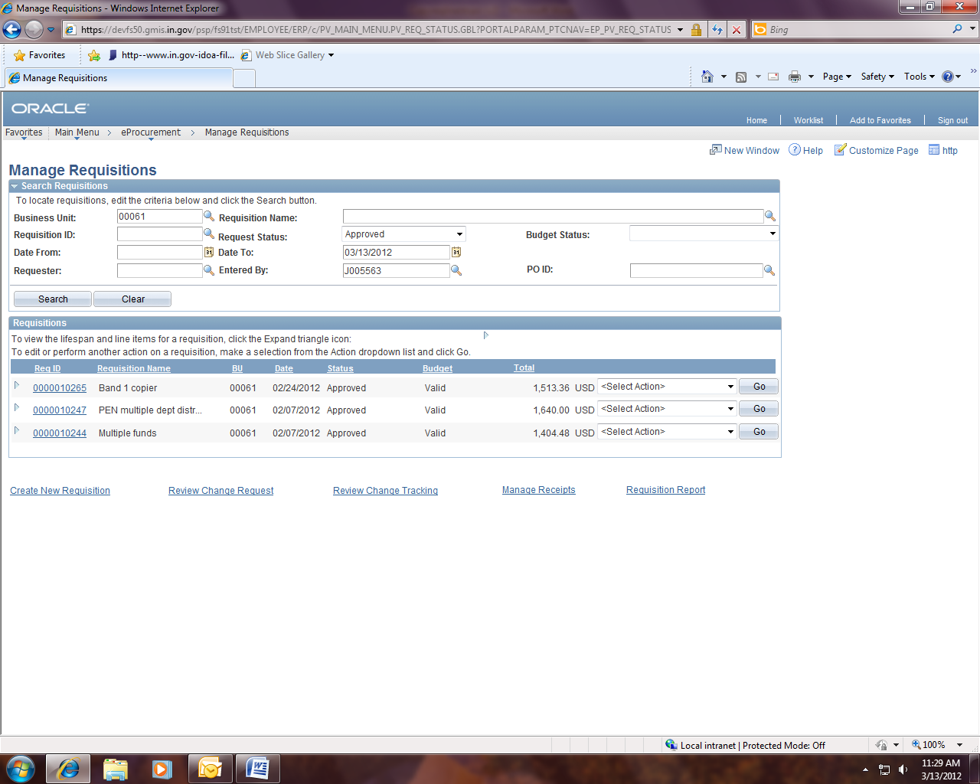Notes about the requisition:
- There should not be a vendor tied to the requisition.
- Submit the signed requisition with the Contract Renewal or Amendment/Renewal paperwork being routed to IDOA for signature. Be sure to update the requisition number on the EDS created for your renewal/amendment.
- Set the requisition up with distribution line information or set it up as an “Amount Only” requisition if needed.
- The EDS number and original purchase order number should be referenced somewhere on the requisition (in the description and justification?).
The existing purchase order must be in “PO Dispatched” or “Partially Received” status so that it can be edited.
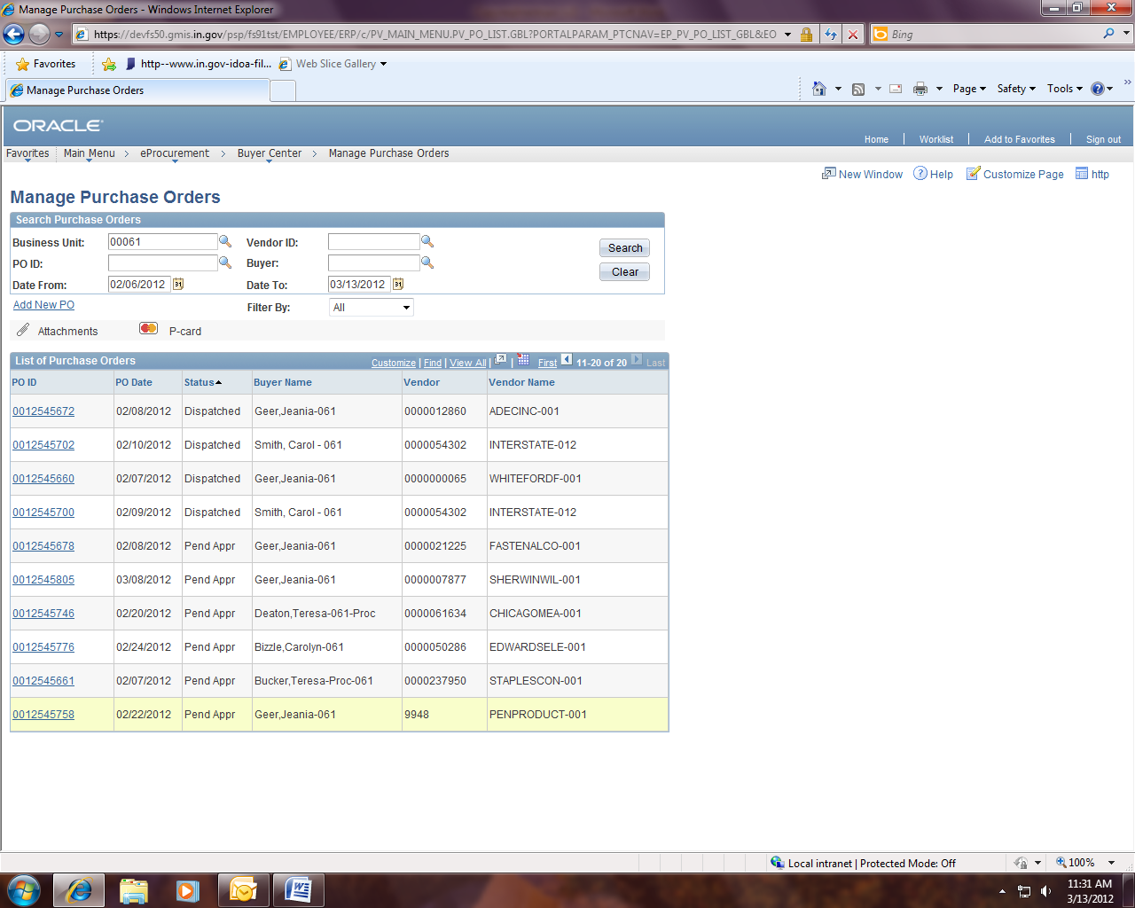
Notes about the purchase order:
- The process should be finished (requisition lines copied to existing PO) after the executed Contract Renewal or Amendment/Renewal is returned to the Agency.
- The EDS number should be populated so that contract information can be verified prior to approval and so the contract can be searched for by the EDS number.
- Does the new purchase order line need to be set to “Amount Only”?

After opening the purchase order, be sure the “EDS” number field is populated.
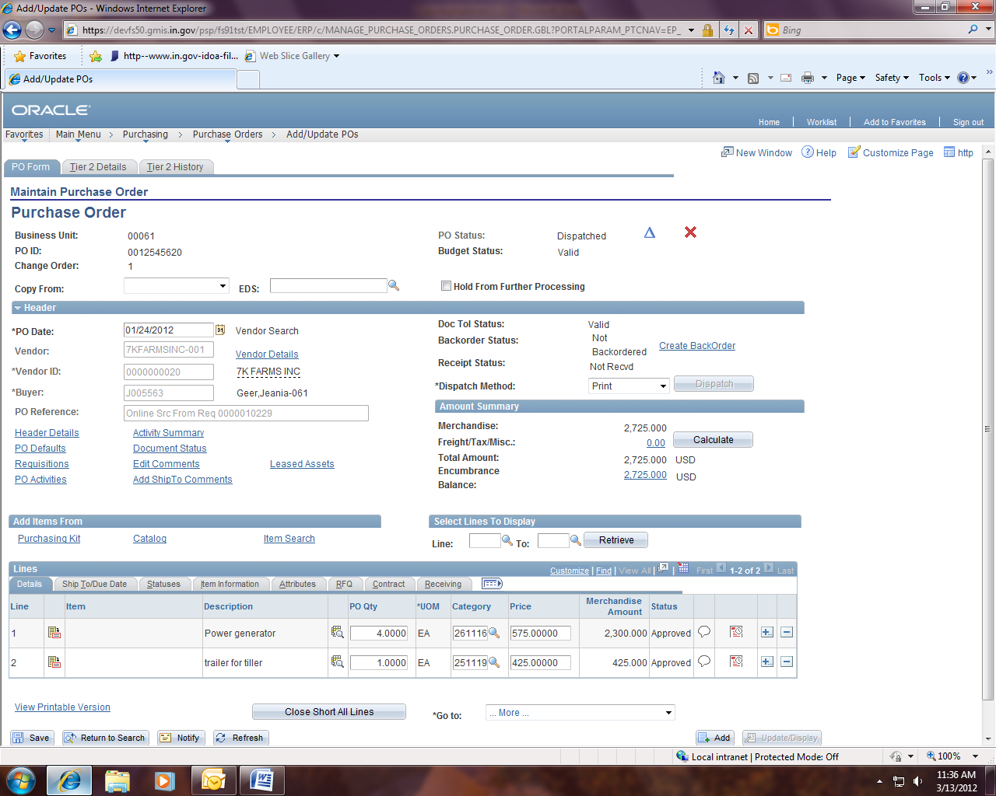Update the “Accounting Date” on the “PO Header” to the date you are editing the purchase order.
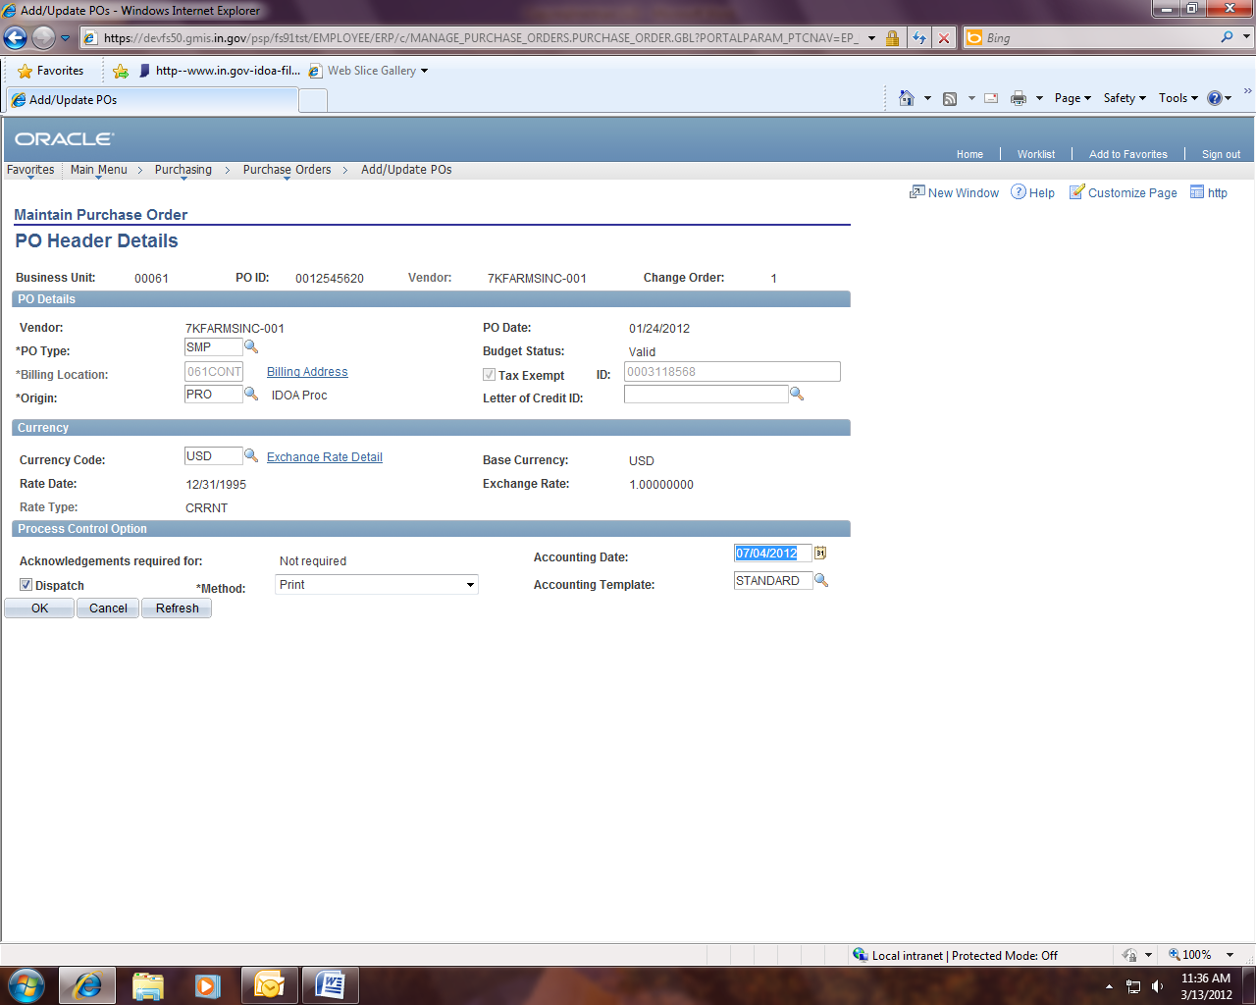
Change the drop down to the right of “Copy From” to “Requisition”.
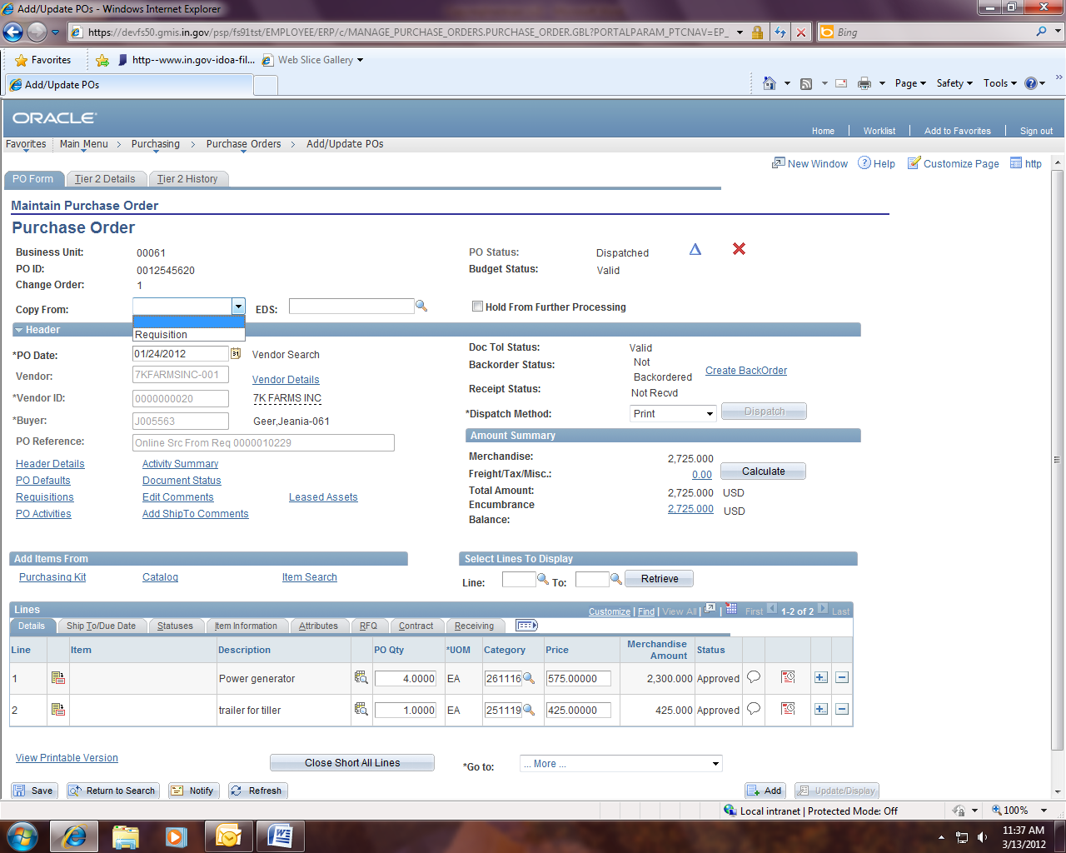
Enter the ten digit “Requisition ID” number and click on the “Search” button.
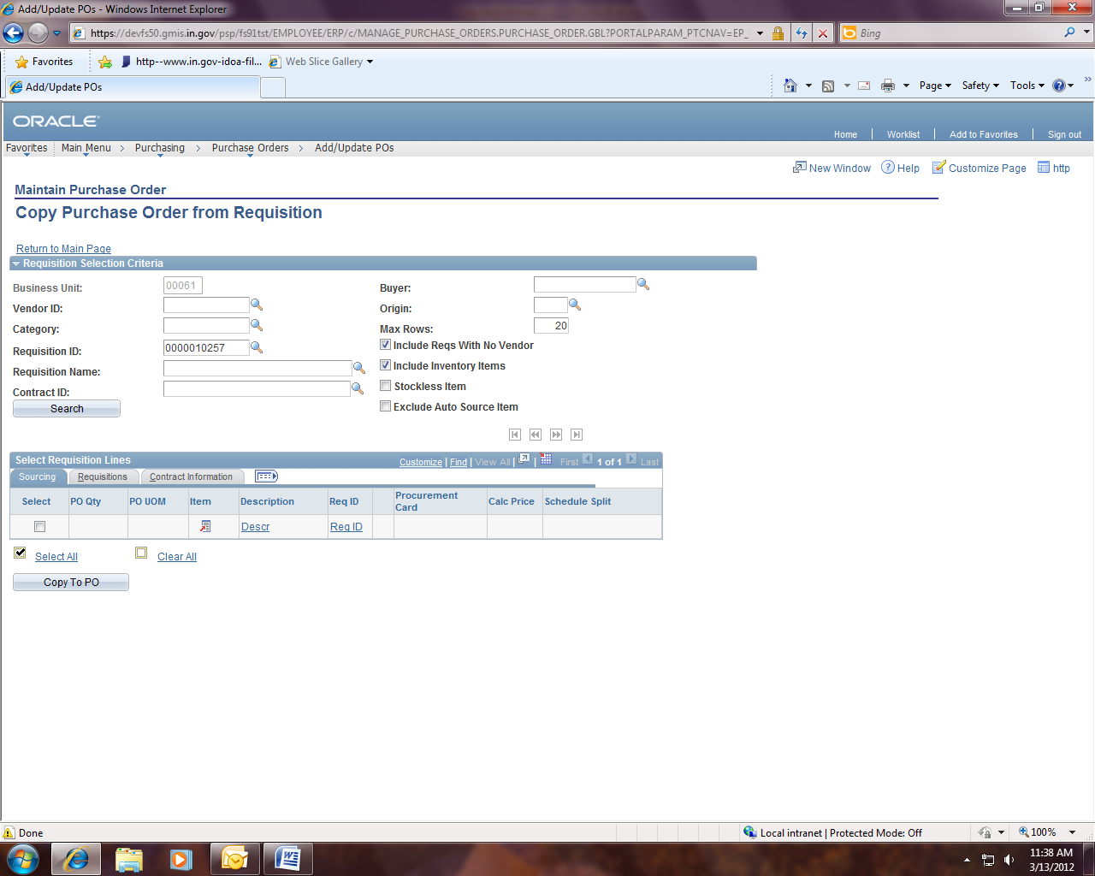

Select the lines from the requisition that you would like to have copied over to the purchase order by clicking the checkbox at the beginning of the row(s) or the blue “Select All” link and click on the “Copy to PO” button.
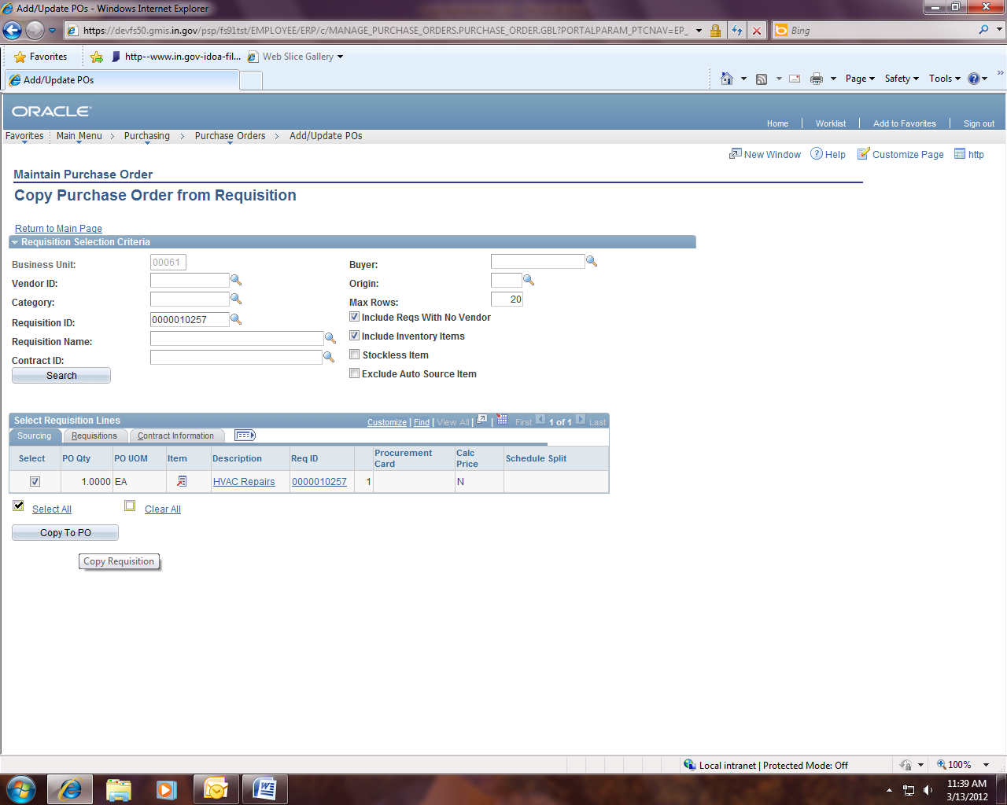

A change order will be created and the lines copied will be added to the bottom of the existing purchase order lines. Click on the “OK” button.
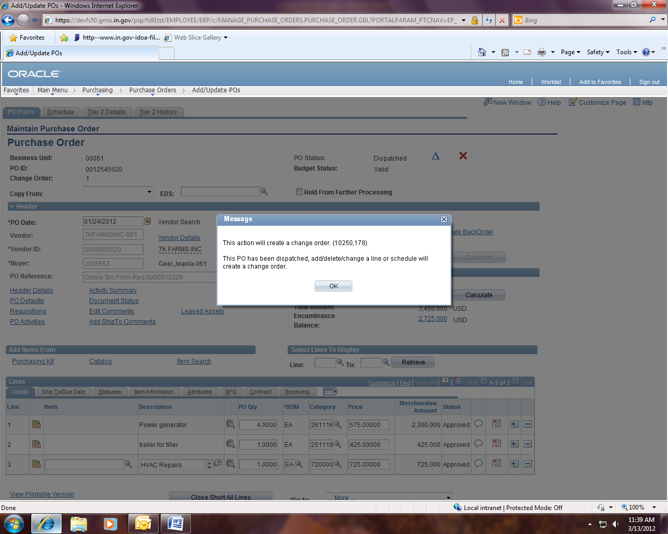

Click on the blue “PO Activities” link to enter a comment as to why the change order was created (complete the Due Date and the Comment fields) and click on the “OK” button to return to the main po panel.
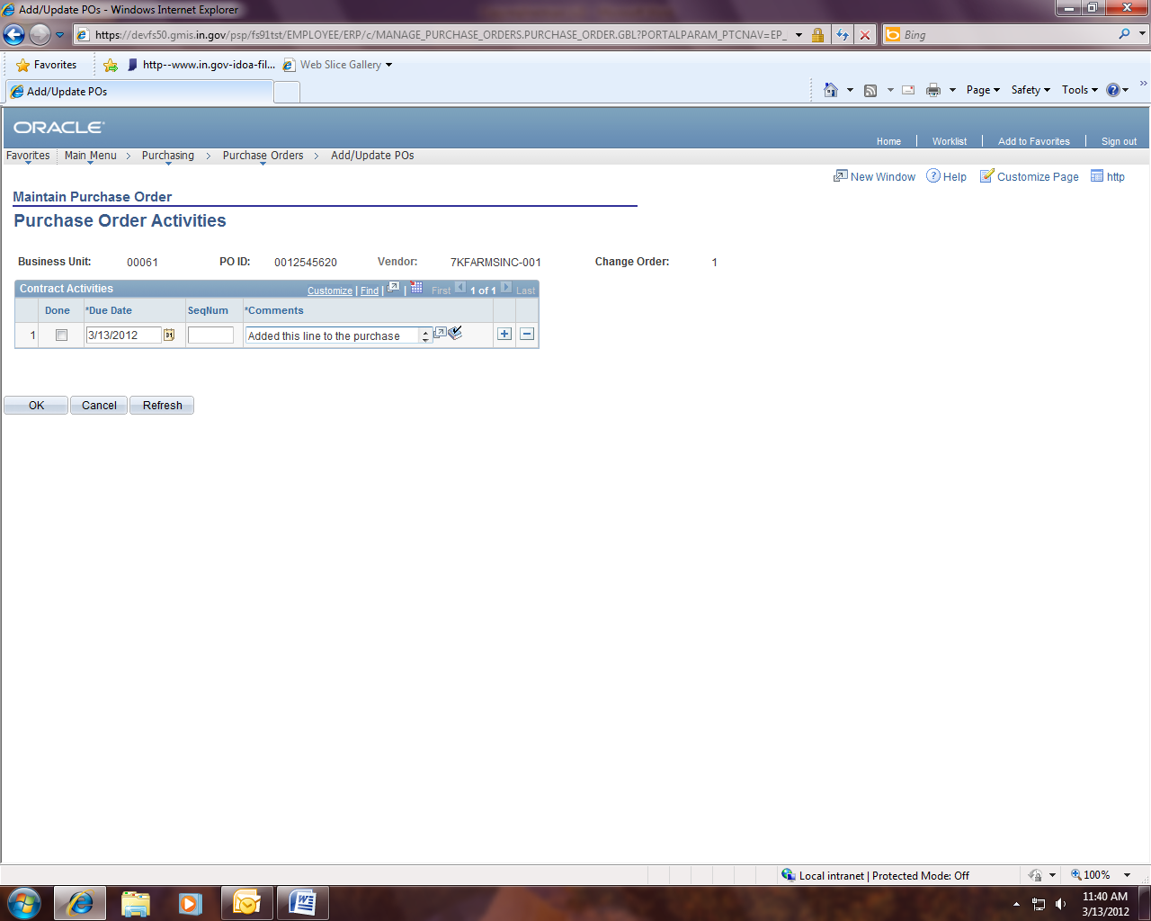Make any adjustments needed and take the purchase order back to “PO Dispatched” status.
Tier 2 Tab – make sure MWBE subcontractor information (taken from the contract/EDS) is accurate
Leased Asset – review for accuracy
Approve – may require IDOA approval if over agency delegation and a purchase order is required by the Auditor
Finalize - to relieve any difference between the pre-encumbrance and the encumbrance
Budget Check – will encumber the purchase order
Dispatch – run the process and send a new copy of the purchase order and the contract document to the vendor

