Background Information

During the American Civil War, women’s contributions both on and off the battlefield proved as vital to the war effort as was the efforts of the soldiers who fought it. Women were engaged in numerous facets of civil, political, and military life in both the North and South. Women on both sides disguised themselves as men and enlisted to fight for their respective side; women made public speeches and published articles, songs, and poems expressing their opinions of the conflict, the opposing side, and the manner in which the war was being conducted. Women readily stepped in to fill the voids left by enlisted men on the farm, in the home, and in the transaction of business. Several women, whether directly affected by the enlistment of a male relative or not, contributed to the war by providing letters, food, and mementos from home to soldiers. They voluntarily wove blankets and clothing to help keep the soldiers warm and comfortable, and to keep up their strength and morale; and they engaged in social fairs, clubs, and other activities to raise money and collect provisions for the soldiers. Women also contributed greatly to the care of sick and wounded soldiers by staffing the hospitals, traveling with the troops, and even taking up residence on the naval hospital ship Red Rover (becoming the forerunners of the Navy Nurse Corps).

Regardless of the individual activities performed by women during the war, the physical, emotional, and psychological contributions of women were immeasurable to the war effort and the historical accuracy and context in which the American Civil War is remembered and discussed.

State and National Standards
State Standards
    - Summarize the participation of Indiana citizens in the Civil War.
    - Using primary and secondary source materials, generate questions, seek answers, and write brief comments about an event in Indiana history.
National Standards
Standard 2: Historical Comprehension
B. Reconstruct the literal meaning of a historical passage.
C. Identify the central question(s) the historical narrative addresses.
H. Draw upon the visual data presented in photographs, paintings, cartoons, and architectural drawings.
Standard 3: Historical Analysis and Interpretation
F. Analyze illustrations in historical stories.
J. Hypothesize influences of the past.
Standard 4: Historical Research Capabilities
A. Formulate historical questions.
Standard 5: Historical Issues—Analysis and Decision-Making
A. Identify problems and dilemmas in the past.
B. Analyze the interests and values of the various people involved.

Lesson Overview

Large Group Instruction:
Approximately 20 minutes
Present lecture (Document 1-1) explaining the “gendered roles” in pre-war Indiana, and the roles and contributions of women during the Civil War [using attached primary sources to demonstrate each] (Documents 1-2, and 1-3). Ask leading questions throughout to ensure comprehension (Document 1-4).
Cooperative Learning:
Approximately 20 minutes
Form six groups by counting off. Put poem (Document 2-1) up on overhead or hand out copies to students. In addition, each group will receive one of three depictions (Documents 2-2, 2-3, and 2-4). Each group will interpret their assigned portion of poem, as well as their assigned sketch using Activity Sheet (Document 2-5). Allow 10 minutes for this assignment. Glossary sheet might assist in completion of this assignment.
Bring students back together for whole-class discussion on activity just completed (Document 2-6). Allow 10 minutes for discussion and review.
If time allows, show students marker text for the Indiana Historical Marker, “Sisters of the Holy Cross, Civil War Nurses, 1861-1865,” (Document 2-7).
Individualized Instruction:
Give students Assignment (Document 3-1) to be handed in the following day.

Emma Lou Thornbrough, Indiana in the Civil War Era, 1850-1880 (Indianapolis, 1965), pp. 1-37, 164-79; 258-69.
W. H. H. Terrell, Indiana in the War of the Rebellion: Report of the Adjutant General [A Reprint of Volume 1 of the Eight-Volume Report Prepared by W. H. H. Terrell and Published in 1869] (Indianapolis, 1960), pp. 398-409, 456-61.
USN Ships—USS Red Rover (1862-1865), http://www.history.navy.mil/photos/sh-usn/usnsh-r/rd-rov-o.htm (accessed January 18, 2007).
Thomas E. Rodgers, “Hoosier Women and the Civil War Home Front,” Indiana Magazine of History, Volume XCVII, No. 2, June 2001: pp. 105-128.
Report of the Indiana Sanitary Commission, Made to the Governor, January 2, 1865 (Indianapolis, 1865), pp. 3-16.
Olin D. Morrison, “Indiana’s Care of Her Soldiers in the Field, 1861-1865,” Studies in American History, Vol. XII (June, September, December 1925): pp. 279-302.
Kate Dooley, “Pioneers of the Navy Nurse Corps,” p. 30.
Rev. John F. McShane, “The Hand of Providence,” (Indianapolis, 1949), pp. 3-26.
Sisters of the Holy Cross, Civil War Nurses, 1861-1865, “Dedication of Memorial,” (Indiana Civil War Centennial Commission, October 31, 1965).

Document 1-1

Lecture Outline

- Gendered Roles Prior to the Civil War (Indiana)
• Include here a brief discussion on the following excerpt from soldier Samuel Mattox of Vigo County to his wife, Ann (Document 1-2): Might want to write this on the board or put on overhead for students to read along
I am getting to be very thrifty. I have learnt how to take care of myself…. I do all my washing and am getting to be a pretty good cook. So you see, if I ever get home I will be a pretty good female.
  - Women
    - Inside the Home
      - Most women “employed” within their homes
      - General tasks included: laundry, cooking, sewing, gardening, and taking care of the children
    - Outside the Home
      - Some women were employed outside of their homes
        - Generally employed in domestic sphere: sewing and household servants
      - Women employed outside the home in non-domestic positions tended to be single or widowed women and positions included teaching and factory work
  - Men
    - Men typically held all Public Sphere positions, including politics, factories, trade laborers, etc.
    - In Indiana especially, many men worked on the farm
      - Handled cash crops
      - Took care of the larger farm animals
      - Constructed buildings and fences
      - Oversaw market transactions
- Women’s Activities During the War

• Include here a discussion of Governor Morton’s Appeal To the Patriotic Women of Indiana (Document 1-3): Might want to put this on the board or an overhead for students to read along
  - Physical, Emotional, and Psychological Contributions to the War
    - Provisions and Supplies
    - Letters, Photographs, Mementos
    - Nurses / Hospitals / Care of Soldiers
    - Social Activities

Document 1-2

Samuel Mattox to Ann Mattox, March 17, 1863:

“I am getting to be very thrifty. I have learnt how to take care of myself…. I do all my washing and am getting to be a pretty good cook. So you see, if I ever get home I will be a pretty good female.”

Document 1-3
Edited for this lesson; full text appears on following page
Boldface indicates word substitution

To the Patriotic Women of Indiana:

When the President issued his first call to the loyal States for help, the Government was unprovided with most, if not all, of the articles necessary to the comfort and health of soldiers in the camp and in the field. The women of Indiana were appealed to, and they supplied the deficiency in our State with a generous enthusiasm which entitles them to the gratitude of the nation. The approach of winter makes it necessary to appeal to them again. Our soldiers, already suffering from exposure, will soon have to endure winter, and multiplied dangers of disease. The Government is doing all that can be done for them, but they still lack many comforts which soldiers need. Many articles of clothing, which, to men with no protection but a tent, no bed but the ground, and whose duty must be performed under the harsh conditions of winter, are absolute necessaries. They may save many lives which will surely be lost without them. These, the patriotic women of Indiana, it is hoped, will supply. An additional blanket to every man in our army will preserve hundreds….Two or three pairs of good, strong socks will be invaluable to men who must often march all day in the snow….Good woolen gloves or mittens will preserve their hands in marching and in handling their arms….Woolen shirts and drawers, too, are a necessity to men exposed to the elements. All these articles the Indiana volunteers ought to have now, and must have before winter sets in, if we would protect them from exposure and disease….Some of the articles the Government does not furnish, and others not in sufficient quantities…. Blankets cannot be purchased. The stock is completely exhausted, and the government is soliciting contributions from the citizens. Will not the women of Indiana do their share in providing for the men of Indiana, in the battlefield?
The women of Indiana alone can meet this emergency, and to them our volunteers, as well as the Government, look for sympathy and aid.

O. P. Morton, Governor of Indiana,
October 10th, 1861.

Full Text

To the Patriotic Women of Indiana:

When the President issued his first call to the loyal States for help, the Government was unprovided with most, if not all, of the articles necessary to the comfort and health of soldiers in the camp and in the field. The women of Indiana were appealed to, and they supplied the deficiency in our State with a generous alacrity which entitles them to the gratitude of the nation. The approach of winter makes it necessary to appeal to them again. Our Volunteers, already suffering from exposure, against which they are inadequately protected, will soon be compelled to endure the utmost severity of winter, and multiplied dangers of disease. The Government is doing all that can be done for them, but, when all is done, they must still lack many comforts which men in ordinary pursuits enjoy, and which soldiers need above all others. Many articles of clothing, which, to men with houses over their heads and warm fires always near, are hardly more than a luxury, to men with no protection but a tent, no bed but the ground, and whose duty must be performed under the unabated rigors of winter, are absolute necessaries. They may save many lives which will surely be lost without them. These, the patriotic women of Indiana, it is hoped, will supply. An additional blanket to every man in our army will preserve hundreds to their country and to their families. Two or three pairs of good, strong socks will be invaluable to men who must often march all day in the snow, and without them, must lie down with cold and benumbed feet, on the frozen ground. Good woolen gloves or mittens will preserve their hands in marching and in handling their arms, and while adding greatly to their comfort, will materially increase their efficiency. Woolen shirts and drawers, too, are a necessity to men exposed to such vicissitudes of weather as soldiers. All these articles the Indiana volunteers ought to have now, and must have before winter sets in, if we would protect them from exposure and disease, that may be averted by this timely preparation. Some of the articles the Government does not furnish, and others not in sufficient quantities to supply the waste produced by the exposure of a soldier’s life. Blankets cannot be purchased. The stock is completely exhausted, and the government is soliciting contributions from the citizens. Will not the women of Indiana do their share in providing for the men of Indiana, in the battlefield?
The women of Indiana alone can meet this emergency, and to them our volunteers, as well as the Government, look for sympathy and aid.

O. P. Morton, Governor of Indiana,
October 10th, 1861.

Document 1-4

Leading Questions / Comprehension Test

- Before you begin the lecture, ask students to write down 3-5 activities performed by women and 3-5 activities performed by men prior to the Civil War, and give a brief explanation as to why they think tasks might have been divided by gender.
- What are the reactions to Samuel’s implication that he would “be a pretty good female?” or Why does Samuel say he would “be a pretty good female,” and what does this say about the division of labor based on gender?
- How many students indicated in their pre-lecture exercise that women completed primarily “domestic” tasks, and what was the rationale behind their answer(s)?
- Ask students how much the division of labor based on gender has changed or in their own experiences, what kinds of tasks do women (mothers, grandmothers, aunts, etc.) and men (fathers, grandfathers, uncles, etc.) perform?
- Ask students why the contributions of provisions / supplies from home might have meant so much to the soldiers (how might the war have affected the nation’s production of essential products such as clothing, food, etc., etc.) – (why was there such a shortage of materials and supplies during the war)?
- Why would letters and mementos from home have been so important to a soldier serving in the war?
- What similarities can the students see in the importance of “packages from home” to soldiers in the Civil War as compared to soldiers serving in the military today?

Document 2-1

A Tribute

Written expressly for the Indiana State Sanitary Fair

And our noble women, the soldier cries,  As he wipes with his sleeve his dimming eyes,  They send us clothing and food and books,  And kindest letters and sweetest looks,  And words of noble and lofty cheer!  And with these what craven [weak, cowardly] could think of fear? | 1
It is this that mans us in battle’s hour,  That nerves the arm and gives it power;  That makes the heart’s blood fresher flow,  And gives to the bosom its noblest glow.  The women we love, the God on high—  They well know how we bravely do or die;  God bless our noble women! | 2
They make the bandage, they scrape the lint,  And they can the fruit with no thought of stint;  They get up fairs for the soldier boys,  And buy with the profit ten thousand joys. | 3
Their silken dresses are laid away,  To show their luster some other day;  For calico dresses are good enough  When the soldier, in shoddy, fares so rough; | 4
And they keep at home the precious gold,  For their hearts for ribbons may not be sold.  They deck their hair with the wilding rose,  And for brooches fair truth in each bosom glows; | 5
The piano practice, the ‘broidery fine,  Are left for a work that is more divine;  For making the soldier clothes so warm,  And tending the hospitals home sweet home  God bless, God bless our noble women! | 6
Mary E. Nealy
Washington, D.C.

Document 2-2

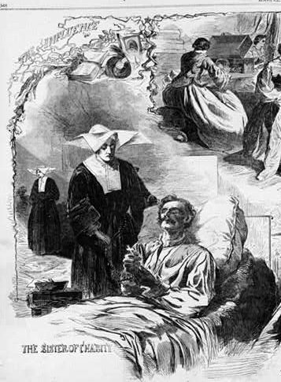

Illustration in Harpers Weekly, 1862 article “The Influence of Women,” accessed on Women Soldiers and Nurses of the American Civil War, http://americancivilwar.com/women/index.html (accessed January 18, 2007).

Document 2-3

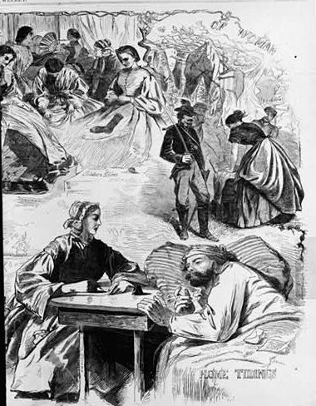

Illustration in Harpers Weekly, 1862 article “The Influence of Women,” accessed on Women Soldiers and Nurses of the American Civil War, http://americancivilwar.com/women/index.html (accessed January 18, 2007).

Document 2-4

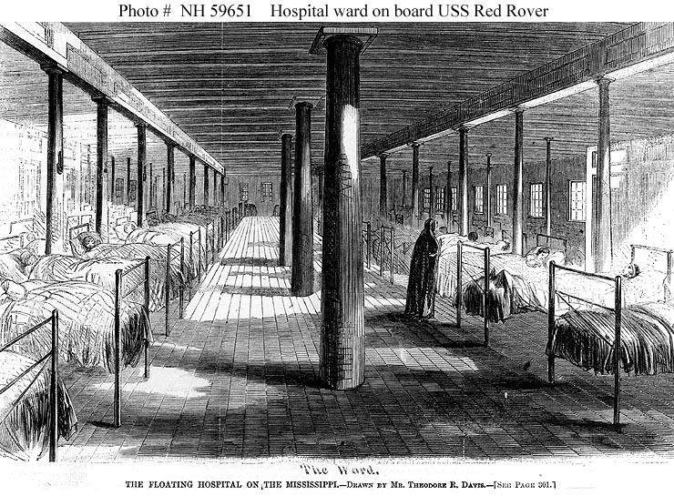

Photo #: NH 59651
USS Red Rover (1862-1865)

Line engraving after a drawing by Theodore R. Davis, published in “Harper’s Weekly,” January-June 1863, page 300, depicting a scene in the ward.
Red Rover served as the U.S. Navy’s hospital ship on the Western Rivers during the Civil War.

U.S. Naval Historical Center Photograph

Accessed at USN Ships—USS Red Rover (1862-1865), http://www.history.navy.mil/photos/sh-usn/usnsh-r/rd-rov-o.htm (accessed January 18, 2007).

Document 2-5

Activity Sheets

GROUP 1

Poem: Read each line of the poem listed below and then write in the space provided (Interpretation) what you think the author is saying in the following lines.

And our noble women, the soldier cries,
As he wipes with his sleeve his dimming eyes,
They send us clothing and food and books,
And kindest letters and sweetest looks,
And words of noble and lofty cheer!
And with these what craven could think of fear?

Interpretation:
________________________________________________________________________________________________________________________________________________________________________________________________________________________________________________________________________________________________________________________________________________________________________________________________________________________________________________

Using this picture, answer the questions below:
What is going on in this picture?

Who is depicted in this image? What are they doing?

What do you think is going through the minds of the individuals represented in this image?

What does your group find most interesting about this image?

Who is not represented in this image that maybe should be? Why? [Think back to the lecture and discussion]

GROUP 2

Poem: Read each line of the poem listed below and then write in the space provided (Interpretation) what you think the author is saying in the following lines.

It is this that mans us in battle’s hour,
That nerves the arm and gives it power;
That makes the heart’s blood fresher flow,
And gives to the bosom its noblest glow.
The women we love, the God on high—
They well know how we bravely do or die;
God bless our noble women!

Interpretation:
________________________________________________________________________________________________________________________________________________________________________________________________________________________________________________________________________________________________________________________________________________________________________________________________________________________________________________

Using this picture, answer the questions below:
What is going on in this picture?

Who is depicted in this image? What are they doing?

What do you think is going through the minds of the individuals represented in this image?

What does your group find most interesting about this image?

Who is not represented in this image that maybe should be? Why? [Think back to the lecture and discussion]

GROUP 3

Poem: Read each line of the poem listed below and then write in the space provided (Interpretation) what you think the author is saying in the following lines.

They make the bandage, they scrape the lint,
And they can the fruit with no thought of stint;
They get up fairs for the soldier boys,
And buy with the profit ten thousand joys.

Interpretation:
________________________________________________________________________________________________________________________________________________________________________________________________________________________________________________________________________________________________________________________________________________________________________________________________________________________________________________

Using this picture, answer the questions below:
What is going on in this picture?

Who is depicted in this image? What are they doing?

What do you think is going through the minds of the individuals represented in this image?

What does your group find most interesting about this image?

Who is not represented in this image that maybe should be? Why? [Think back to the lecture and discussion]

GROUP 4

Poem: Read each line of the poem listed below and then write in the space provided (Interpretation) what you think the author is saying in the following lines.

Their silken dresses are laid away,
To show their luster some other day;
For calico dresses are good enough
When the soldier, in shoddy, fares so rough;

Interpretation:
________________________________________________________________________________________________________________________________________________________________________________________________________________________________________________________________________________________________________________________________________________________________________________________________________________________________________________

Using this picture, answer the questions below:
What is going on in this picture?

Who is depicted in this image? What are they doing?

What do you think is going through the minds of the individuals represented in this image?

What does your group find most interesting about this image?

Who is not represented in this image that maybe should be? Why? [Think back to the lecture and discussion]

GROUP 5

Poem: Read each line of the poem listed below and then write in the space provided (Interpretation) what you think the author is saying in the following lines.

And they keep at home the precious gold,
For their hearts for ribbons may not be sold.
They deck their hair with the wilding rose,
And for brooches fair truth in each bosom glows;

Interpretation:
________________________________________________________________________________________________________________________________________________________________________________________________________________________________________________________________________________________________________________________________________________________________________________________________________________________________________________

Using this picture, answer the questions below:
What is going on in this picture?

Who is depicted in this image? What are they doing?

What do you think is going through the minds of the individuals represented in this image?

What does your group find most interesting about this image?

Who is not represented in this image that maybe should be? Why? [Think back to the lecture and discussion]

GROUP 6

Poem: Read each line of the poem listed below and then write in the space provided (Interpretation) what you think the author is saying in the following lines.

The piano practice, the ‘broidery fine,
Are left for a work that is more divine;
For making the soldier clothes so warm,
And tending the hospitals home sweet home
God bless, God bless our noble women!

Interpretation:
________________________________________________________________________________________________________________________________________________________________________________________________________________________________________________________________________________________________________________________________________________________________________________________________________________________________________________

Using this picture, answer the questions below:
What is going on in this picture?

Who is depicted in this image? What are they doing?

What do you think is going through the minds of the individuals represented in this image?

What does your group find most interesting about this image?

Who is not represented in this image that maybe should be? Why? [Think back to the lecture and discussion]

Document 2-6

Discussion

- Using Activity sheets completed by each group interpret the entire poem and discuss its implications on various individuals who might have read it.
- Put up transparency of image #1 and have groups 1 and 4 discuss with the class their answers to the activity questions; have groups 2 and 5 do the same for their image (#2), and groups 3 and 6 the same for their image (#3).

Document 2-7

The Indiana Historical Bureau administers, installs, and maintains the Indiana Historical Marker Program. Historical markers serve the purpose of communicating the rich political, social, cultural, economic, intellectual, and scientific history of Indiana to the public. Markers are intended to function as permanent educational tools for teachers, students, and others wishing to learn more about the state’s history.

Sisters of the Holy Cross, Civil War Nurses, 1861-1865 (St. Joseph County, Indiana)

In response to Governor Morton's call of October 1861, eighty Sisters of the Holy Cross under the leadership of Mother Angela served as military nurses. The Sisters became the forerunners of the Navy Nurse Corps in 1862 when they boarded the Red Rover, the navy's first hospital ship.

The Sisters of the Holy Cross marker can be viewed online at:
http://199.8.200.229/db/markers_display.asp?ID=280

All Indiana Historical Markers can be viewed by visiting:
http://www.statelib.lib.in.us/www/ihb/markers/index.html
Document 3-1

Assignment:

Complete one of the four activities listed below for tomorrow:

1) Write a letter to a soldier serving in the war. Describe what your typical day includes (this will depend on your “occupation”), how the war has affected you, and what your opinions or feelings are towards the war.

2) Write an article, poem, or song for a local newspaper. Describe the various activities that the women of your community are involved with, and how these activities are influencing the war, the soldiers, and the women.

3) Draw a collage, depicting the various activities that women and men are involved with because of the war. (Be sure and indicate the impact these various activities have on each individual – Hint: a nurse comforting a dying soldier is likely to be feeling what?)
4) Write the marker text for an Indiana Historical Marker describing the activities of Indiana women during the Civil War and the impact of those activities on the overall war effort using the marker template provided.

Glossary

• Noble – good
• Craven – weak, cowardly
• Bosom – chest, heart
• Lint – soft material for dressing wounds
• Stint – limit, set limits to, bring to an end
• Luster – dazzling, splendid, radiant
• Calico – plain-woven cotton cloth
• Shoddy – of poor quality
• Brooches – broach; clasp or ornament having a pin at the back for passing through the clothing and a catch for securing the point of the pin
• ‘Broidery – embroidery
• Divine – good



Samuel Mattox to Ann Mattox, March 17, 1863, Diary and Civil War Letters and Diary of Samuel H. Mattox, typescript (Vigo County Public Library, Terre Haute, Ind.), cited from Thomas E. Rodgers, “Hoosier Women and the Civil War Home Front,” Indiana Magazine of History, 2 (June 2001): 107.
W. H. H. Terrell, Report of the Adjutant General of Indiana (8 vols., Indianapolis, 1865-1869), a reprint of Volume I (Indianapolis, 1960), p. 398-399.
Sanitary Fair Bulletin (Indianapolis), October 4, 1864, No. 1, p. 1.

