Resource Guide for Developing and Sustaining Employee & Friends Resource Groups

Welcome
We are delighted that you want to make a difference and impact in the State of Indiana’s Equity, Inclusion, & Opportunity journey by forming a new Employee & Friends Resource Group ((hereinafter referred to in this document as an “EFRG)”).
We recognize that EFRGs can make a significant contribution to the journey we are on, to evolve our Hoosier Culture. This journey starts by grounding our Hoosier Culture in a growth mindset focused on the mission and vision of the Governor and the Office of the Chief Equity, Inclusion, & Opportunity Officer (hereinafter referred to in this document as the “CEIOO)”). EFRGs enable the State of Indiana in achieving these objectives by helping the state to support current and future employees and to serve our agencies and business needs more effectively. EFRGs introduce new and current employees to our culture and help build and maintain employee engagement and satisfaction.
EFRGs offer employees community, fellowship, and connections to the State of Indiana and one another, giving them a sense of belonging and psychological safety. We know we need to be unwavering in our efforts to build a diverse and inclusive organization, and ss are a valuable tool in facilitating this.
Guide Contents
This guide will provide you with helpful information and a suggested framework to form an EFRG. To help you navigate, this guide has the following sections:
- The State of Indiana Policy | 6. EFRG Charter Example
- Considerations | 7. Roles & Responsibilities
- Getting Started | 8. EFRG Charter Proposal
- Forming an | 9. Bylaws and Articles
- Operating and Sustaining an

- The State of Indiana EFRG Policy
The State of Indiana supports employees’ ability to freely associate and form EFRGs. Association is among our most precious freedoms, and Indiana law expressly acknowledges your right to be a member of an employee organization (Indiana Code § 4-15-17-6).
EFRGs are independent of, and operate separately from, the State of Indiana, and their activities are not state action. While neither the State of Indiana, nor its management, will form or administer EFRGs, we encourage the voluntary creation and organization of EFRGs by state employees to be thoughtful, structured, and deliberate in order to enable success. Please be aware that the CEIOO is open and available for discussing EFRGs and their operation with you.
Code of Ethics: It is important to understand that if you elect to establish and operate an EFRG, it must be done in a way that does not violate the Indiana Code of Ethics. Attached to this guide is an exhibit that outlines important rules for you to keep in mind and follow. If you have any questions on whether your prospective operation of, or participation in, and EFRG complies with the Code of Ethics, you should contact your agency’s Ethics Officer or seek a confidential informal advisory opinion from the Office of the Inspector General (OIG). You can request an informal advisory opinion at: IG: Informal Advisory Opinions, or contact the OIG at 317-232-3850, or at info@ig.in.gov.
Open membership: It is the State’s policy to provide equal access and to eliminate separation, since segregation is an impediment to equal opportunity. Indiana Code § 22-9-1-2(a). Consequently, EFRGs must be open to any and all State employees, including full-time and part-time employees, regardless of any attributes that make each person unique, and cannot exclude non-members from its activities.
Activities and Events: Because EFRGs operate independent of the State, any time spent in connection with EFRG meetings, activities, and events, or performing EFRG related work, may not be done on State working time/hours. You may, however, attend meetings, activities and events that occur during your lunch break, or before or after your normal working hours. In addition, state agencies are encouraged to be flexible with their employees’ schedules for such EFRG activities and events under the State’s WHOLE policy. For example, an EFRG may organize development, networking, and community outreach events, collaborate and partner with other EFRGs, and sponsor awareness events. Philanthropy and giving back are part of the Hoosier Culture, and EFRGs may also elect to participate in these activities.

Public Records: Please be mindful as you establish and operate your EFRG that use of state property, such as your state computer or state email account, for communication or other purposes involving your EFRB may result in the creation of a public record that could be subject to disclosure under Indiana’s Access to Public Records Law found at Indiana Code § 5-14-3-1.

- Considerations
It is recommended that all EFRGs review and identify the areas of focus identified below, i.e. Workplace, Marketplace, and Workforce. Detailed are more specific examples of objectives that EFRGs may want to include in their business purpose and key activities.
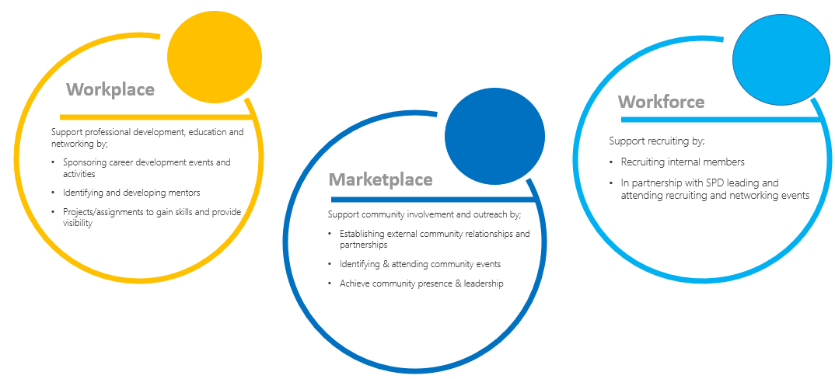
These recommended focus areas provide State employees with opportunities for:
- Enhancing their skills and becoming known within the state via work and initiatives;
- Mentoring and networking;
- Professional development.
- Getting Started
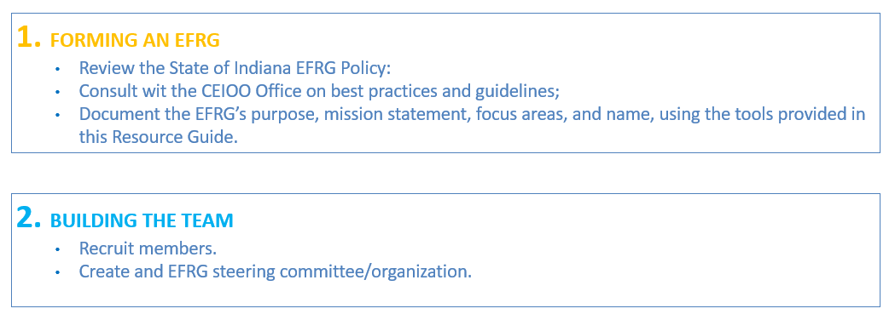
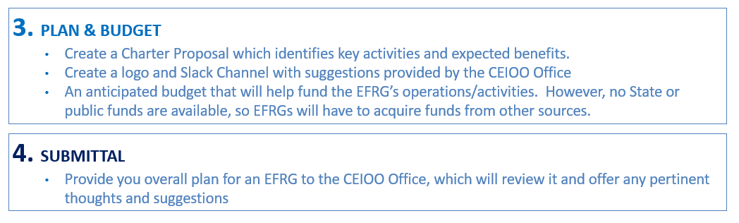
- Forming an EFRG
Leadership Structure
It is recommended that s have a Chair (or co-leaders), a Steering Committee, and at least 10 members.
It is also recommended that the Steering Committee consist of leadership roles in the areas of: (1) Operations; (2) Communications; and (3) Events & Initiatives. The EFRG members filling these roles can be chosen in a variety of way, such as through Steering Committee elections or appointment by the EFRG Chair.
EI&O Office  Available to offer thoughts, suggestions, and advice | EFRG Chair/s  Formal leader/s of the EFRG , responsible for leading the Steering Committee to create an aligned, actionable, and results-oriented plan for the year.
Operations Lead  Prepares and maintains the official documents of the and coordinates day-to-day operations. |  | Communications Lead  Develops the overall messaging for the. They also strategize and develop communications about the group’s events.
Events Lead
Oversees strategizing, developing, and implementing group events, including opportunities to collaborate with other EFRGs.

Election
This is for guidance purposes only, and each EFRG should decide what works best for their particular organization.
The first election at the start of an EFRG should be conducted, in good faith, by the individual who is the primary organizer of the EFRG, utilizing a fair, objective, and transparent process. The following presents and example of a possible election process that could be used by and EFRG.
Example process:
Announcement of the election will be emailed to all members of an EFRG at least four weeks prior to the date thereof. The announcement would indicate the offices/positions that are available and the rules to be followed for the election, which should include eligibility, offices/positions, responsibilities, and term (length of service). If there is only one name on the ballot for an office/position, the election should proceed and the person will be elected so long as they receive a majority of the votes that are cast. In the event of a vacancy, new elections for that office/position should be held no sooner than two weeks, nor later than eight weeks, after the vacancy occurs.
Once elected, leaders may serve for a term of two years, but may be re-elected for additional two-year terms. No leader should serve for more than six years in any particular office/position. To help ensure a smooth transition, any outgoing leader should serve in an advisory capacity for at least three months.
For any and all subsequent elections that occur after the initial election, it is suggested that the election process and its general timeframe follow the outline below:

- Operating and Sustaining an EFRG
Operating and sustaining an EFRG requires a high level of organization from the EFRG leadership group. To assist in your organization, below are some suggestions on how to conduct meetings efficiently and effectively.
Implementation of Charter:
- Recruiting, welcoming, and engaging members
- Communication and marketing of EFRG
- Measuring, tracking, and coordinating all group business activities and events
Reporting
- All EFRG leaders must provide quarterly reports to the CEIOO
Annual Planning & Review
- Review of previous year along with accomplishments
- Submitting annual action plans and goals to CEIOO
Succession Planning
- Succession planning of EFRG Leadership Team
- Orientation of new leaders

Meeting Management Tips for EFRG Leaders
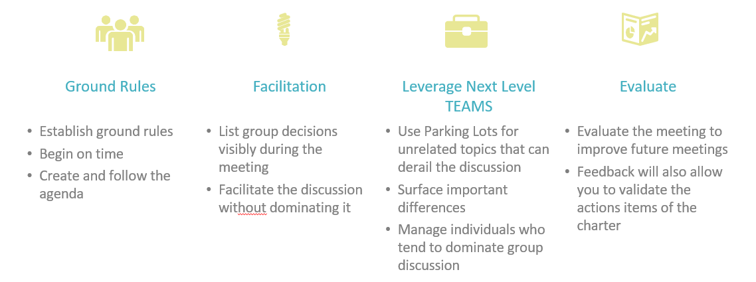

Establish Ground Rules

Begin on Time
Especially because the members of your EFRG are volunteering their time or may have only a limited time (for example, their lunch hour) to participate, it’s important to get the most out of everyone’s time, and respect beginning and ending times for meetings, whenever possible.
s should determine ground rules for how its members want to interact with each other during meetings. Ground rules help the group articulate the norms it is trying to build in terms of respect, timeliness, discussion, and decision-making. A sample list of ground rules is below.

I agree to:

- Arrive on time, whenever possible.
- Be prepared for our meeting.
- Welcome newcomers with warmth and enthusiasm.
- Share responsibility for following and enforcing these ground rules.
- Stick to the agenda.
- Listen respectfully and thoughtfully.
- Value my colleagues and openly express my appreciation of their contributions.
- Limit my comments to the issues at hand and avoid personal attacks.
- Avoid interrupting others, conducting side conversations, or taking phone calls.
- Not prematurely judge, criticize, or put down another person’s ideas.
- Use consensus/parliamentary procedures to make major decisions.
- Be open to surfacing differences in perspectives in a constructive manner.
- Be supportive when a decision is made within the.

CREATE AND FOLLOW AN AGENDA
An agenda will help the achieve its objectives and ensure important issues are discussed. Although it should be flexible enough to accommodate issues, it provides guidance in allocating time and meeting priorities. Establish approximate time allocations for each item and strive to stay on track, as much as possible.

FACILITATION

USE “PARKING LOT” FOR UNRELATED TOPICS THAT CAN DERAIL THE DISCUSSION
When topics come up that, although important, may derail the current discussion, place them on a flipchart for inclusion in a later part of the agenda, or for another meeting. This “parking lot” approach assures others that their ideas have been heard but keeps the discussion on track.

LIST GROUP DECISIONS VISIBLY DURING THE MEETING

Use a flipchart or white board to list decisions that the EFRG has made during the meeting. This keeps those decisions clear in everyone’s minds and keeps everyone on the same page.

FACILITATE THE DISCUSSION WITHOUT DOMINATING IT
leaders should spend more time listening and less time talking, to help ensure that other members feel that their perspectives are being heard. As an leader, it will be important to suspend judgment on others’ ideas prematurely to allow open discussion of those ideas.

Encourage all members to keep an open mind. Use active listening skills to facilitate the flow of ideas and perspectives instead of stifling them.

LEVERAGE NEXTLEVEL Teams

SURFACE IMPORTANT DIFFERENCES
When there are important differences in perspective between EFRG members, employ your conflict management skills to help uncover and resolve those differences. When important differences go underground, they can corrode morale and effectiveness.

MANAGE INDIVIDUALS WHO TEND TO DOMINATE GROUP DICUSSION
Ensure that everyone in the EFRG has an opportunity to participate by setting limits with participants who tend to be long-winded, interrupt others, or put down others and their ideas in a disrespectful manner. Establishing meeting ground rules can help set these limits. In some cases, however, you may need to confront a participant directly and constructively, either in the group or in a private setting.

Evaluate the Meeting to Improve Future Meetings

At the end of each EFRG meeting, ask the members to provide feedback on the meeting, either verbally or through a written evaluation sheet, or discuss the meeting with a few
EFRG members. This evaluation, whether formal or informal, helps you reflect on what went well or did not go well at the meeting, and how to improve group functioning for future meetings.

- EFRG Charter Example
Drafting a Charter
The Charter provides a framework for the EFRG Leadership Team to identify the purpose, principal activities, and expected benefits of the new EFRG. It should also state that membership is open to all interested employees of the State of Indiana who are committed to accomplishing the EFRG’s objectives.
Bylaws and Articles
Each EFRG should have bylaws and articles to help with organizational structure. A template is provided in the “Templates” section of this guide, to help assistss. The template does not have to be copied verbatim, but it is recommended that EFRG charter and bylaws should roughly follow this structure and include these substantive areas.
Mission Statement
Develop a mission statement outlining EFRG’s purpose, business, and values. It should be a concise statement of yours’s purpose, what it hopes to accomplish, and how it will go about doing so.
Purpose | What are the opportunities or needs that the EFRG will address?
Business | What will the EFRG do to address those needs?
Values | What principles and values will guide the EFRG?

Sample Mission Statements for EFRGs:
“The mission of the xxx Employee & Friends Resource Group is to build advocates and allies to create a better understanding of cultural awareness that will drive a more inclusive workplace and community.”
EFRG Charter Proposal Template
EFRG Chair
EFRG Proposed Name:
Mission Statement
Identify at least one goal or priority, and potential metrics and outcomes, that align to your chosen area(s) of focus, i.e. workplace, marketplace, workforce.

Workplace | Marketplace | Workforce
Support professional development, education and networking by;  - Sponsoring career development events and activities  - Identifying and developing mentors  - Projects/assignments to gain skills and provide visibility. | Support community involvement and outreach by;  - Establishing external community relationships and partnerships  - Identifying & attending community events  - Achieve community presence & leadership | Support recruiting by;  - Recruiting internal members  - In partnership with SPD, leading and attending recruiting and networking events

Focus Area(s) | Goals/Priorities | Metrics | Outcomes

Proposed first initiative or event
(How would you like to begin? How will you know that you have been successful?)

Suggested EFRG Structure:
Role |  | Name
Chair
Members
If applicable | Operations Lead
 | Communications Lead
 | Event Lead
 | (other)

- Roles and Responsibilities

Chair
Formal leader of the EFRG, responsible for leading the Steering Committee to create an aligned, actionable, and results-oriented plan for the year. The Chair should be responsible for the following:

- Work on succession planning for sustaining success
- Provide leadership to the EFRGs membership, including articulating goals and development of an annual action plan.
- Establish goals for the aligned to the focus areas of professional career development, building community, and recruitment.
- Mentor a new chair for six months prior to departure
- Meet with fellow leaders monthly to share best practices.

Steering Committee
Participating on an Steering Committee is a privilege for the State of Indiana’s employees, who are both passionate about the mission and vision of an and able to successfully meet the expectations of their roles as determined by the EFRG’s leadership.
In addition, participation on the Steering Committee, or in connection with an EFRG, must not interfere with the employee’s job for the State of Indiana. State employees serving on Steering Committees should be mindful that their roles in the EFRG should be performed on their own personal time.

Value Proposition:
- Increased visibility within the organization
- Insight into other business functions, departments, and agencies
- Opportunities to:
- Lead/partner on a relevant project, possibly in another business function;
- Experiment and learn in a safe and nurturing environment;
- Develop and apply skills like leadership, program management, organizational development, consulting, problem solving;
- Contribute toward measurable change at the State of Indiana.

Operations Lead
The Operations Lead prepares and maintains the official documents of the. The Operations Lead should be responsible for the following:
- Taking minutes at EFRG meetings.
- Taking notes and attendance during events and meetings.
- Keeping track of dates for the annual planning calendar.
- Creating and maintaining all records and lists for the in a central location. These lists include: Leader Team Roster, Steering Committee List, Membership
List and Metrics.

Communications Lead
The Communications Lead develops the overall messaging for the . They also strategize and develop communications about the group’s events, in conjunction with the leads for each particular event. Serves as relationship manager to ensure any necessary approvals and notices are provided. They do this by:
- Leading development of core messaging about the, and spearheading consensus on it from the Chair and Steering Committee Members.
- Facilitating communication within the.
- Maintaining sharepoint site, Slack channel, membership, and email list, and managing all communications.
- Identifying and providing input into other internal communications vehicles such as recruiting materials for EFRG messaging, social media, and marketing of activities.
- Developing a process for creation and approval of write-ups and marketing copy for -sponsored events.
- Drafting content for e-mail, print, and web communications.
- Streamlining quality, quantity, and timing of communications.
- Taking photography and/or securing photography at events.
- Sharing initiatives, accomplishments, events, and best practices across s.

Events Lead
The Events Lead oversees strategizing, developing, and implementing group events, including opportunities to collaborate across other EFRGs. Depending on the number of events in the EFRGs annual plans, there may be more than one person needed to serve in the role of Events Lead. Their responsibilities should include:
- Planning the event, including determining the event’s objectives, identifying KPIs and metrics for the event, scheduling of the event, and putting together a team to deliver the event
- Working with the Communications Lead on the communication plan for the event
- Post the delivery of the event, sharing the results and learnings from the event with the Steering Committee.

- EFRG Charter Proposal (Example One)
EFRG Proposed Name: | Indiana YPO
Mission Statement
Indiana YPO is focused on establishing a network for new hires and young professionals which fosters the State of Indiana’s growth and success through community involvement, personal empowerment, and professional development.
Our vision is to inspire every potential employee to join the State of Indiana’s team and every current team member to be proud to be advocates for the state.

Workplace | Marketplace | Workforce
Support professional development, education and networking by;  - Sponsoring career development events and activities  - Identifying and developing mentors  - Projects/assignments to gain skills and provide visibility. | Support community involvement and outreach by;  - Establishing external community relationships and partnerships  - Identifying & attending community events  - Achieve community presence & leadership | Support recruiting by;  - Recruiting internal members  - In partnership with SPD leading and attending recruiting and networking events

Identify at least one goal or priority, and potential metrics, that align to your chosen area(s) of focus.
Focus Area | Goals/Priorities | Metrics | Outcome
Workplace | - Developing young professionals and new hires at the State of Indiana to grow and advance their careers.  - Develop a State-wide network of young professionals and new employees which will facilitate greater communication across functions and create excitement for working at the State of Indiana. | - Number of attends at networking events.  - Survey satisfaction scores.  - Increase on Inclusion Index on Engagement survey. | - Employees are connecting and engaging with one another, to build their network and enhance contributions. Employees are advocates for the State of Indiana.  - Impact on retention rates.
Marketplace | - Identify, promote, and participate in positive, impactful and fun opportunities for Indiana YPO to make a difference in the community. | - Identification and engagement with local community.  - Number of Indiana YPO employees engaged.  - Level of contribution to community. | - Showcasing meaningful contributions.  - Increase positive State Employment recognition.  - Sending strong message to potential candidates.
Proposed first initiative or event
(How would you like to begin? How will you know that you have been successful?)
1. Engage with SPD to create a flyer for our that can be leveraged during New Hire Onboarding, to enroll new hires. Tracking new hire enrollment numbers will indicate impact of messaging.
2. As Indiana YPO EFRG, participate in Day of Giving. Share engagement with others and through State social media and newsletter to the extent permissible.

EFRG Structure:
Role | Name | Alias
Chair | Golden Eye | geye@fssa.in.gov
Operations Lead | Dr No | dno@doc.in.gov
Communications Lead | Gold Finger | gfinder@dwd.in.gov
Event Lead | Thunder Ball | tball@spd.in.gov

Charter Proposal (Example Two)
EFRG Proposed Name: | EMBRACE
EFRG Mission Statement
“The mission of the EMBRACE Employee Resource Group is to build advocates and allies to create a better understanding of cultural awareness to drive a more inclusive workplace and community.
EMBRACE is committed to creating a network for women and employees to connect, engage, and thrive across multiple groups and disciplines.

 | Workplace |  | Marketplace |  | Workforce
 | Support professional development, education and networking by;  - Sponsoring career development events and activities  - Identifying and developing mentors  - Projects/assignments to gain skills and provide visibility. |  | Support community involvement and outreach by;  - Establishing external community relationships and partnerships  - Identifying & attending community events  - Achieve community presence & leadership |  | Support recruiting by;  - Recruiting internal members  - In partnership with SPD leading and attending recruiting and networking events
Focus Area |  | Goals/Priorities |  | Metrics |  | Outcome
Workforce |  | Networking  Providing networking opportunities via book clubs and speaker series  Career Development  Provide career development workshops, focusing on professional branding, visibility, and work life balance.  Build Allies and Advocates program.  Create mentoring program. |  | - Number of attends at networking events and career development workshop.  - Survey satisfaction scores.  - Increase on Inclusion Index for the Engagement survey.  - Number or mentors signed up. |  | - Employees are connecting and engaging with one another, to build their network and enhance contributions.  - Impact on retention rates.
Proposed first initiative or event
(How would you like to begin? How will you know that you have been successful?
1. Select book for reading club, that is relevant to the topic of career development and work-life balance. After first meeting, share thoughts and areas for implementation. Engage and invite male advocates and respective leaders to solicit help and engagement in applying the learnings.
Impact: Better understanding amongst leaders of how they can contribute to creating an inclusive culture for all.
2. In partnership with SPD, research workshops available with a gender focus to cover branding, visibility, career development and growth.
Impact: Women professionals gain greater personal empowerment over their career. This impacts retention and creates advocates for FutureWorks.
Structure:
Role | Name | Alias
Chair | Cookie Monster | cmonster@doh.in.gov
Members of Steering Committee | Oscar  Miss Piggy  Kermit

- Bylaws and Articles¹

ARTICLE I: name
The name of this organization shall be " ."

ARTICLE II: VISION AND MISSION STATEMENT

ARTICLE III: MEMBERSHIP

Membership in is open to all employees of the State of Indiana who are committed to accomplishing the objectives of
. The following employees have expressed a desire to form and join our EFRG: [provide a list of at least 10 employees].

ARTICLE IV: STRUCTURE

[Insert the explanation of your proposed leadership structure. At a minimum, each EFRG shall have an Executive Chair to support, guide, and advocate the objectives of the organization. Other contemplated leadership positions should also be explained in this section and might include a Communications leader (who can create communications and plans to improve awareness of current and future activities as well as highlight important EFRG achievements), an Operations leader (responsible for tracking goal progress and internal and external event planning), and/or an Events leader (responsible for strategizing, developing, and implementing group events, including opportunities to collaborate across other EFRGs).]

ARTICLE V: MEETINGS

[Insert your plan for meetings. The language included is just a sample—you may alter.]

Regular general body meetings will be held quarterly, unless otherwise scheduled by the Executive Chair. Attendance shall be taken at meetings for the purpose of establishing active membership. A quorum shall be required for the conduct of business. A quorum is defined as at least one-half of the EFRG leaders and at least one-half of the active membership for general meetings. Active membership shall be established from previous general meeting attendance.

The procedure for voting at regular or leadership meetings shall follow general parliamentary procedure. A simple majority of votes of those present is required for all decisions. Timely communication (one week before the meeting) of agenda items will allow for each individual who cannot attend the meeting to submit input on agenda items before the voting procedures. EFRG leaders are responsible for keeping and maintaining meeting minutes.

