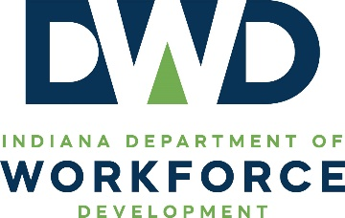
Request for Additional Workforce Education Initiative (WEI) Funding Adult Education

The Workforce Education Initiative (WEI) is a partnership between Indiana Adult Education and Hoosier employers to help employees retain jobs, improve performance, and advance in their professions. This form is to request additional funding to provide services to employers. It should be completed when an adult education provider has exhausted funding and needs additional resources to move forward.

- Who is the employer? What is the training? How will the training benefit employees? How many cohorts and students are expected? Where will the course(s) take place? What is the timeframe and how many hours a week (in-person and distance) are planned?

- What barriers to success do employees have on the job? Is the employer able to incentivize employee participation, and if so, what is the incentive?

- What additional costs are associated with this request? List expenses by category (examples include instructional (personnel) costs, equipment, materials and supplies, and technology).

Total Request $____________ Program _____________________________________________

_______________________________________ _______________________________________
Director of Adult Education Date Company Representative Date

Approved _______________________________________
Roy B. Melton |WEI Coordinator |Date

