Below is the brochure that we just sent out to the RV industry and I thought I would also send your way for any interest from the Army Credentialing Assistance Program. I would like to offer our veterans and their families the same pricing as I am offering to the RV industry folks, $275.00 for the course. This program will prepare a person for immediate employment in the RV industry at a Dealership or as a Mobile Technician. RVTI will assist in the placement of the veteran as well if he or she desires.
I hope you find this offering something that brings value to our veterans and their families.
Curt Hemmeler <chemmeler@rvti.org

Due to the overwhelming response to the first online session, the RV Technical Institute is offering a second opportunity to receive training for the only industry-wide certification. Enroll today in the RV Technical Institute Level 1 course and kick-start your path to becoming a Master Technician.

The RVTI Level 1 course covers the training to understand how to conduct pre-delivery inspectons (PDI) with a proven skill set to prepare an RV for customer delivery by verifying the operation of all components. The course will be held as an online Webinar via Zoom and will be conducted for 4 hours daily from 10am - noon and 1pm - 3pm ET. Hands-on labs will be demonstrated and it is expected that learners will perform these labs independently when class is not in session.

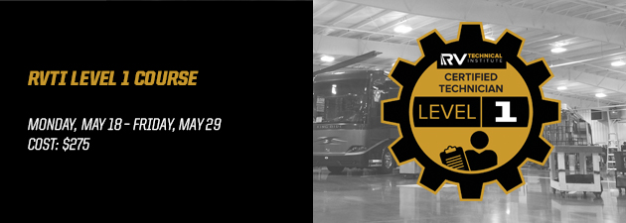

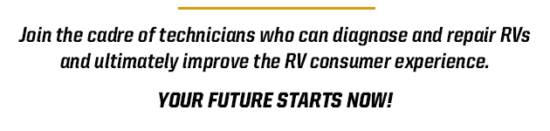

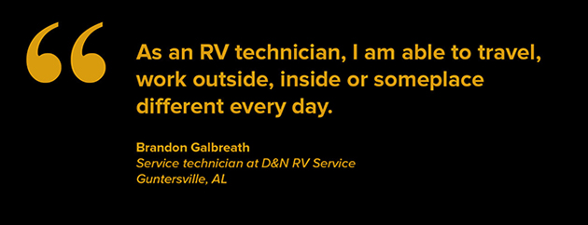

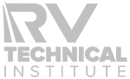
THIS EMAIL WAS SENT BY THE RV TECHNICAL INSTITUTE
3333 MIDDLEBURY ST., ELKHART, IN 46516 | RVTI.ORG
CLICK HERE TO UNSUBSCRIBE

