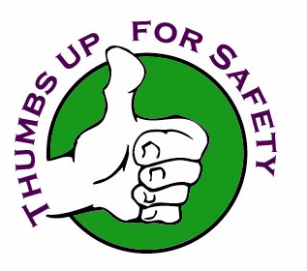
Top 10
CAUSES FOR INCIDENTS

PLEASE REMAIN ALERT & AWARE!

- Time pressure or constraint
- Distractive environment
- Heavy workload
- First time evolution
- First working day after days off from work
- 30 minutes after waking-up or meal time
- Vague, incorrect or improper guidance
- Over-confidence inducers
- Imprecise communications
- Work stress

