SCOPE OF SERVICES
SEDIMENT REMOVAL PLAN

LAKE AND RIVER ENHANCEMENT (LARE) PROGRAM
INDIANA DEPARTMENT OF NATURAL RESOURES
DIVISION OF FISH & WILDLIFE

I. Project Purposes:

The purposes of the Sediment Removal Plan are to:

- Map deposits of accumulated sediment and material at a minimum for the sites identified on aerial attached.

- Identify potential sediment disposal sites.

- Prioritize sites based on Sponsor and LARE staff inputs.

II. Project Tasks:

The scope of services outlined below should be considered a draft that is subject to revision prior to the final contract, based on discussion with the LARE project manager, sponsoring local organization regarding cost-effectiveness of proposed services.
- Contact information for the organization responsible for the project.

Provide appropriate contact information for the person(s) who will be the representative(s) for the project.

- Project location.

  - Provide the name of the affected lake, the county in which it’s located, the nearest town and any other pertinent georeferencing information. Record the 12 digit HUC (Hydrologic Unit Code). Record the location of proposed sediment removal and dewatering basins using Latitude and Longitude Coordinates expressed in decimal degrees, using NAD 1983 Datum and in UTM (Universal Transverse Mercator) Coordinates.

  - Provide a detailed map of the project locations on the lake.

- Public involvement. It is important that affected lake residents and lake users are included in the planning of the project.

  - Conduct a minimum of one public meeting discussing plan objectives, gathering comments and discussing additional potential dredging sites.

  - Describe how they have been notified of the potential project and the extent to which they have become involved in the planning process.

  - Include any meeting minutes or correspondence in plan.

- Narrative description of the targeted sediment deposit(s), its dimensions and volume, its composition and its origin.

  - Explain how the deposit’s dimensions were determined and how the volume was calculated.

  - Describe the sediment’s characteristics (e.g., primarily decomposing plant material vs. inorganic soil) and how they were determined.

  - Sediment deposits in lakes generally result from tributary inflows that have transported eroded soil from an upstream location. If the sediment was transported into the lake by a tributary stream, provide information about the stream. It is essential that the source of the deposit is identified and that measures are instituted to address the erosion.

  - If the tributary is a “regulated drain”, it will be necessary to provide information regarding cooperation between the project sponsor and the governmental entity responsible for maintenance of the drain. Indicate how and to what extent the drain’s regulating entity is involved in the proposed project.

Each site proposed for dredging will have its own project narrative similar to the example below:

    - Site ____will undergo maintenance dredging by removing sediment of an average depth of ___feet. A total of ____ cubic yards of accumulated material will be removed resulting in a finished water depth of ____feet. The sediment will be removed by _______ method and transported/pumped to an upland containment/basin area for dewatering. This project is partially funded by a grant from the Lake and River Enhancement Program.

- Mapping the lake bottom – contours before and after dredging.

  - Indicate the normal elevation of the lake’s water surface. Also include lake level at the time of sediment probing.

  - Provide a detailed scale drawing of the project site indicating current water depth and sediment thickness.

  - Include cross sections for each site similar to below; 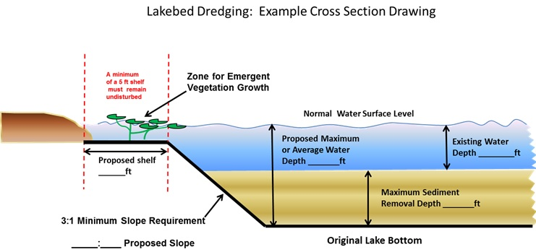

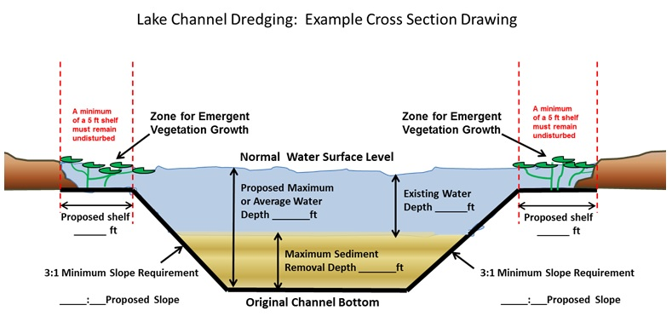

  - Provide the rationale for determining the depths to which excavation will occur.

  - A map indicating the location(s) of emergent plants present prior to dredging will be useful as a baseline for future monitoring.

- Chemical composition of sediment. It is important to know that there are no contaminants in the sediment that would preclude safe disposal of the material.

  - Describe how the sediment has been evaluated to determine its environmental suitability for disposal at whatever site has been chosen. At a minimum the following will be tested for: arsenic, barium, cadmium, chromium, lead, mercury, selenium and silver. If the area to be dredged is suspected to be impacted by petroleum products, such as a marina, total petroleum hydrocarbon test shall be completed.

- Land easements, ownership, leasing and availability. There is a need to know in advance that a disposal site(s) is available and that all necessary arrangements have been made to utilize the site(s). LARE funding will not be granted without an approved agreed-upon site for sediment disposal.

  - Describe what has occurred with respect to the acquisition of sediment disposal and dewatering site(s) and/or access to the property (ies).

  - Describe the status of any efforts to obtain easements, to lease or purchase property, etc.

- Equipment and method of excavation. There are different methods available for excavating sediments.

  - Describe how the selected dredging and disposal methods were evaluated to determine their suitability for the project.

  - Describe the equipment to be used and the sequence of events related to the actual dredging.

  - Explain what measures will be implemented to assure that the work will not adversely impact the lake.

- Contractor. It is essential that only qualified, experienced personnel perform sediment removal. This is to assure that a project does not cause unnecessary damage to the affected lake.

  - Explain the process that will be used to select a contractor(s) to perform the dredging and/or disposal site construction work.

  - Describe the process that will be used to monitor the project’s progress and assure its timely and proper completion.

- Disposal and/or dewatering.

  - Describe the manner in which the dredge spoil will be transported and disposed.

  - Include pumping distances from dredging sites to basin locations (if applicable).

  - Describe the type of disposal and dewatering facilities that will be required and their methods of construction. If dewatering of the dredge spoil will be necessary, explain how the characteristics of the sediment has been evaluated to determine the type/dimensions of settling/dewatering facility required.

  - Describe any special considerations such as the need for chemical flocculation, screening, etc.

  - Explain what temporary and permanent erosion control measures will be used at the facilities.

  - Describe how the sites will be restored when the dredging is completed, providing a description of final landscaping and stabilization measures for the site(s).

- Permits. Applications for sediment removal projects will not be considered for funding unless there are assurances that all necessary permits will be issued for the project.

  - Initiate permit discussion with Department of Natural Resources Division of Fish & Wildlife’s Lakes Permitting Biologist. Include all correspondence and comments in the plan.

  - Include any County or local permits or certifications that will be needed.

  - Describe the permits required for the proposed project, who will be responsible for preparation and submittal of all the permit applications.

- Construction schedule and sequence of work.

  - Provide an anticipated schedule for initiation and completion of the various project elements.

  - Indicate how the timing was determined.

- Cost.

  - Provide a detailed cost estimate for each individual site and for the various project elements and explain how the amounts were determined. These should specify mobilization costs, sediment removal costs (per cubic yard removed), and dewatering basin construction and closure expenses, as well as any final site restoration expenses.

  - Identify any costs associated with unusual physical and/or social aspects of the proposed project.

III. Data Presentation:

- Where practical, data should be presented clearly and concisely in the form of graphs and tables.

- Figures should be incorporated into the main body of the report and not presented as appendices at the end of the report. Whenever possible, figures should be limited to
8 1/2" x 11" in size. In most cases, large-scale maps and photos are not necessary.

- Present data in English unit. Example: 5 ft, cubic yards, and acres. Similarly, use common names for species with scientific names in parentheses or include a table with all common and scientific names used in the document.

- Raw data sheets need not be bound into each copy of the report. However, at a minimum, one set of all laboratory and field data sheets must be forwarded to the LARE project manager office to aid in the review of the draft report.

IV. Review Process:

- One digital copy (in either MS-Word© or Adobe PDF© format) of the draft report must be provided to the project sponsor. One digital copy of the draft report must be provided to the LARE project manager for review by the LARE staff

- To facilitate review of the draft report, a meeting between a representative of the project sponsor, consultant or contractor, LARE project manager, and other agency staff as needed may be held to discuss the review comments in conjunction with the final public meeting. The entire review process will be coordinated by LARE project manager and normally takes at least three weeks

- Upon addressing the review comments, one printed copy of the complete final report should be provided to the LARE project manager. In addition a digital copy of the full report. Two printed copies and one digital copy of the final report must also be provided to the project sponsor.

- Reports must be reproduced with two-sided pages for hard copies and as a single electronic file in MS-Word© or Adobe PDF© format, suitable for posting to the LARE website.

Follow these guidelines for digital copies:
- Digital file names must follow this protocol: Name Water Body Sediment Removal Plan Name County Month Year.pdf or .doc

- All digital copies must contain the complete digital copy of the full report including appendices, figures, maps and photos in either MS-Word© or Adobe PDF© format as a single digital file. Do not submit multiple files that need to be merged into one file for web posting.

