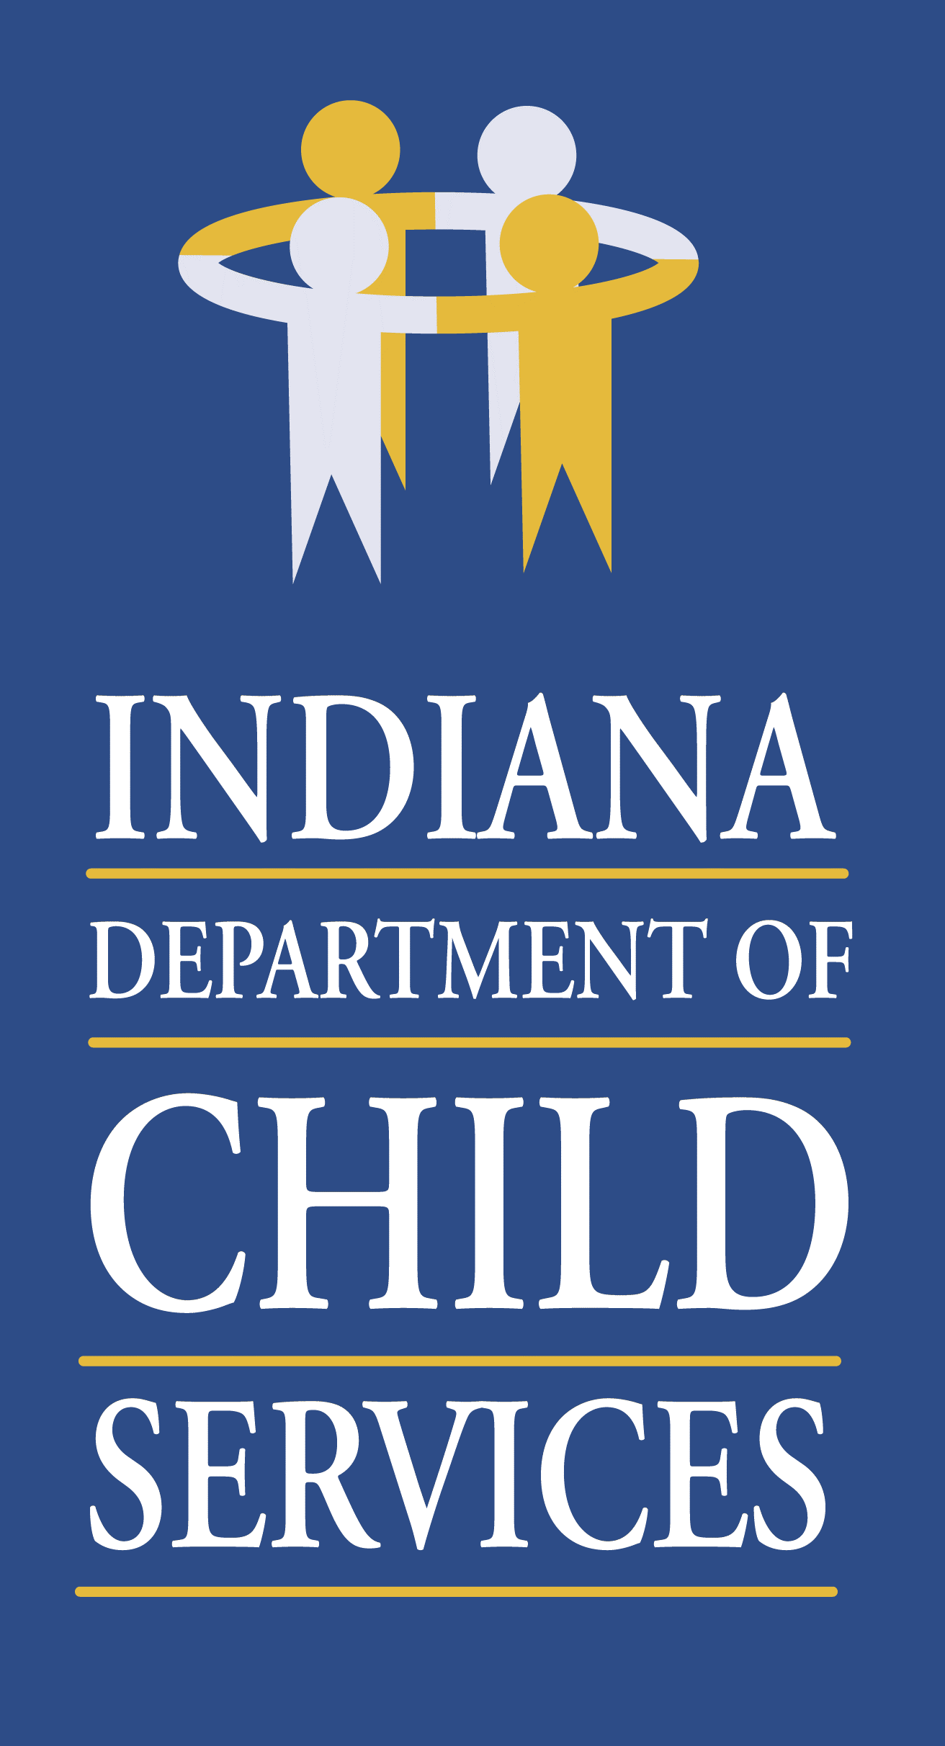
Regional Service Council Meeting Agenda
Region 3
Monday January 9th, 2023 @ 10:00 a.m.
St. Joseph County DCS Local Office
300 N. Dr. Martin Luther King Jr. Blvd., Ste 200
South Bend, IN 46601

- Welcome/Introduction of Members & Guests: Kathryn Stephenson, Regional Manager
- Review/Approval of Previous Meeting Minutes
- Community Partners Update: Christy Robbins, Program Administrator
- Service Update: Dion Smith, Regional Service Coordinator
- Regional Budget Update: Joni Tusing, Regional Financial Manager
- County Updates: Local Office DCS Directors
- Elkhart – Tamara Perkey
- Kosciusko – Sara Cole
- Marshall – Amanda Egger
- St. Joseph – Teresa Zornig

- Other Business:
  - none

- Adjourn

