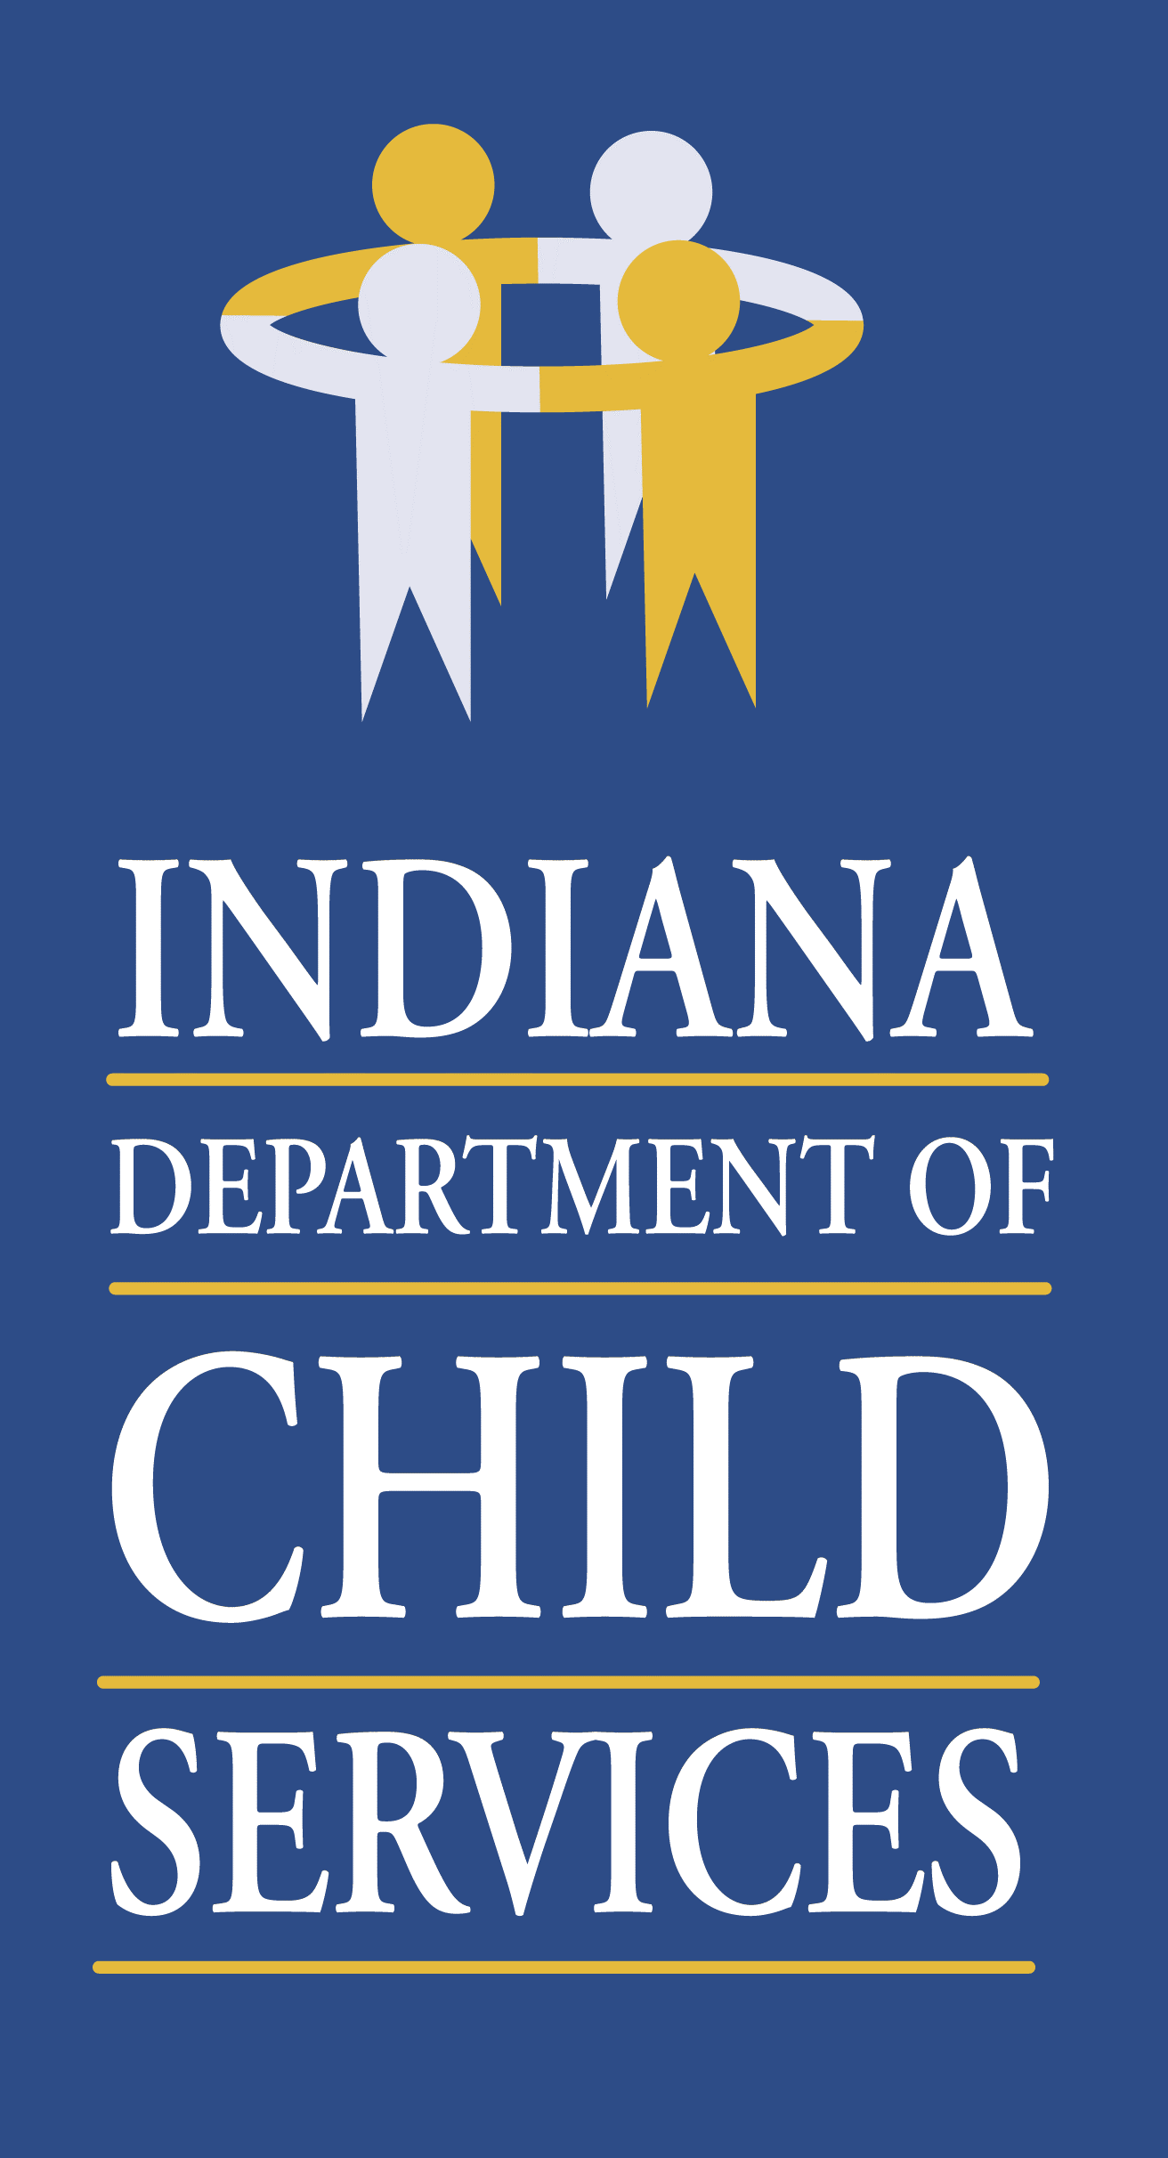
Regional Service Council Meeting Agenda- Region 3
Monday April 11th, 2022 @ 10:00 a.m.
Join Microsoft Teams Meeting
indiana@m.webex.com
Video Conference ID: 115 580 186 2
Or call in (audio only)
+1 317-552-1674,,109896475# United States, Indianapolis
Phone Conference ID: 109 896 475#

- Welcome/Introduction of Members & Guests: Kathryn Stephenson, Regional Manager
- Review/Approval of Previous Meeting Minutes
- Community Partners Update: Christy Roberts, Program Administrator
- Service Update: Dion Smith, Regional Service Coordinator
- Regional Budget Update: Joni Tusing, Regional Financial Manager
- County Updates: Local Office DCS Directors
- Elkhart – Tamara Perkey
- Kosciusko – Sara Cole
- Marshall – Amanda Egger
- St. Joseph – Teresa Zornig
Other Business:
N/A
- Adjourn

