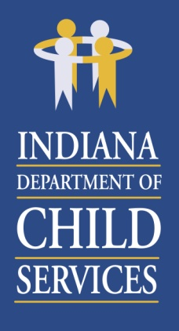
Region 14 Regional Services Council
May 19, 2020
8:30AM
Microsoft Teams Meeting

Agenda:

- Welcome & Introductions
- Approval of February 18, 2020 Minutes
- Preservation Services – Jason Nelson
- Regional Financial Status Report – Belinda Foreman
- Community Partners – Children’s Bureau
- Public Comment & Adjourn

Thank you for your continued commitment to the Regional Services Council.

Next RSC Meeting Scheduled:
August 18, 2020 beginning at 8:30am

Location:
Due to COVID19 our meeting location is yet to be determined

