## Vision clearance triangle

No building, structure, or improvement, including landscaping, shall be erected, placed, planted or maintained within a Vision Clearance Triangle (see below) so as to interfere with a vision clearance area; the vision clearance area is the area of space within a Vision Clearance Triangle between the heights of two and one half (2 ½) feet and twelve (12) feet above the crown of a street, driveway or alley. With the exception of official warning signs or signals necessary for public safety, a vision clearance triangle shall be established for all streets whether public or private, driveways, railroad crossings and alleys as prescribed in (A) through (D) below.

* + 1. Street/Road Intersection

Unless excluded elsewhere in this Ordinance, a property abutting a street/road intersection is subject to a vision clearance triangle. The vision clearance triangle is triangular shaped with two sides being formed by the street right-of-way lines and the third side being the line connecting points twenty-five (25) feet from the intersection of such street right-of-way lines, or in the case of a round or cut property corner, from the intersection of the street right-of-way lines extended. See Figure 3.1 (a) & (b) for examples

**Figure 3.1 (a) & (b) – Vision Clearance Triangle; Street & Road Intersections**



* + 1. Land adjacent to an at-grade railroad crossing

Unless excluded elsewhere in this Ordinance, land adjacent to an at-grade railroad crossing is subject to a vision clearance triangle. The vision clearance triangle is triangular shaped beginning at the point of intersection of the street/road right-of-way and the railroad right-of-way, then extending along each right-of-way line a distance of twenty-five (25) feet to two end points. The end points are then connected to create a third line thus establishing the vision clearance triangle. See Figure 3.2 for an example.

**Figure 3.2 – Vision Clearance Triangle; Adjacent to A Railroad Crossing**

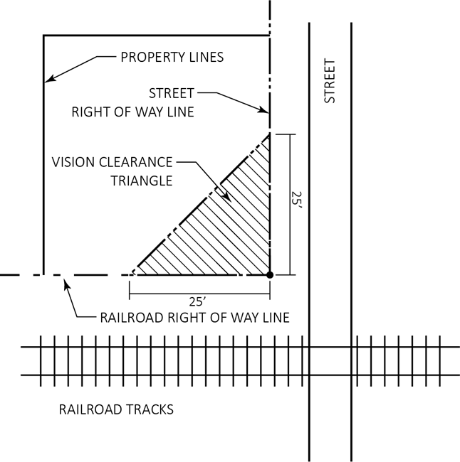

* + 1. Street/Road & Alley Intersections

Unless excluded elsewhere in this Ordinance, all street/road and alley intersections are subject to a vision clearance triangle. The vision clearance triangle is triangular shaped, one side of which is formed by the street right-of-way line, the second side of which is formed by the alley right-of-way line. The third side is formed by connecting the two points twenty-five (25) feet from the intersection of the two sides formed by the street/road and alley right-of-way sides.

See Figure 3.3 for an example.

