Student Success and Completion Committee Meeting
Guest Speakers | August 9, 2018

Cathy Day, Acting Chair and Associate Professor, Department of English
Prof. Cathy Day is the Acting Chair of English, one of the largest departments in the College of Sciences and Humanities. She’s the author of two books: Comeback Season and The Circus in Winter, a collection of linked stories about her hometown of Peru, Indiana. The Circus in Winter has been translated into German and Czech, was a finalist for the Story Prize, the Great Lakes Book Award, and the GLCA New Writers’ Award. She earned her B.A. in English at DePauw University and her M.F.A. in Creative Writing at the University of Alabama.

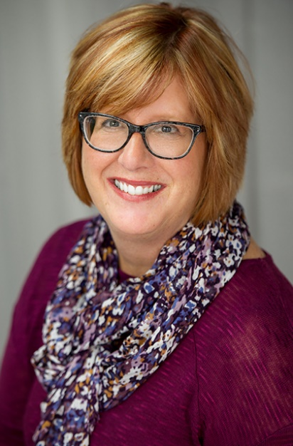
Dorothy Douglas, VP of Human Resources, Mutual Bank
Dorothy Douglas received the 2014 Indiana Chamber of Commerce/Ogletree Deakins Excellence in Human Resources Award and is a graduate of the rigorous 3-year program at the Graduate School of Banking, Madison, WI. She serves on Ball State University Human Resources Advisory Board; Indiana Bankers Association Human Resources Committee. She is a past president and board member of ECIHRA, and has served other community organizations such as Altrusa International of Muncie, Indiana, committee chair; Altrusa Foundation Board; United Way as a Loaned Executive, & Account Executive; YWCA Board; Sigma Sigma Sigma Alumnae, & Muncie Central High School Alumni Association.

Jim McAtee, Director of the Career Center
Jim leads a comprehensive career services office including Career and Professional Development, Employer Relations and Recruiting, KEY Careers (retention), On-Campus Student Employment, and Data -Operations -and Technology (D.O.T.T.) He served on two NACE committees, and his team earned the 2017 Career Services Excellence Award. With over 19 years of experience in the employment business including corporate and higher education, Jim has lead offices through periods of change and growth. He is the recipient of the 2012 and 2013 Excellence in MBA teaching award for leading a case based MBA course for executives and other working professionals. Jim is published in the summer 2012 edition of “Stepping up to Stepping Out: Helping Students Prepare for Life After College”, and has presented at NACE, SOACE, NCACE, and CDPI, and is the recipient of the 2017 MWACE President’s Award. Jim holds the Career Development Facilitator (C.D.F.) designation and earned his M.B.A. from East Carolina University in Greenville, NC.

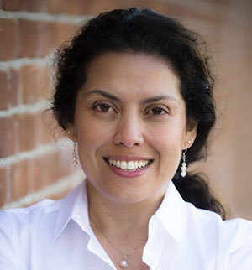
Dr. Susana Rivera-Mills, Provost and Executive Vice President for Academic Affairs
Susana Rivera-Mills became provost and executive vice president for academic affairs at Ball State University in July 2018. As provost, she oversees all aspects of our academic mission, including supporting leadership for all academic units. She plays a crucial role in the development and implementation of our strategic plan.
She brings extensive administrative experience, and her passion to connect universities to their communities, to Ball State. Susana’s goal is to create a learning environment where all students can access a high-quality education and succeed in order to reach their full potential.
Before coming to Ball State, she served as vice provost for academic programs and learning innovation at Oregon State University. There, she served in other key positions including dean of undergraduate studies and was professor of Spanish linguistics and diversity advancement.
As a first-generation college student, Susana understands the transformative power of education. She earned her bachelor’s in Spanish and a master’s in Spanish linguistics from the University of Iowa. Her doctorate is from the University of New Mexico. Susana’s research focuses on Latino communities, Spanish language and culture, issues in sociolinguistics, as well as online teaching and learning.
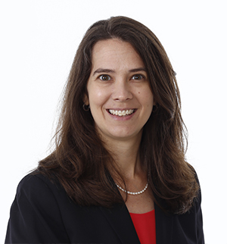
Dr. Jennifer R. Wies, Professor and Chair, Department of Anthropology
Jennifer R. Wies (Professor and Chair, Department of Anthropology, College of Sciences and Humanities) is an applied medical anthropologist dedicated to teaching and practicing anthropology. Her books and peer-reviewed publications focus on research and advocacy with victims of gender-based violence, families affected by incarceration, people with HIV/AIDS, and first-generation and marginalized higher education students. An important aspect of her anthropological practice is engaging students in service-learning experiences that apply anthropological insights and methods to social inequities. Jennifer serves as Treasurer and Executive Board member for the Society for Applied Anthropology and President-Elect for the Association for Feminist Anthropology.

