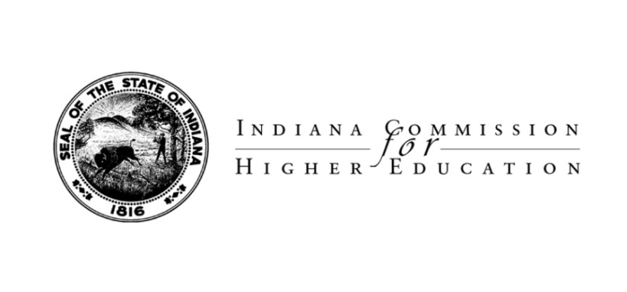

AGENDA

2011 Annual Faculty Leadership Conference

“Faculty Engagement toward Student Learning Outcomes”

Friday, April 29, 2011

8:00 a.m. Registration

9:00 a.m. Welcome and Introductions
Cynthia Baker, Faculty Commission Member
Indiana University School of Law - Indianapolis
Indiana University Purdue University Indianapolis

9:20 a.m. Keynote Address: Eliciting and Assessing Our Student’s Best Work
Carol Geary Schneider, President, Association of American Colleges & Universities

Dr. Schneider’s leadership of AAC&U and her work as one of four co-authors of the Degree Qualifications Profile (DP) have helped our nation’s faculty think about student learning outcomes. Both LEAP (Liberal Education – America’s Promise) and DPs present frameworks for defining quality in American higher education and for developing new capacity to better identify and assess student learning outcomes throughout postsecondary education. How should faculty respond? How should this impact teaching?

10:20 a.m. Break

10:30 a.m. Panel Discussion: Student Learning Outcomes in Indiana: A Response to
Dr. Schneider

Moderator – Cynthia Baker
Marianne Wokeck, Chancellor’s Professor of History; Co-Chair, History Discipline Team, Tuning Indiana Pilot, IUPUI
Elizabeth Mix, Associate Professor of Arts + Design, Butler University
Paul Hecht, Assistant Professor of English, Purdue University North Central

This panel will share perspectives from Indiana campuses about the challenges and opportunities presented by recent initiatives and proposals (e.g., DPs, LEAP, Tuning) related to student learning outcomes. What can we learn to help our students, our institutions, and our state? What best practices exist to improve teaching and learning and to assess student learning outcomes more effectively? What needs to change and what can be retained?

11:30 a.m. Supporting Student Learning Outcomes through Performance Funding and Student State Financial Aid Reform

Jason Dudich, Associate Commissioner and Chief Financial Officer

Commission for Higher Education

This will be an overview of the higher education performance funding formula’s seven metrics, including successful completion of courses; on-time graduation; increased graduation of low income students; and overall increases in degree production. He will also provide a legislative update on financial aid reform and its impact on student achievement.

12:00 p.m. Lunch – Ballroom

12:30 p.m. Luncheon Address
Teresa Lubbers, Commissioner, Commission for Higher Education

1:15 p.m. Statewide Transfer and Articulation Committee Update
Ken Sauer, Senior Associate Commissioner, Research and Academic Affairs
Commission for Higher Education
Kathy Tobin, Chair, Statewide Transfer and Articulation Committee
Ione Deollos, Incoming Chair, Statewide Transfer and Articulation Committee

Issues concerning credit mobility, such as dual credit and credit transfer, impact Indiana’s efforts to provide the best environment to help our college bound students earn their postsecondary degrees. This presentation will provide an update on the recent work of STAC and an opportunity to discuss how STAC can be a conduit or a barrier to improving student learning outcomes.

2:15 p.m. Raising the Bar or Changing the Bar?: The Next Generation of College Readiness Assessment
Allison Jones, Senior Fellow for Postsecondary Engagement, Achieve, Inc
Leader, Partnership for the Assessment of Readiness for College and Careers (PARCC)

Every state in the nation is working to improve its academic standards and assessments to ensure students graduate from high school with the knowledge and skills needed to be successful in college and careers. Indiana has continued its commitment to college- and career-readiness through the adoption of the Common Core State Standards (CCSS). The next step is assessing student learning of those standards by participating in the PARCC assessment consortium as a Governing State. This session will address the necessity of building and involving statewide cadres of postsecondary faculty leaders in the process of developing and implementing meaningful next-generation college- and career-ready assessments that will signal students are ready for success in entry-level postsecondary courses and careers.

3:00 p.m. Closing Remarks

Cynthia Baker

