GAI CONSULTANTS, Inc.
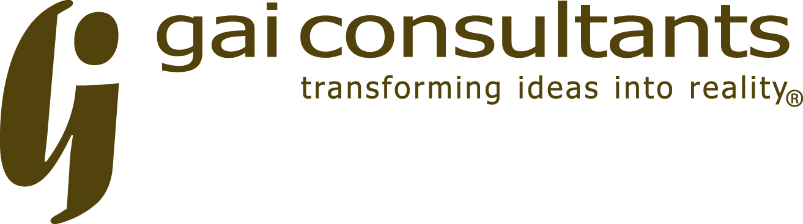
201 N. ILLINOIS St.
sUITE 1700
iNDIANAPOLIS, IN 46204
pHONE: (317) 570-6800
fAX: (317) 570-6810

To be assured that your comment will be included in the official project file, please forward to GAI Consultants, Inc. by September 19, 2020.

Hearing Date: September 04, 2020
Project: US-421 over South Fork Wildcat Creek Bridge Rehabilitation
Des. No.: 1593276

Name (please print):
Address:

Comments:

Signature:

