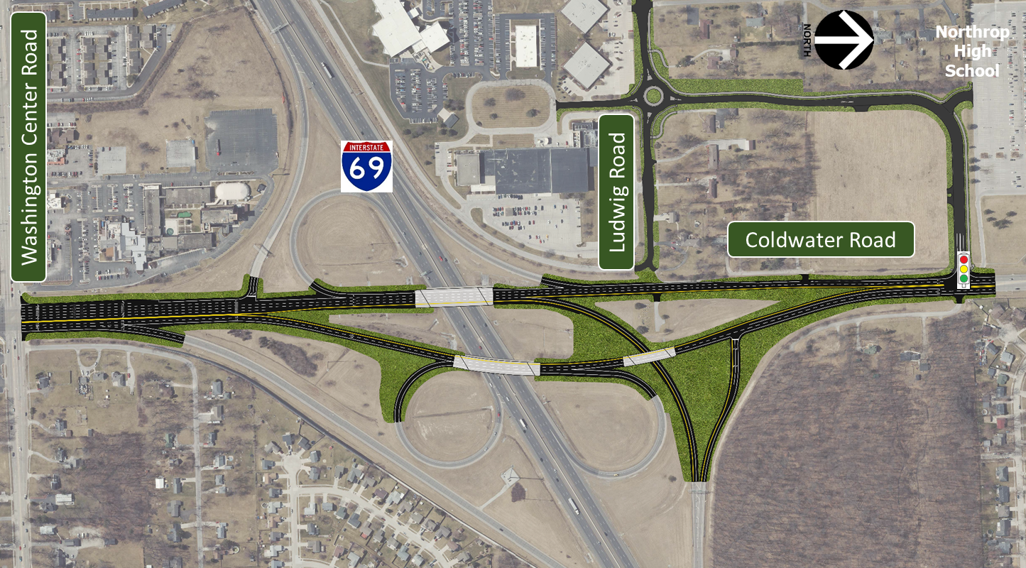

INDOT’s mission is to collaboratively plan, build, and maintain safe and innovative transportation infrastructure that enhances quality of life, drives economic growth, and accommodates new modes of transport.

https://www.in.gov/indot/2703.htm

855-463 -6848

[INDOT4U@indot.in.gov](mailto:INDOT4U@indot.in.gov)

**FOR MORE INFORMATION**

PROJECT NUMBERS:

1800036, 18000162, 1601991, 1901492, 1901493

PROJECT STATUS: In Design

ANTICIPATED CONSTRUCTION START: Spring 2022

ESTIMATED CONSTRUCTION COST: Approx. $11M

The purpose of this project is to address deteriorated pavement and bridge conditions located within the project limits, provide adequate vertical bridge clearance, and accommodate Ludwig Road alignment modifications being completed by the City of Fort Wayne. Proposed improvements include an HMA overlay – with potential full depth patching areas – from Washington Center Road to the new intersection of Oakbrook Parkway, realigning the off-ramp from SB I-69 to NB Coldwater Road, replacing the bridge that carries NB Coldwater Road over the SB I-69 to SB Coldwater Road ramp, and placing rigid concrete overlay and pier patching on both bridges carrying Coldwater Road over I-69.

During construction, Coldwater Road will be open to traffic with 2 lanes maintained in each direction throughout construction. SB I-69 ramps to NB & SB Coldwater Road will be closed during certain phases of construction. The inside and outside lanes on I-69 will be closed intermittently.

No right-or-way is anticipated in order to construct the proposed project improvements.

**PROJECT DETAILS**

**I-69 AT COLDWATER ROAD IN ALLEN COUNTY**

**DES. 1800036, 1800162, 1601991, 1901490, 1901491**