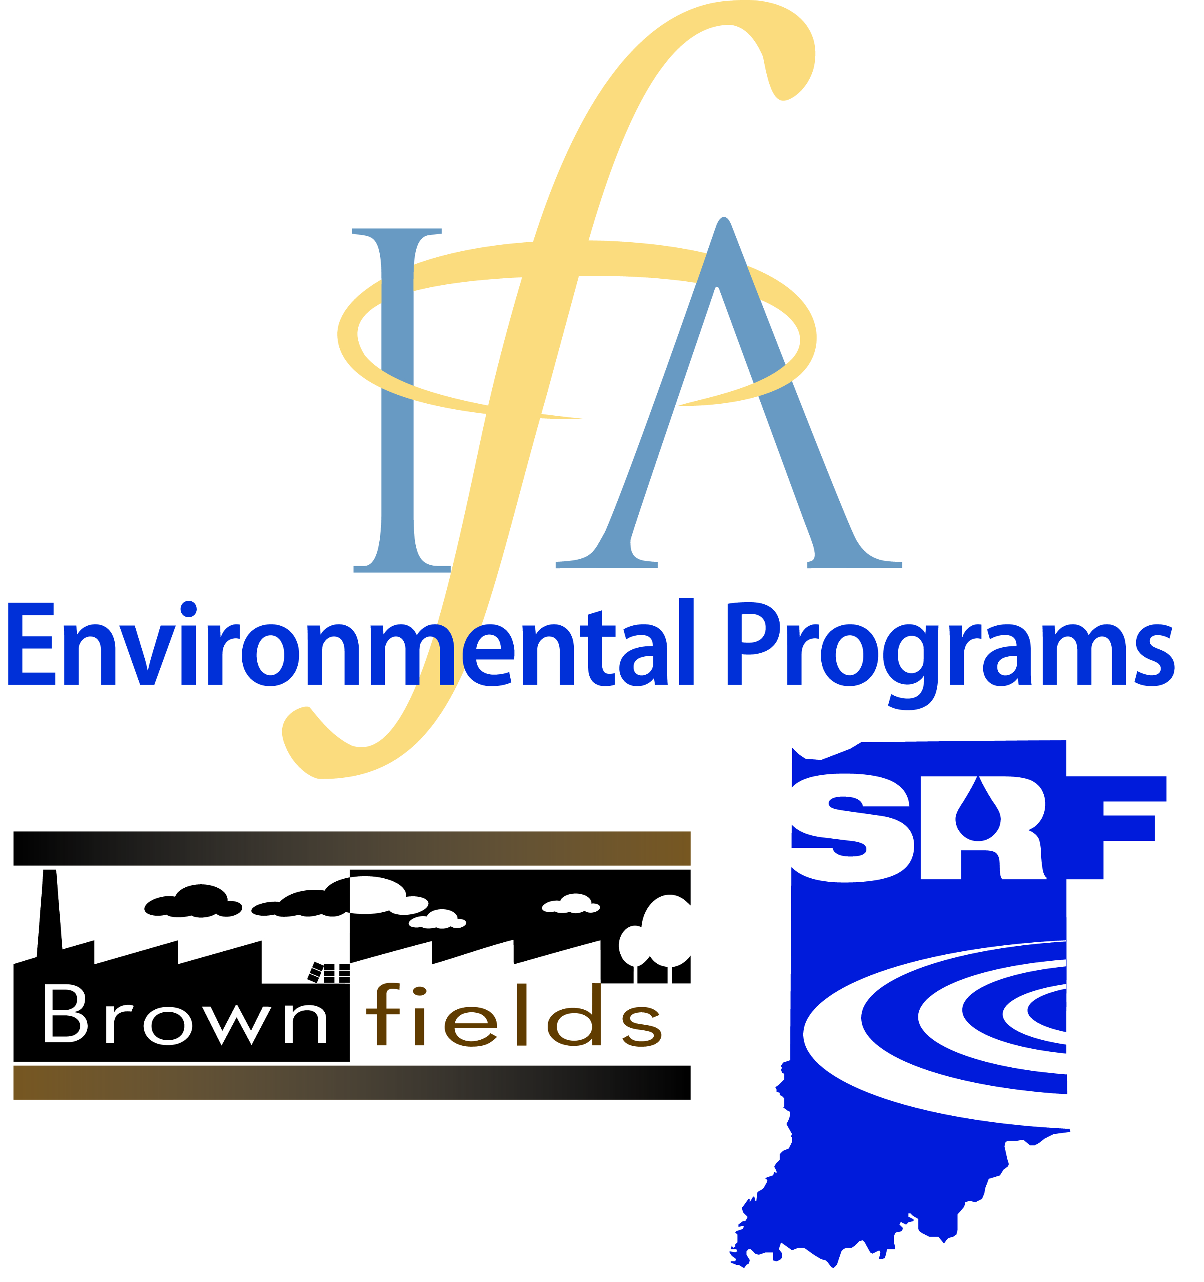
For immediate release
September 29, 2015

Contact: Jim McGoff, Director of Environmental Programs, (317) 232-2972, jmcgoff@ifa.in.gov
Silvia Perez, Project Manager, (317) 234-7701, sperez@ifa.in.gov

Indiana again awarded U.S. EPA grant funding for brownfield cleanup loans

INDIANAPOLIS, September 29, 2015— The U.S. Environmental Protection Agency (U.S. EPA) awarded an additional $500,000 in Hazardous Substances Brownfield Revolving Loan Fund (RLF) Supplemental loan funding to the Indiana Finance Authority (IFA) which will enhance the existing Indiana Brownfields Program (Program) RLF Incentive, a flexible, low-cost funding source for brownfield cleanup. This grant award is targeted for a loan to the City of Richmond (City) for remediation activities at the former Reid Memorial Hospital located at 1401 Chester Boulevard in Richmond (Site).
RLF funds enable grant recipients to provide loans and/or sub-grants to carry out cleanup activities at brownfield sites and often serve as critical gap financing to jump start the redevelopment process on a brownfield site. When these loans are repaid, the loan amount and any interest accrued is then returned to the fund and sub-granted or re-loaned to other borrowers, providing an ongoing source of capital for brownfield cleanup. This is the Program’s fifth supplemental RLF funding award in six years. Upon announcing the awards, Mathy Stanislaus, assistant administrator for U.S. EPA’s Office of Solid Waste and Emergency Response, noted that supplemental RLF funds are awarded to grantees, “who have already achieved success in their work to clean up and redevelop brownfields and… are some of the nation’s top performers.”
In response to the news of another award, Jim McGoff, Director of Environmental Programs for the IFA, remarked, “Brownfield redevelopment is a vital component to improving the economy, providing jobs, cleaning up neighborhoods and enhancing the quality of life for Indiana residents. Helping Indiana communities fund these efforts continues to be a challenge and a priority for the IFA. We appreciate U.S. EPA’s assistance, as it will enable the Program to continue its assistance to Indiana communities.”

Reid Memorial Hospital operated at the 1401 Chester Boulevard location from 1904 until 2008. The Site was sold in 2006 and the relocation of hospital operations completed in September 2008. Since 2006, Site ownership has changed hands several times and the City of Richmond now intends to acquire the abandoned, tax-delinquent, blighted Site for future redevelopment. The 6-parcel Site consists of approximately 74 acres with a main structure that has had numerous building additions. The City of Richmond has invested countless hours to address public concerns about the Site and thousands of dollars in maintenance of the Site, including mowing grass, securing the buildings, and addressing health and safety hazards. The City has committed a portion of the $6 million in funds estimated as necessary to demolish unsafe structures on the Site. The Program has utilized its U.S. EPA 128(a) funding to conduct site assessment work to investigate subsurface conditions and assess asbestos-containing materials posing a concern within Site buildings. Subsurface contamination detected at the Site includes arsenic, chromium, lead, thallium, Aroclor 1232, petroleum aromatic hydrocarbons, dioxin, lithium and radionuclides in soil and/or ground water.

Using RLF funds, the City is ready to begin the remediation activities required to prepare the Site for redevelopment, which will include an estimated $1 million or more in asbestos abatement. The Site is viewed as a potential asset for the community due to its close proximity to the City’s downtown core, adjacency to the east fork of the Whitewater River and proximity along US 27, where the Indiana Department of Transportation has a major project planned for 2016. With new sights set on Site redevelopment could come thousands of dollars in new tax revenue and hundreds of jobs for the community, as well as improved sight lines on a prominent thoroughfare in the City. The City of Richmond anticipates the economic and quality-of-life benefits from remediation and redevelopment of the former Reid Memorial Hospital will include eliminated human health and environmental hazards, improved neighborhood aesthetics, and new employment opportunities, which will promote economic growth in the surrounding community. Tony Foster II, Executive Director for the City of Richmond Department of Metropolitan Development, expressed, “The City of Richmond is excited to work with the Indiana Finance Authority Brownfields Program to clean up the former Reid Hospital property. We have been working with previous owners of the property and the Indiana Brownfields Program has been an asset to our efforts. We are excited to be able to begin cleanup at another brownfield site in Richmond.”

For information on how you can apply to obtain RLF loan funding for brownfield redevelopment, contact Michele Oertel, Federal Funding and Community Relations Coordinator for the Indiana Brownfields Program, at moertel@ifa.in.gov or (317) 234-0235.

About the Indiana Finance Authority (IFA):
The IFA’s mission is to oversee State-related debt issuance and provide efficient and effective financing solutions to facilitate state, local government and business investment in Indiana. On May 15, 2005, the IFA was established through consolidation of several previously independent debt-issuing entities including the Indiana Brownfields Program.

About the Indiana Brownfields Program:
The Indiana Brownfields Program, a part of IFA’s Environmental Programs, works in partnership with the U.S. EPA and other Indiana agencies to assist communities in making productive use of their brownfield properties. The Program’s mission is to encourage and assist investment in the redevelopment of brownfield properties by helping communities via educational, financial, technical, and legal assistance to identify and mitigate environmental barriers that impede local economic growth. For more information about the Indiana Brownfields Program, visit the IFA Web site at http://www.brownfields.in.gov .

