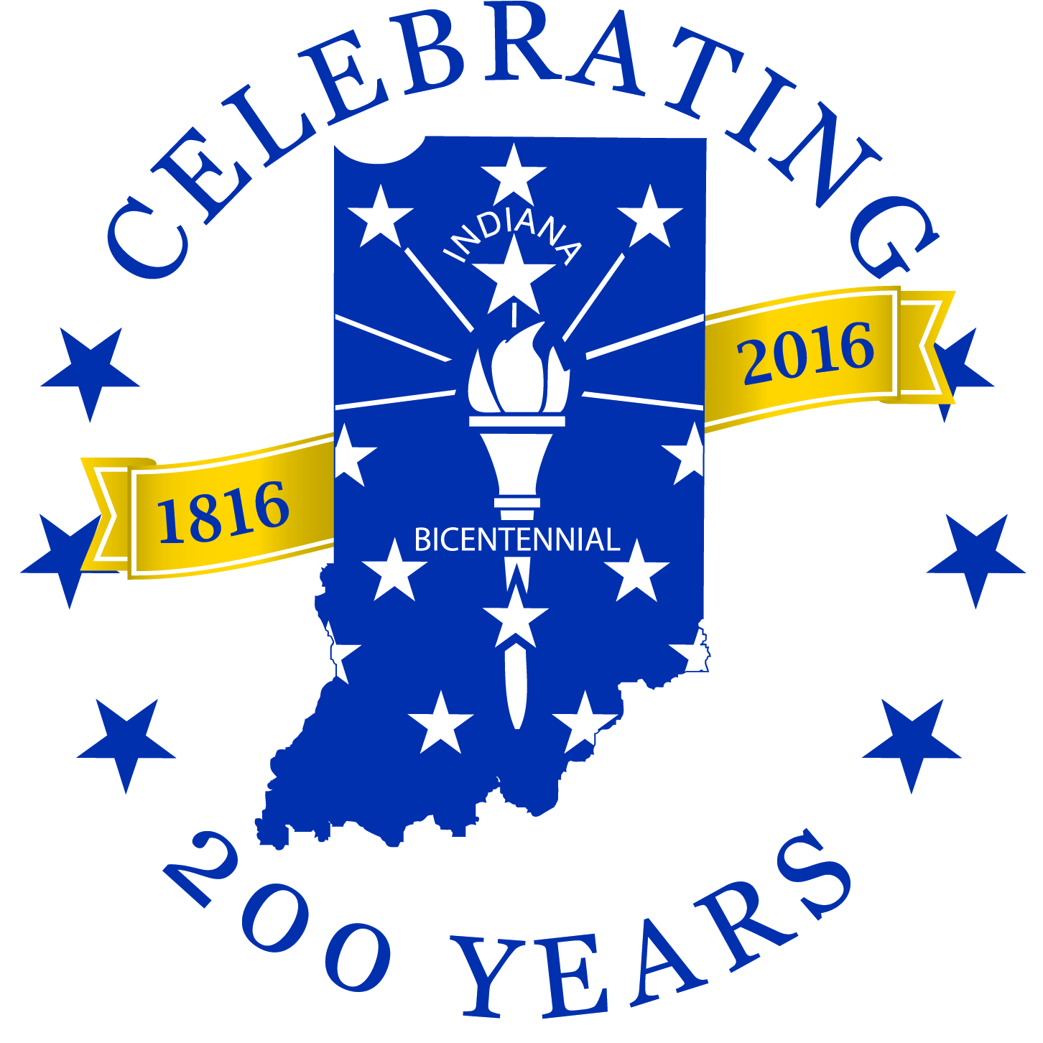
Celebrate history – Ignite the future
2016 Indiana Bicentennial Commission
Endorsement Committee
140 N. Senate AVE, Room 410
Indianapolis IN 46204
endorsements@indiana2016.in.gov
317-234-8686
Application for Endorsement of a Bicentennial Legacy Project

Thank you for your interest in becoming an endorsed project or program of the 2016 Indiana Bicentennial Commission! Indiana’s official 200th birthday is December 11, 2016, but the entire state will commemorate the bicentennial in the years leading up to and during 2016 and into the future.

Benefits of Endorsement
2016 Indiana Bicentennial Commission endorsed projects and programs receive:
- Listing on the 2016 Indiana Bicentennial website, www.indiana2016.org
- Permission to use the official 2016 Indiana Bicentennial logo, in accordance with the established logo guidelines, on Indiana Bicentennial related promotional materials
- Letter of endorsement from the 2016 Indiana Bicentennial Commission

Endorsement Criteria
To be considered for endorsement by the 2016 Indiana Bicentennial Commission, the applicant must demonstrate to the Commission’s satisfaction that the proposed project meets the following required criteria and at least one of the recommended goals or characteristics outlined below. Priority will be given to projects that meet multiple goals. The Commission reserves the right to refuse endorsement of a project or program.

All requests for endorsement must be submitted using State Form 55624, Application for Endorsement of a Bicentennial Legacy Project.

Projects or programs MUST be:
- Open and accessible to the public
- Relevant to Indiana and the state’s bicentennial
- Fundable (without Commission support)
- Achievable

Projects or programs must also meet at least one of the following recommended goals or characteristics:
- Culturally inclusive
- Creating a legacy for the future
- Celebratory
- Engaging and inspiring to youth and young adults

Exclusion Clause
Please note that the Indiana Bicentennial Commission will not consider endorsing the following:
- Individuals (i.e., candidates for public office)
- For-profit ventures (The Indiana Bicentennial Commission may consider entering into a licensing, program or partnership or sponsorship agreement for use of the Bicentennial logo. Please contact the Indiana Bicentennial Commission office for more information.)
- Political organizations

http://www.indiana2016.org/events-programs/programs/
APPLICATION FOR ENDORSEMENT OF A BICENTENNIAL LEGACY PROJECT
State Form 55624 (R2 / 12-15)
Note: Please save this form to your computer before filling it out.
Application and attachments may be submitted by e-mail at endorsements@indiana2016.in.gov.
Applicants will be considered based on submitted applications and any accompanying documentation.
Applications will be reviewed at the Bicentennial Commission meetings. Those dates can be found at www.in.gov/ibc/2362.htm.
You may contact Indiana Bicentennial Commission by e-mail at endorsements@indiana2016.in.gov or by telephone at (317) 234-8686.
SECTION 1 – PROPOSED PROJECT / PROGRAM INFORMATION
Suggested project title |  |  |  |  |  | County location of project
Target audience |  |  | Date(s) of implementation (month, year)  From: To:
SECTION 2 – APPLICANT CONTACT INFORMATION
Name of sponsoring organization |  |  |  | Website of organization
Type of organization
Non-profit Government / Municipal Educational Other
Name of contact person | Daytime telephone number  ( ) |  |  |  | E-mail address
Address (number and street) |  | City / Town |  |  |  |  | State  IN | ZIP code
SECTION 3 – FUNDING
I understand that if the proposed project / program is endorsed, it must be fundable without Indiana Bicentennial Commission support.
SECTION 4 – IMPLEMENTATION
This project / program is achievable due to the involvement of our community partners, staff, and volunteers.
List who will be participating and how.

Page 1 of 2
http://www.indiana2016.org/events-programs/programs/
SECTION 5 – PROJECT / PROGRAM DESCRIPTION
This project / program meets all requirements for endorsement as follows:

Write a brief description of the proposed project / program (75 to 100 words – 700 characters).
NOTE: This will be used on the 2016 bicentennial website www.indiana2016.org and in promotional materials. Please be sure it is accurate and descriptive.

SECTION 6 – THE SPECIFIC BENEFITS TO INDIANA’S 2016 BICENTENNIAL
Mark all that pertains to your project / program:
Culturally inclusive Creates a lasting legacy for Indiana’s future
Celebratory Engaging and inspiring to youth and young adults
Write a description (Maximum 300 words – 2,000 characters) how your project / program will be relevant to Indiana’s 2016 Bicentennial.
NOTE: Mention the bicentennial’s goals that your program meets.

SECTION 7 – LETTER OF SUPPORT
I have attached at least one (1) letter of support from partners.
SECTION 8 – ADDITIONAL MATERIALS
I have attached additional materials* deemed relevant for Endorsement Committee consideration.
* Submitted materials / documentations will not be returned.

Page 2 of 2
http://www.indiana2016.org/events-programs/programs/

