Rx Awareness Campaign Toolkit for Agencies & Organizations in Indiana

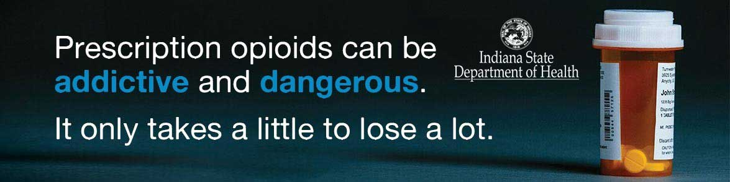

Created by the Indiana State Department of Health’s Division of Trauma and Injury Prevention
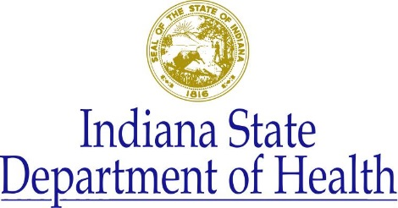
November 2017

Dear State and Local Agencies and Organizations,

Overdose deaths involving prescription opioids have quadrupled in the United States since 1999. This national epidemic is impacting Indiana as well, where more than 3,000 people have died due to prescription opioid overdose in the last 15 years. In fact, more Hoosiers die annually from prescription drug overdoses than from motor vehicle accidents. To address this public health crisis, the Indiana State Department of Health (ISDH) is taking part in the Centers for Disease Control and Prevention’s (CDC’s) Rx Awareness campaign.
The national campaign, designed to bring attention to the risks associated with prescription opioids, focuses on the dangers of these drugs, whether they are used for medical or nonmedical (recreational) purposes. Through a series of testimonials from people affected directly by prescription opioid overdose, the effort aims to increase awareness that prescription opioids can be addictive and dangerous and decrease the number of individuals who use opioids recreationally or overuse them.
Success of the Rx Awareness campaign relies on partnership with state and local agencies and organizations across the country to share the messages and resources. This is why ISDH is highly encouraging all such entities within Indiana to participate in this campaign. ISDH has developed a toolkit to condense the Rx Awareness campaign and make it easier to implement. This toolkit contains campaign materials including a press release, a newsletter article, website content, and social media posts that have been tailored to include Indiana-specific statistics and the ISDH logo. However, we leave it up to agencies such as local health departments to incorporate their own county-specific data and logos to the campaign materials if they so choose. If your agency or organization wants to incorporate more campaign material than what is included in this toolkit, we encourage you to explore more of the campaign at CDC.gov/RxAwareness. All campaign materials are available online for free.
In late November, ISDH hosted a webcast that explained the campaign, this toolkit, and how to tailor campaign materials using Stats Explorer for county-specific data. If you would like to view the webcast, please visit the ISDH videocenter webpage.

Thank you for your time and effort in communicating this important public health message.

Yours truly,
Indiana State Department of Health’s Division of Trauma and Injury Prevention

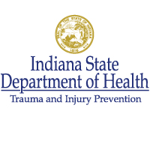

Table of Contents

- Press Release Template……………………………………………………………………………………………………………page 4
- Newsletter Template …………………………………………………………………………………………………………...…page 6
- Website Content ………………………………………………………………………………………………………………….….page 8
- Social Media Material – Facebook and Twitter……………………………………………………………………….page 11
- Additional Facebook and Twitter content……………………………………………………………………………….page 14

Press Release Template
Overdose deaths involving prescription opioids have quadrupled in the United States since 1999. This national epidemic has impacted Indiana as well, where more than 3,000 people have died due to prescription opioid overdose in the last 15 years. In fact, more Hoosiers die each year from prescription drug overdoses than they do from motor vehicle accidents. To address this public health crisis, the NAME OF AGENCY OR ORGANIZATION is now taking part in the Centers for Disease Control and Prevention’s (CDC’s) Rx Awareness campaign, designed to bring attention to the risks associated with prescription opioids.
Rx Awareness focuses on the dangers of prescription opioids, whether they are used for medical or nonmedical (recreational) purposes. Through a series of testimonials from people affected by prescription opioid overdose, the campaign aims to increase awareness that prescription opioids can be addictive and dangerous and strives to decrease the number of individuals who use opioids recreationally or overuse them.

To roll out the campaign in COUNTY NAME, the NAME OF AGENCY OR ORGANIZATION will disseminate information through digital and social media messaging.

Whether you are a healthcare provider, first responder, public health official or local resident, the opioid epidemic has likely impacted your community. Everyone has a role to play in helping end the opioid overdose epidemic—it starts with addressing prescription opioid misuse and overdose. Here are some things you can do:

- Learn more about prescription opioids to help those at risk for opioid use disorder and overdose in your community.
- Help those struggling with addiction find the right care and treatment. Anyone who takes prescription opioids can become addicted, and help is available if you or someone you know is battling opioid use disorder.
- Spread the word and increase awareness in your community about the risks and dangers of prescription opioids.

{Insert the Rx Awareness campaign video located below}

Youtube:
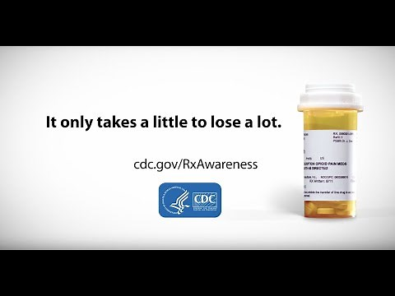

Mp4 file:

Located on the ISDH webpage and available for download.
Learn more
- Learn more about the Rx Awareness campaign.
- Learn about what Indiana is doing to combat the prescription opioid crisis.
- Learn what the CDC is doing to combat the crisis.

Newsletter Template
Title: CDC launches "Rx Awareness" campaign to raise opioid overdose awareness
Overdose deaths involving prescription opioids have quadrupled in the United States since 1999. This national epidemic has impacted Indiana as well, where more than 3,000 people have died due to prescription opioid overdose in the last 15 years. In fact, more Hoosiers die each year from prescription drug overdoses than they do from motor vehicle accidents. To address this public health crisis, the NAME OF AGENCY OR ORGANIZATION is now taking part in the Centers for Disease Control and Prevention’s (CDC’s) Rx Awareness campaign, designed to bring attention to the risks associated with prescription opioids.
Rx Awareness focuses on the dangers of prescription opioids, whether they are used for medical or nonmedical (recreational) purposes. Through a series of testimonials from people affected by prescription opioid overdose, the campaign aims to increase awareness that prescription opioids can be addictive and dangerous and strives to decrease the number of individuals who use opioids recreationally or overuse them.

To roll out the campaign in COUNTY NAME, the NAME OF AGENCY OR ORGANIZATION will disseminate information through digital and social media messaging.

Take Action and Help
Whether you are a healthcare provider, first responder, law enforcement officer, public health official or local resident, the opioid epidemic is likely affecting you and your community. No matter who you are, you can take action to end the opioid overdose epidemic. We all have a role to play on the frontlines of this fight—it starts with addressing prescription opioid misuse and overdose.

What can you do?

- Avoid taking prescription painkillers more often than prescribed.
- Dispose of medications properly, as soon as the course of treatment is done. Avoid keeping prescription painkillers or sedatives around "just in case."
- Help prevent misuse by not selling or sharing prescription drugs. Never use another person's prescription drugs.
- Learn more about prescription opioids, and spread the word to increase awareness in your community about the risks and dangers.
- Help those struggling with addiction find the right care and treatment. Start by calling the Indiana Addiction Hotline at 1-800-662-HELP (4357). If you have questions about medicines, call Poison Help at 1-800-222-1222.

For more information about the campaign, visit IN.gov/isdh/27679.htm.

{Insert images below as part of the newsletter}:

With ISDH logo:
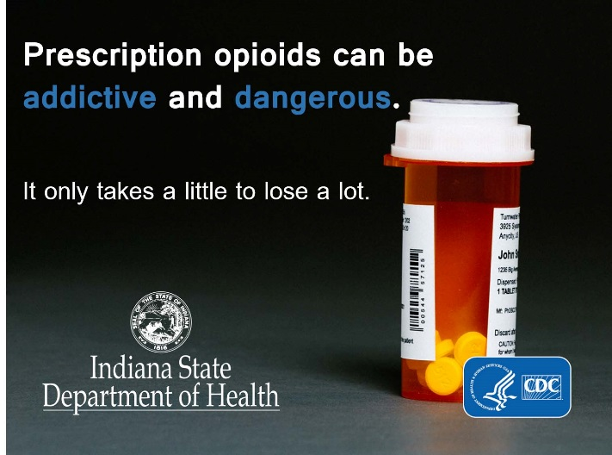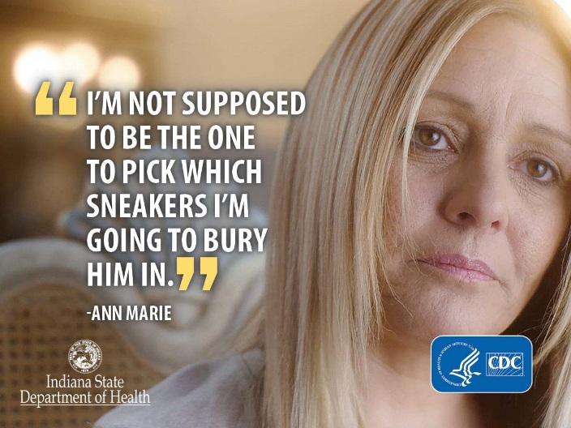

Without ISDH logo:
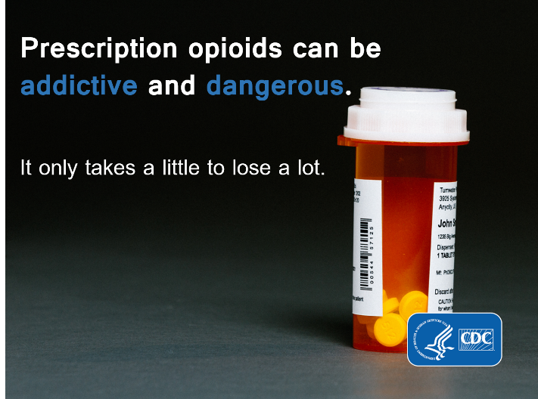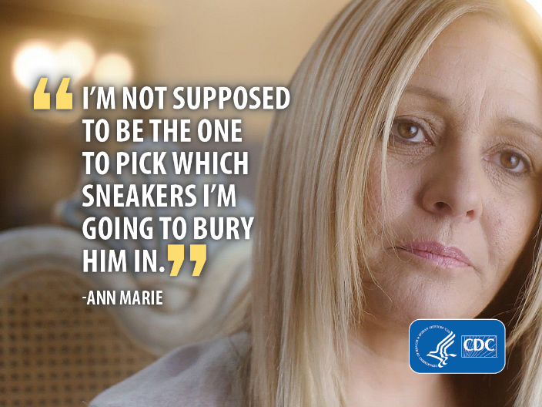

Website Content

Image to include on website (with ISDH logo):

Without ISDH logo:
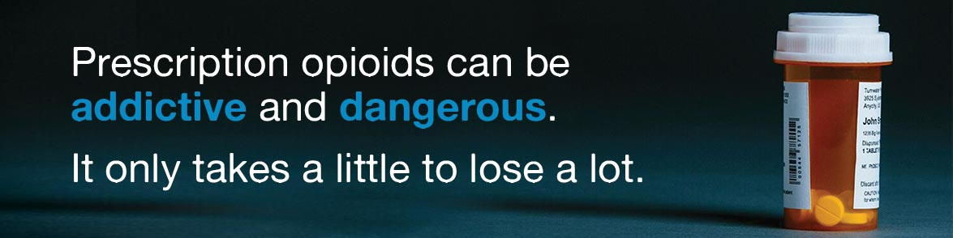

Website Text
What you need to know:
- Most opioids are prescription medications used to treat pain.
- Opioids are highly addictive.
- Opioid addiction and overdose is a growing problem both nationally and within the state of Indiana.
- There are other effective ways to deal with pain.
- Opioid use at a young age increases the potential for addiction later in life.
- Prescribers play a role in the supply and use of opioids in our communities.
About the campaign
Overdose deaths involving prescription opioids in the United States have quadrupled since 1999. This national epidemic is impacting Indiana as well, where more than 3,000 people have died due to prescription opioid overdose in the last 15 years. In fact, more Hoosiers die each year from prescription drug overdoses than from motor vehicle accidents. To address this public health crisis, the NAME OF AGENCY OR ORGANIZATION is taking part in the Centers for Disease Control and Prevention’s (CDC’s) Rx Awareness campaign.

The Rx Awareness campaign tells the real stories of people whose lives were devastated by prescription opioids. The ultimate goal is to increase awareness that prescription opioids can be addictive and dangerous. This effort also strives to decrease the number of individuals who use opioids recreationally or overuse them.

Campaign materials
Watch the videos below to hear personal testimonials from people directly affected by the opioid overdose epidemic.

Devin:
Devin shares his Rx Awareness story of using prescription opioids after a minor surgery as a teenager and his path to recovery from opioid use disorder.

{Insert the video below}
YouTube:
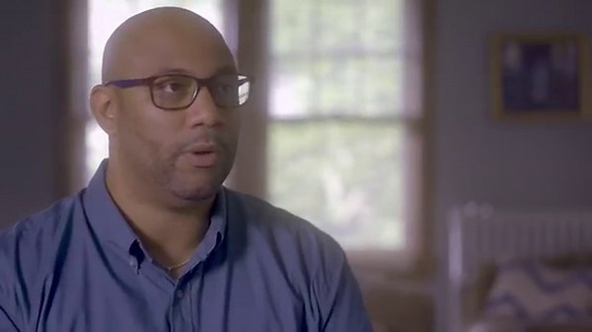
Mp4 file:

Located on the ISDH webpage and available for download.

Anne Marie:
Ann Marie is a mother who lost her 22-year-old son, Chris, to a prescription opioid overdose.

{Insert the video below}
YouTube:
Mp4 file:

Located on the ISDH webpage and available for download.

Mike:
Mike became addicted to a prescription opioid. He ended up leaving school and no longer playing college sports. At the time he “didn’t understand the dangers of the drug and was addicted after a matter of months.”

{Insert the video below}
YouTube:
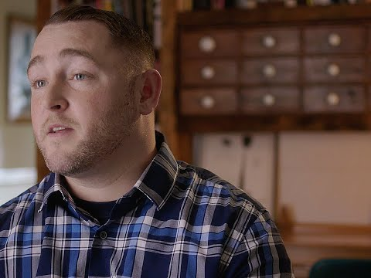

Mp4 file:

Located on the ISDH webpage and available for download.

Ask yourself, “Do I really need this?”

If you are prescribed opioids, talk with your doctor about the risks, including addiction and overdose.

Take action and help
Whether you are a healthcare provider, first responder, law enforcement officer, public health official, or area resident, the opioid epidemic is likely affecting you and your community. No matter who you are, you can take action to end the opioid overdose epidemic. We all have a role to play on the frontlines of this fight—it starts with addressing prescription opioid misuse and overdose.

- Avoid taking prescription painkillers more often than prescribed.
- Dispose of medications properly, as soon as the course of treatment is done. Avoid keeping prescription painkillers or sedatives around "just in case."
- Help prevent misuse by not selling or sharing prescription drugs. Never use another person's prescription drugs.
- Learn more about prescription opioids, and spread the word to increase awareness in your community about the risks and dangers.
- Help those struggling with addiction find the right care and treatment. Start by calling the Indiana Addiction Hotline at 1-800-662-HELP (4357). If you have questions about medicines, call Poison Help at 1-800-222-1222.

Learn more
- View more of CDC’s Rx Awareness campaign.
- Learn what Indiana is doing to combat the prescription opioid crisis.
- Learn what the CDC is doing to combat the crisis.
- Access addiction services.
Social Media Material – Facebook and Twitter
Each of the images/videos below has accompanying Facebook and Twitter captions.
1. General image

Facebook caption: Every day in the United States, more than 1,000 people are treated in emergency departments for misusing prescription opioids. More than 40 people die from prescription opioid overdoses. To address this national public health crisis, the NAME OF AGENCY OR ORGANIZATION is taking part in the Centers for Disease Control and Prevention’s (CDC’s) Rx Awareness campaign, designed to bring attention to the risks associated with prescription opioids. Learn more about the campaign at IN.gov/isdh/27679.htm.

Twitter caption: Help the NAME OF AGENCY OR ORGANIZATION bring attention to the prescription opioid crisis. Learn more about CDC’s #RxAwareness campaign at IN.gov/isdh/27679.htm.

2. General image
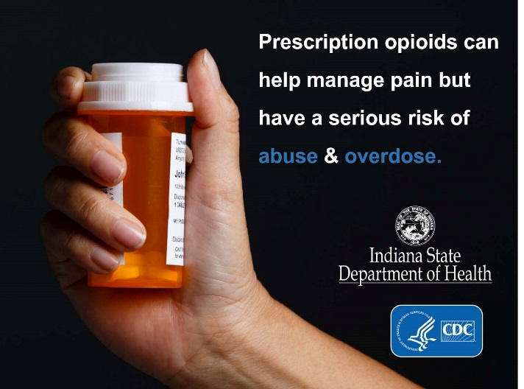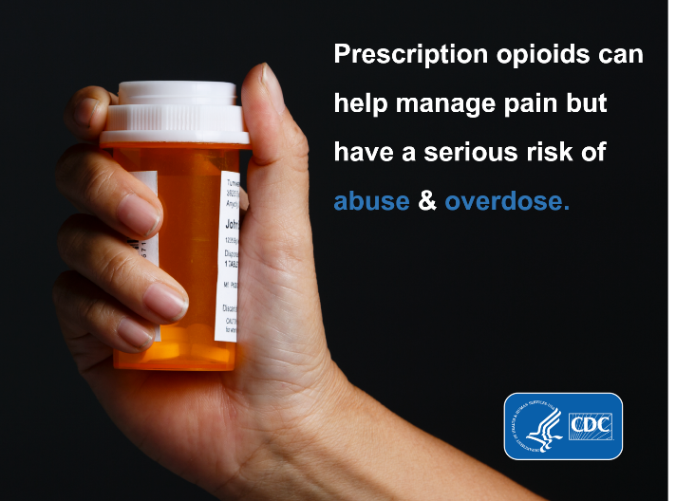

Facebook caption: Prescription opioids killed 488 Hoosiers in 2016. Together, we can stop this growing trend and keep friends and family safe. Learn how at IN.gov/recovery #RxAwareness

Twitter caption: Prescription opioids killed 488 Hoosiers in 2016. Together, we can stop this growing trend. Learn how at IN.gov/recovery #RxAwareness
3. Ann Marie’s story

Facebook caption: She never expected she’d lose her son to prescription opioid overdose. Hear Ann Marie’s story at CDC.gov/RxAwareness. What’s your prescription opioid story? #RxAwareness

Twitter caption: She never expected she’d lose her son to prescription opioid overdose. What’s your prescription opioid story? #RxAwareness

- Mike’s story

Facebook caption: Mike watched his life slip away from addiction to prescription opioids. Hear more about his journey at CDC.gov/RxAwareness. What’s your prescription opioid story? #RxAwareness

Twitter caption: Mike watched his life slip away from addiction to prescription opioids. What’s your prescription opioid story? #RxAwareness

5. Devin’s story
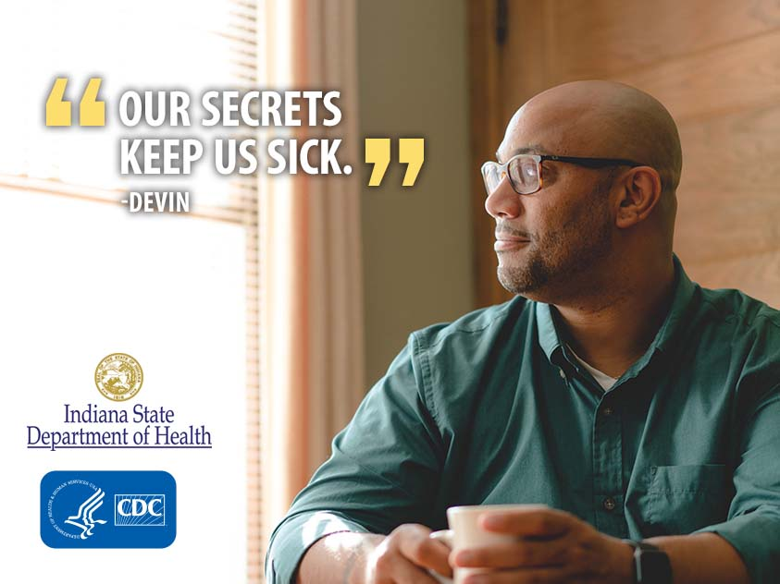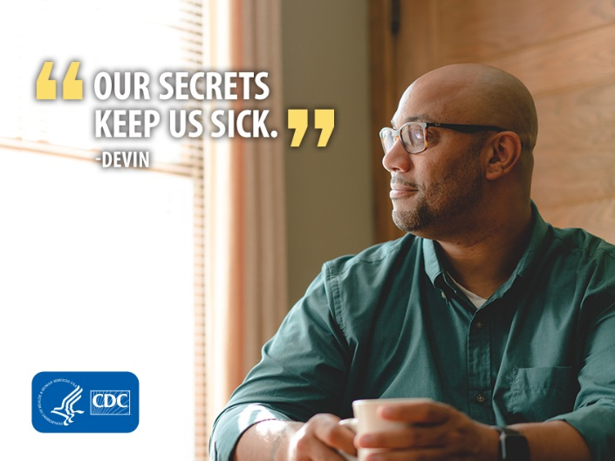

Facebook caption: Devin’s addiction to prescription opioids began with a minor surgery at age 16. Learn more about the dangers of prescription opioids at CDC.gov/RxAwareness. #RxAwareness

Twitter caption: “I got a 30-day prescription. I took them all in three days.” Hear Devin’s #RxAwareness story at CDC.gov/RxAwareness

Additional Facebook posts without images/videos:
- Prescription opioids have serious risks of misuse and overdose. Learn what Indiana is doing to help reduce these risks in our communities. #RxAwareness IN.gov/recovery.
- #RxAwareness starts with you. Tell others how prescription opioids have affected you. Learn more at CDC.gov/RxAwareness.
- Can you guess which of the below statistics is true?
- The number of prescription opioids now sold in the U.S. is four times greater than the number sold in 1999.
- Despite the increase in prescriptions, there is no significant change in the amount of pain that patients report.
- At least one half of all opioid overdose deaths involve a prescription opioid.
Answer: All of the above. Opioid overdose is a national public health epidemic, and it’s affecting your community. Find out what you can do to help combat the crisis at IN.gov/recovery.

Additional Tweets without images/videos:
- It only takes a little to lose a lot. What’s your prescription #opioid story? #RxAwareness CDC.gov/RxAwareness
- #RxAwareness starts with you. Tell others how prescription #opioids have affected you. CDC.gov/RxAwareness
- Prescription #opioids can be addictive and dangerous. Learn more at IN.gov/isdh/27679.htm. #RxAwareness
- Know the risks associated with prescription #opioids. Talk to your doctor for #RxAwareness.
- Prescription #opioids can help manage pain but have a serious risk of misuse & overdose. IN.gov/isdh/27679.htm. #RxAwareness
- 4 out of 5 new heroin users are former misusers of prescription opioids. Know the risks associated with prescription opioids. #RxAwareness
- Learn what you can do to combat the prescription opioid crisis in your community at IN.gov/isdh/27679.htm. #RxAwareness

