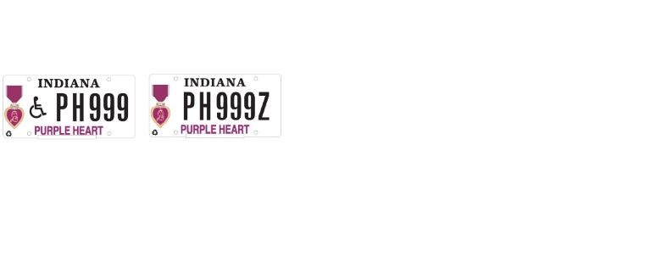

Dear Veteran,

Your application for a Purple Heart / Disabled Purple Heart license plate has been approved.
This entitles you to display the Purple Heart / Disabled Purple Heart license plate for one, or more of your vehicles.
The Purple Heart / Disabled Purple Heart license plate allows the Purple Heart recipient free parking at legal metered spaces in Indiana. (This may not be true in other states).
Only the eligible veteran is entitled to this free parking privilege within Indiana.
The Disabled Purple Heart license plate has the universal handicap symbol. Those with Disabled Purple Heart license plates can park in a designated handicap parking space nationwide.

Please take the approved, stamped application to your local License Branch for further processing. Should you have any questions concerning this matter, do not hesitate to contact us at our toll-free number, 1-800-400-4520 or contact your local County Veteran Service Officer.

Thank you for your service,

Indiana Department of Veterans’ Affairs

