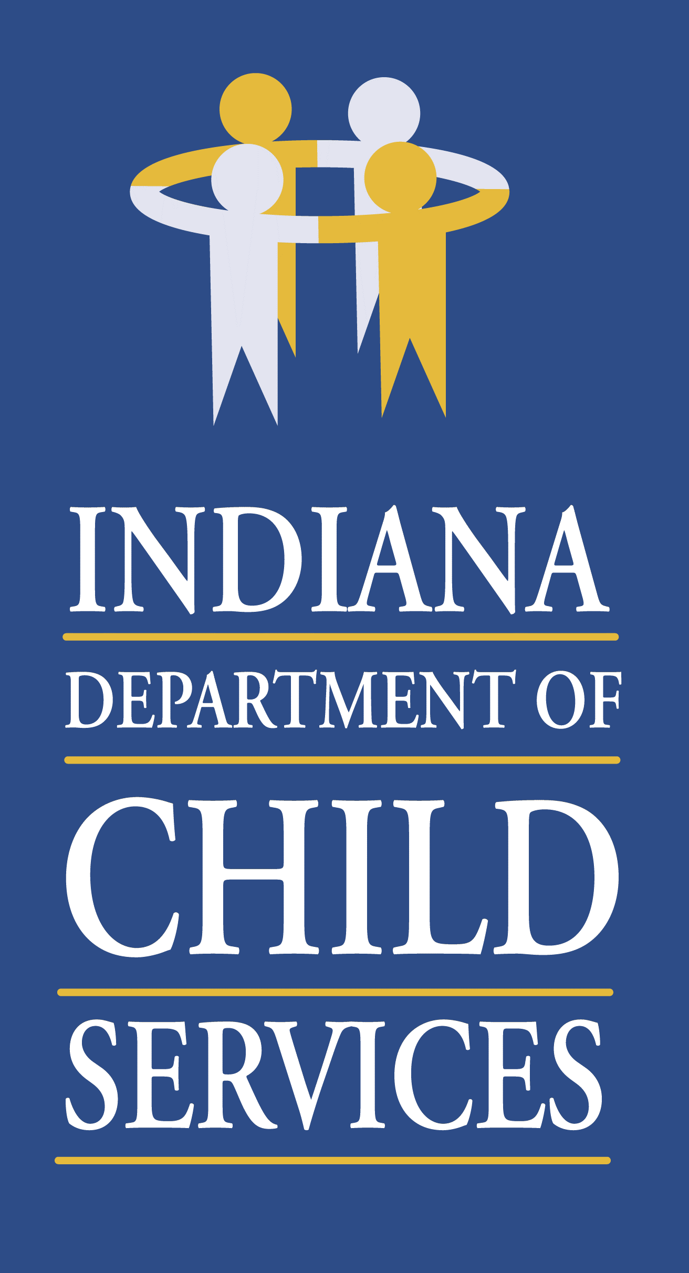
Regional Service Council Meeting Agenda- Region 3
Monday January 11th, 2020 @ 10:00 a.m.
Join Microsoft Teams Meeting
+1 317-552-1674 United States, Indianapolis (Toll)
Conference ID: 865 841 565#

- Welcome/Introduction of Members & Guests: Twan Stokes, Regional Manager, Region
- Review/Approval of Previous Meeting Minutes
- Community Partners Update: Lisa Blanchard, Program Administrator
- Service Update: Dion Smith, Regional Service Coordinator
- Regional Budget Update: Joni Tusing, Regional Financial Manager
- County Updates: Local Office DCS Directors
- Elkhart – Wendy Disher-Taljaard
- Kosciusko – Lindsay Castro
- Marshall - Michael Carroll
- St. Joseph – Teresa Zornig

- Other Business:
- Provider Presentations
  - NYAP, Tara Hamilton & Courtney Marek
  - SCAN, MaryAnn Goodwell, Father Engagement Services

- Adjourn

