Antibiotic Testing Flow Chart
Revision 8/3/2021
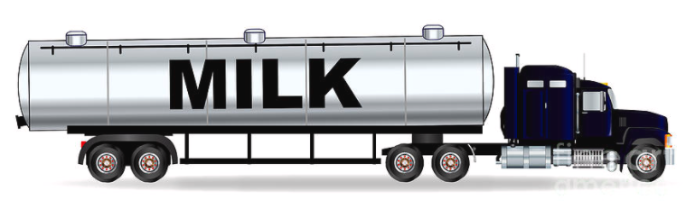
Load Sample
(Tanker)
KEY POINTS TO REMEMBER

- After receiving a positive result, DO NOT re-calibrate the equipment, it is only necessary to run controls
- All presumptive positives must be reported to BOAH in a timely manner
- If initial positive is obviously the result of an analyst error, testing must move forward according to the positive result (ie. run controls and run the same sample in duplicate)
SCREENING TEST POSITIVE
LOAD MUST BE DESTROYED.
FOLLOW PRODUCER TRACEBACK PROTOCOL

Analyst runs positive and negative controls.
Same sample in duplicate promptly.
Controls must give appropriate reactions.

NF
NF
Pos
NF
Pos
Pos
NF
NF
Pos
Pos
Pos
NF

PRESUMPTIVE
POSITIVE

From this point forward, testing must be performed by:
Certified Lab or CIS

No further testing
Milk can be received
Same analyst runs positive and negative controls.
Same sample in duplicate promptly.
Controls must give appropriate reactions.

First Test:
Initial Positive
First Test:
None Found (NF)
Producer Traceback Protocol
Revision 8/3/2021
Producer
Negative
Confirmed Producer Positive
NF
NF
Pos
Pos
Pos
NF

Analyst runs positive and negative controls.
Same sample in duplicate promptly.
Controls must give appropriate reactions.

Initial
Positive
Producer traceback.
Test all producer samples using same test as used to screen milk.

